# Stanford : Computer vision course

<https://www.youtube.com/watch?v=vT1JzLTH4G4&list=PLf7L7Kg8_FNxHATtLwDceyh72QQL9pvpQ>

Lecture 1 : Intro about the course…

## Lecture 2: Image Classification

We used to do logic on edges… to recognize cats… or compare difference between a new image and a dog class images and other different class images and picked the one most similar to… didn’t work well. CNN are the best solution there is now.

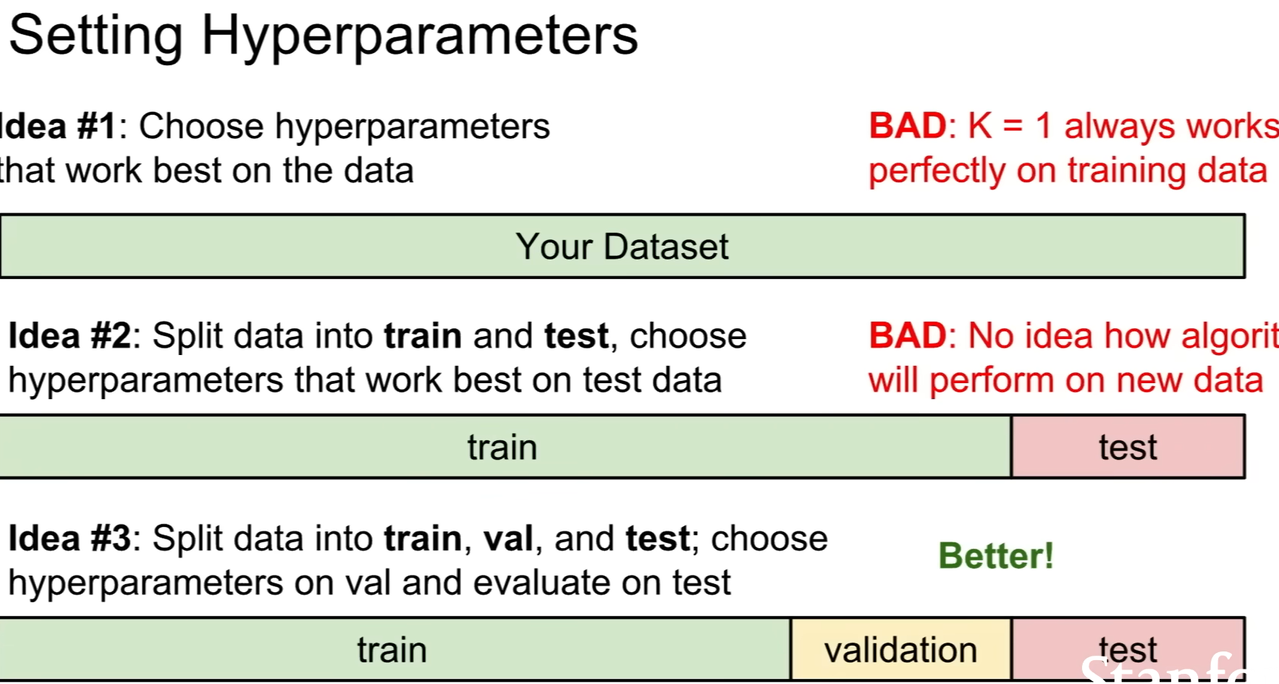

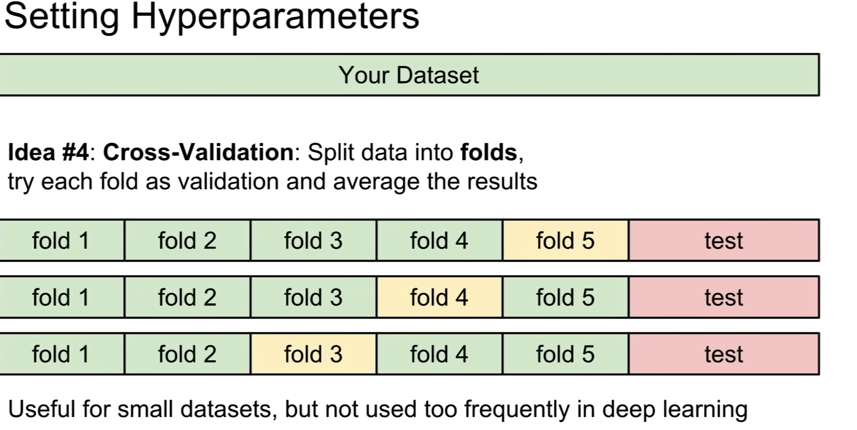

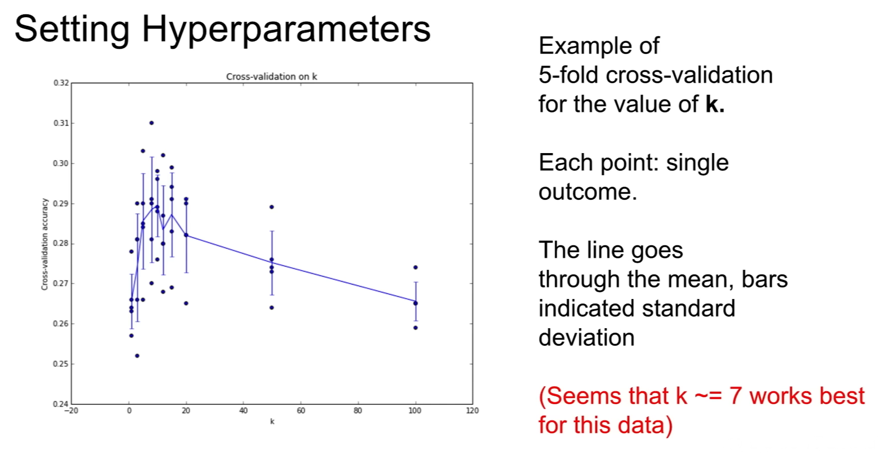

Pick the k value for k-nearest neigbors. But similar to every AI/ML thing: you run different training and pick the one performing the best on test set.

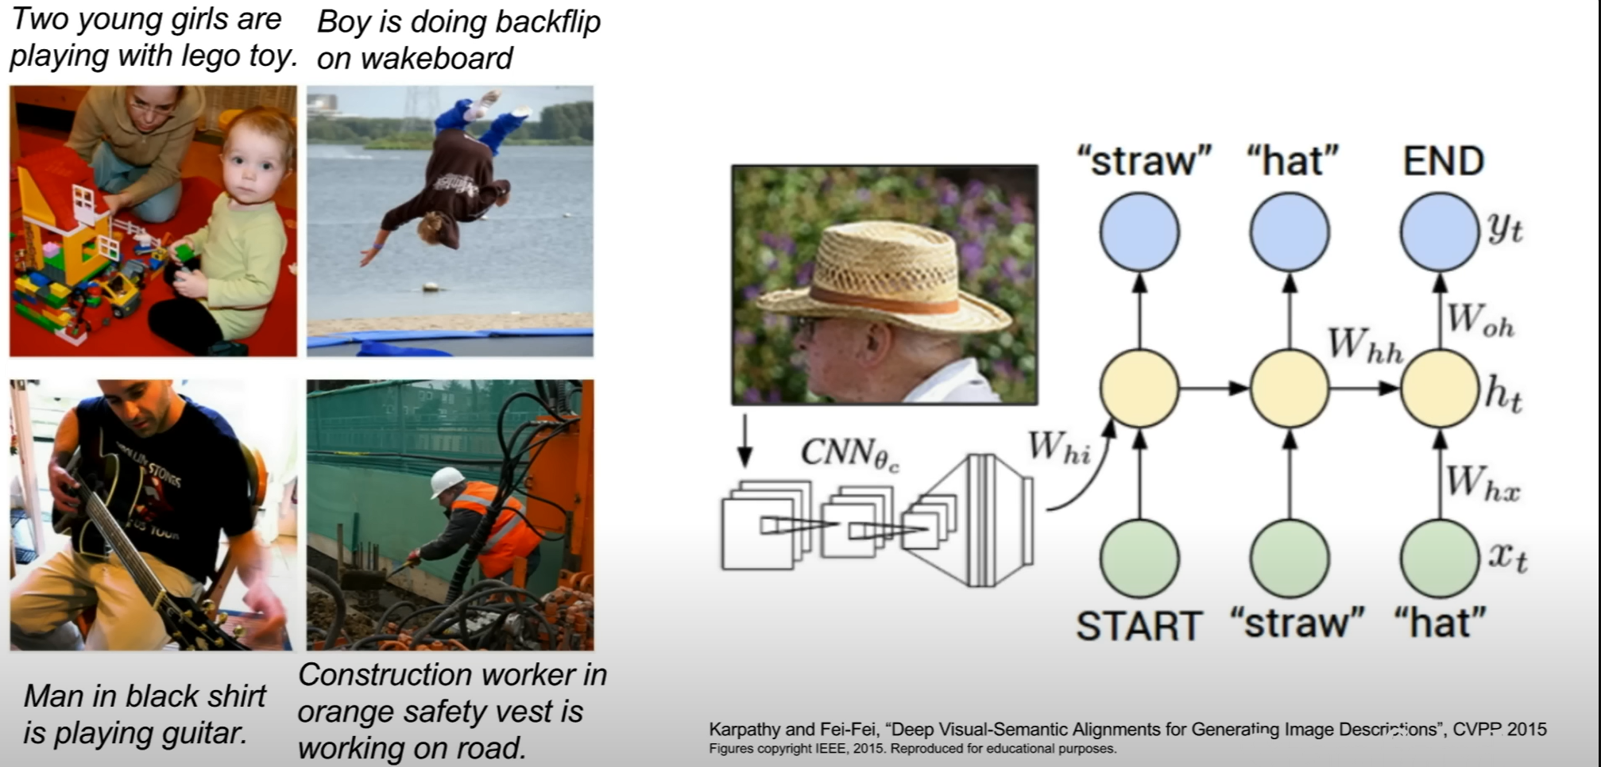

they link chain neural networks (one understand images, an other words, and last “sentences” and together the describe images.

Linear classification

F(X,W) = X.W+b

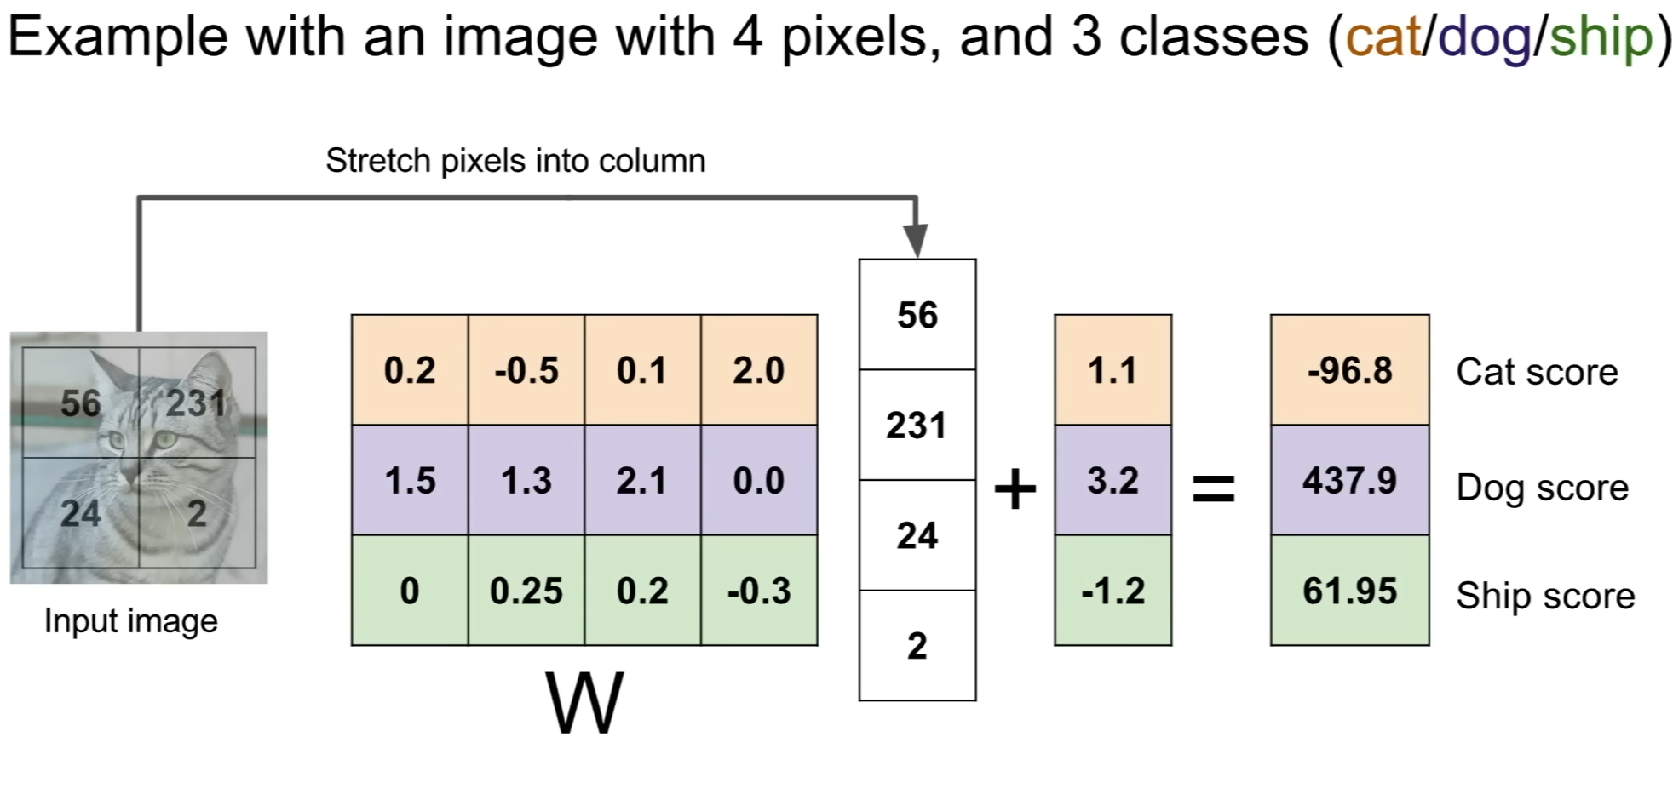

Gives a dog,cat,ship score to know which one it is. You manipulate the data as you want. You just need a score for each.

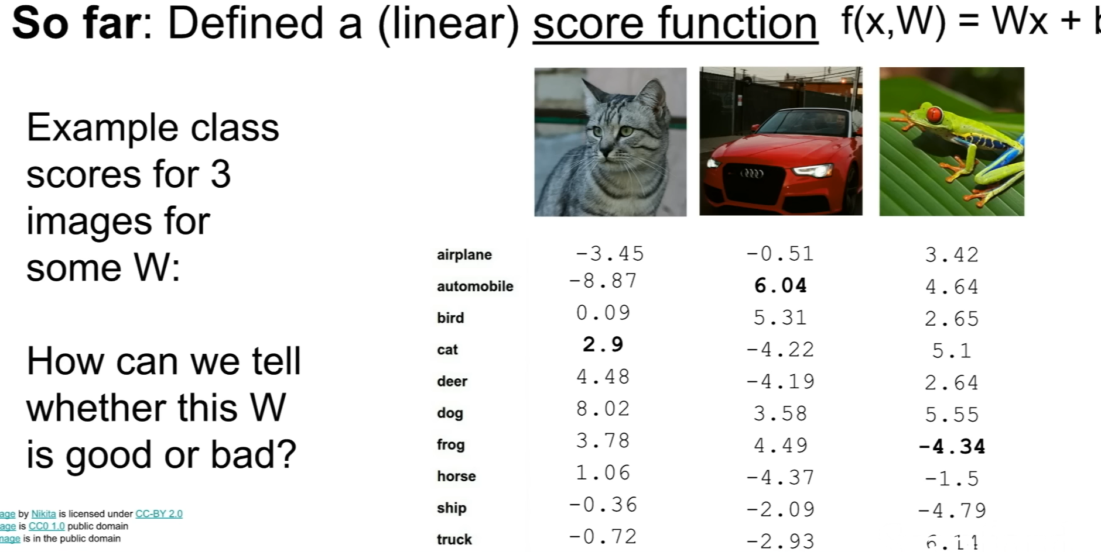

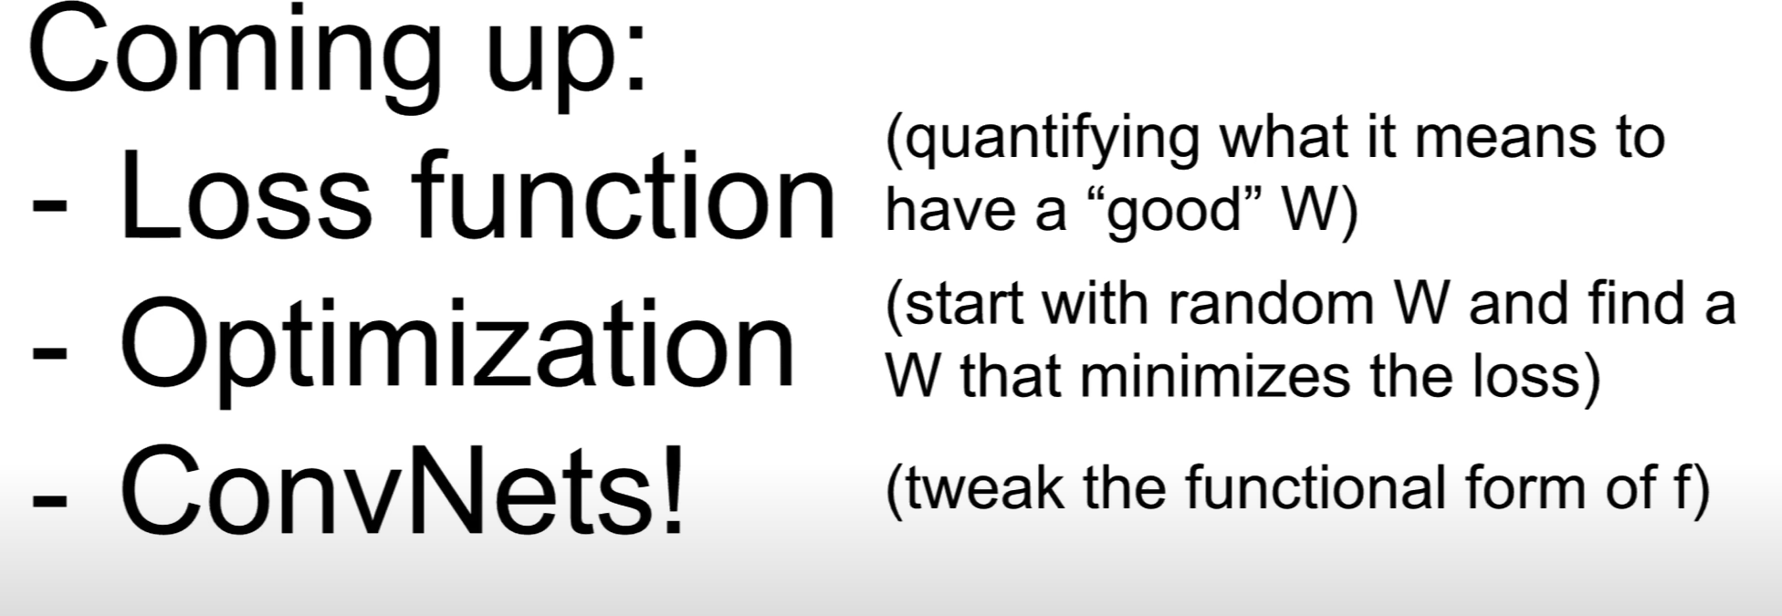

## Lecture 3: Loss function and optimization

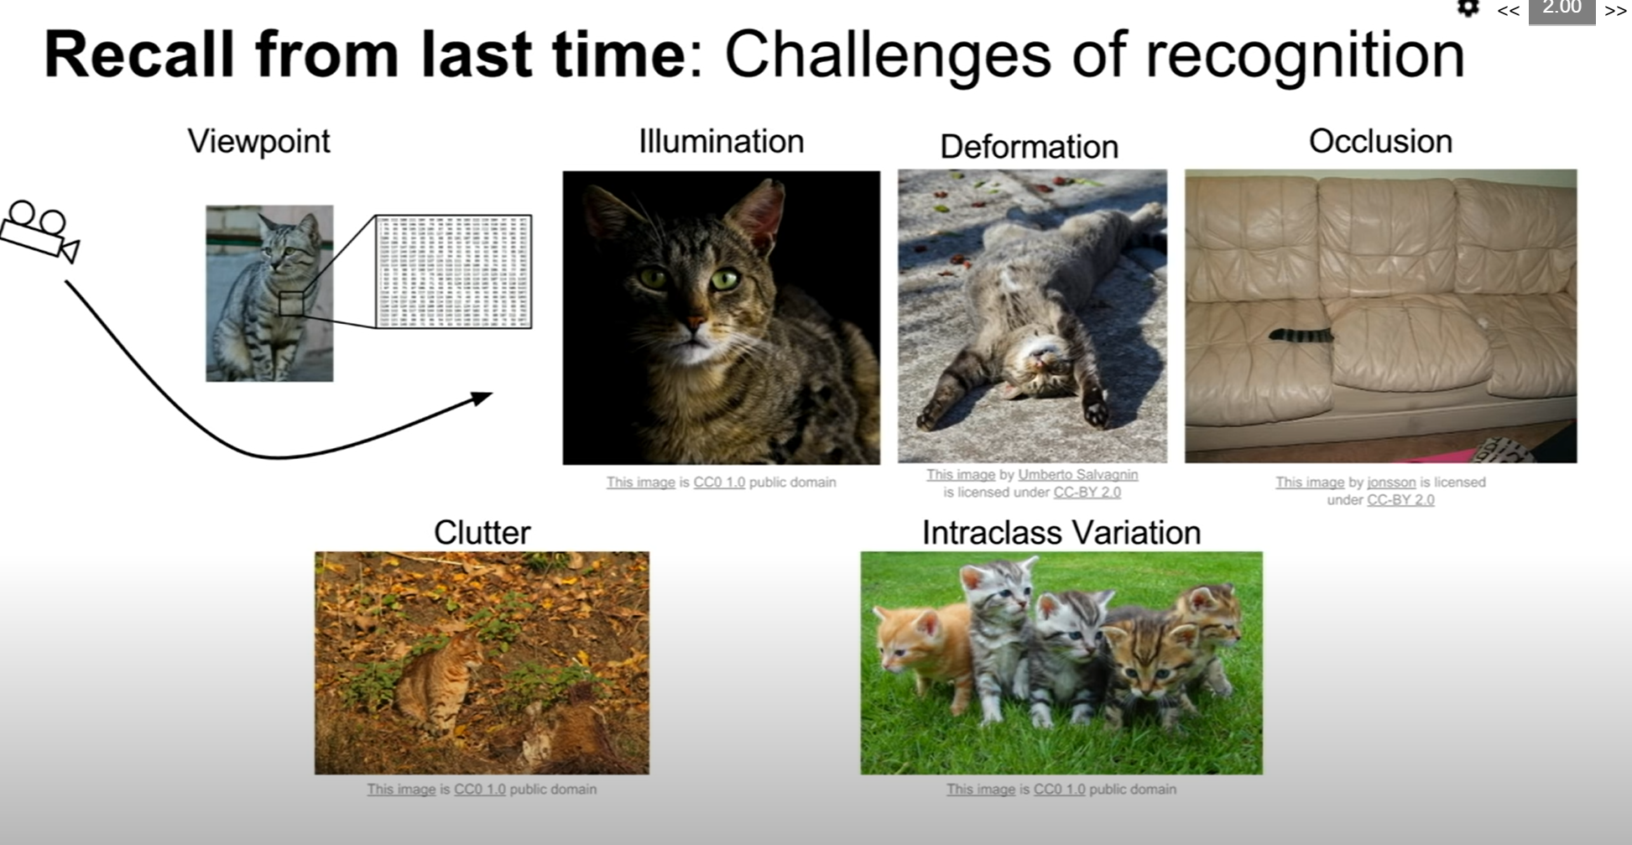

Maybe check again course 2 on k-nearesst problem because I didn’t get the relationship with images

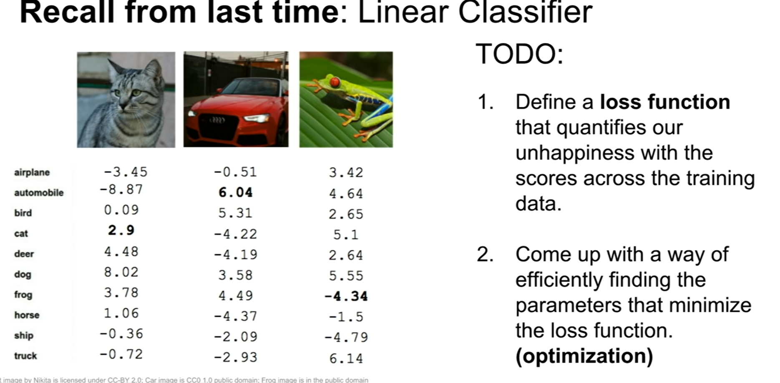

|  |  |
| --- | --- |
|  |  |

The +1 in right screen is a safety margin. If frog score 7 on frog but 6.8 on car we can’t say it is successful. The goal is to compare the score of correct category against score of other categories (if >, then loss is 0) otherwise it is the difference between those.  
it is called a Hinge loss:

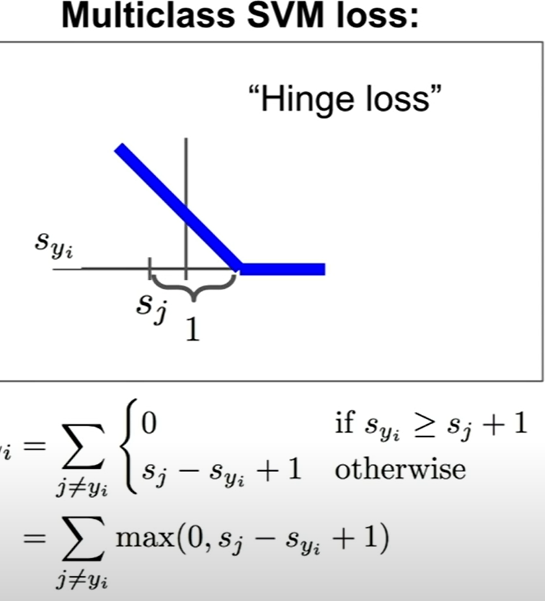

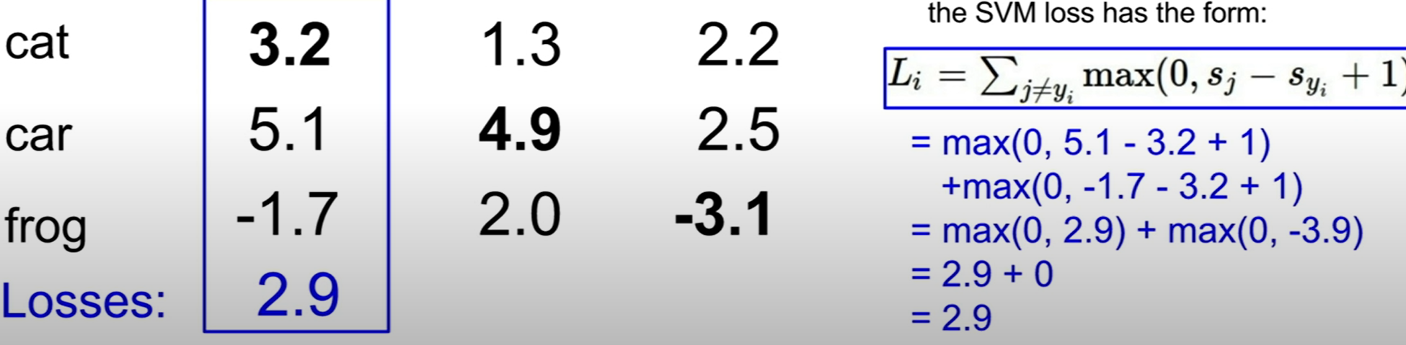  
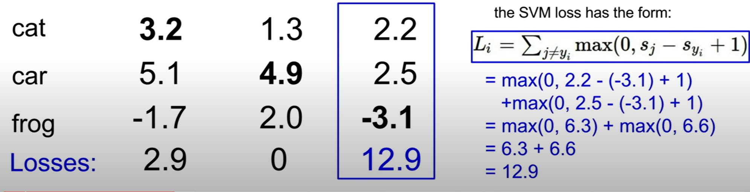  
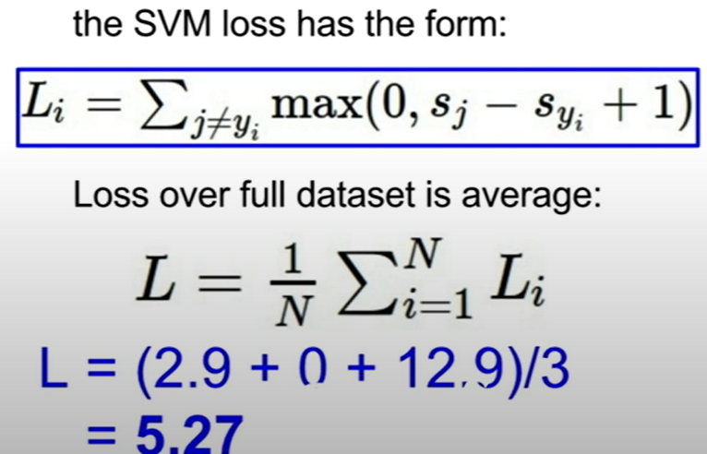

When starting new dataset, errors are always so low (loss low), close to 0, so change the 1.

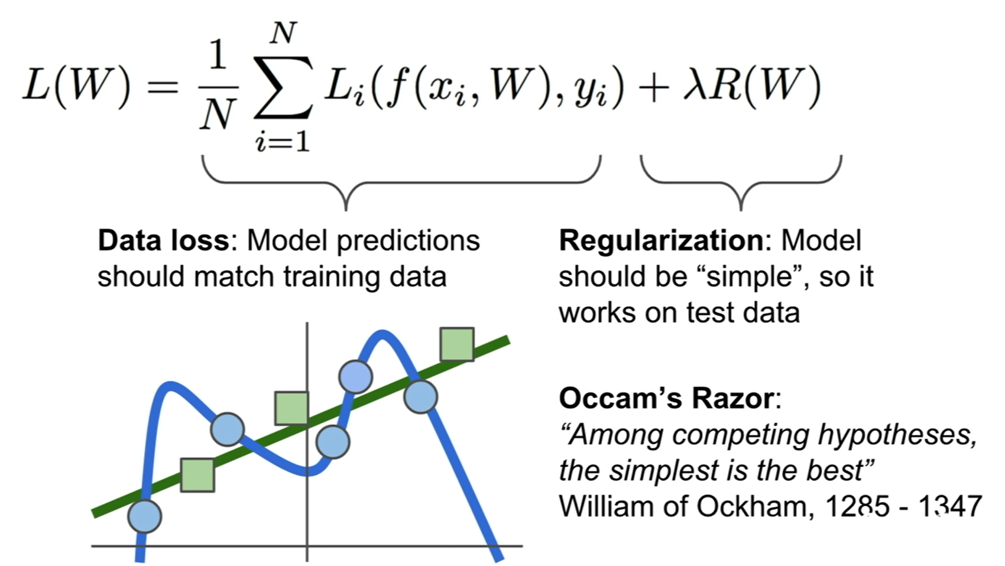

For difference between training data and real world, regularization.

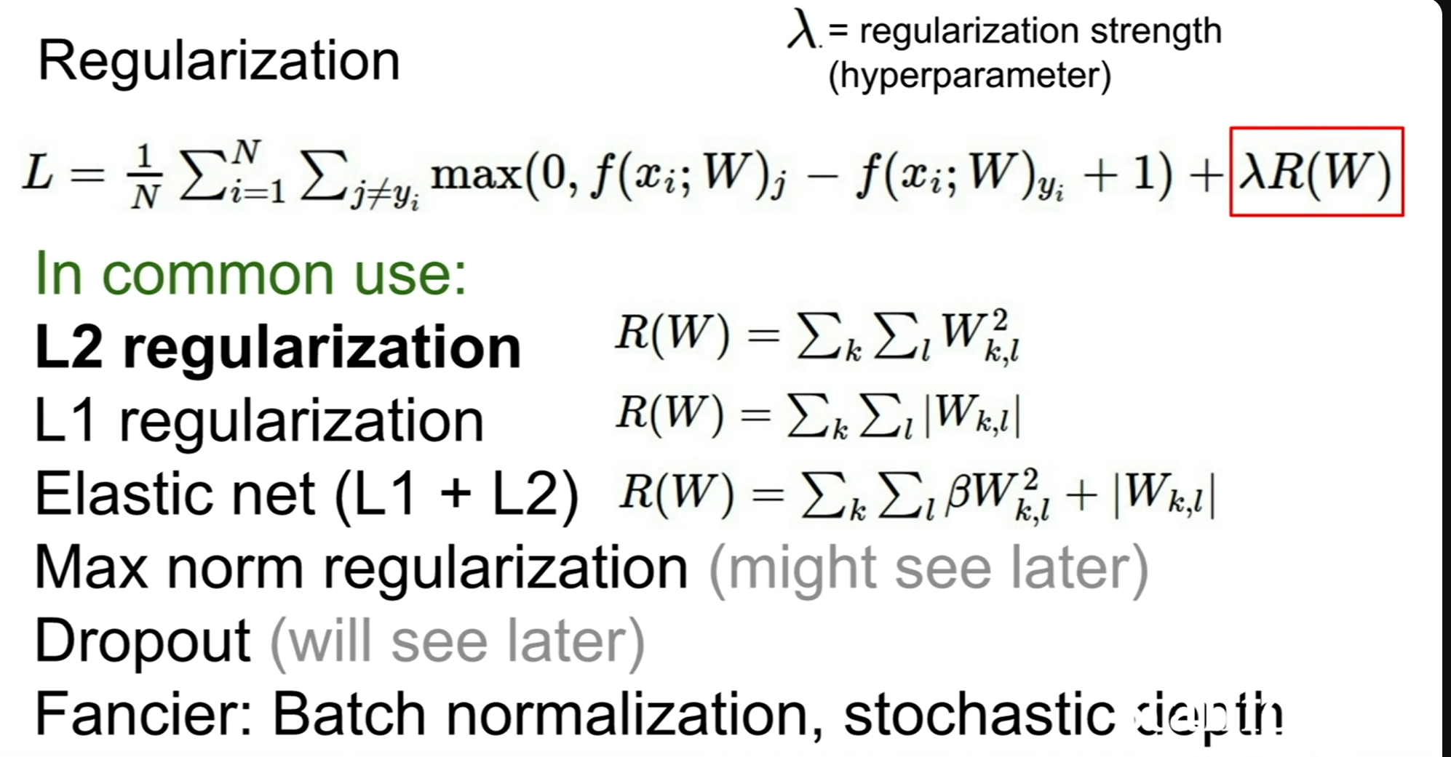

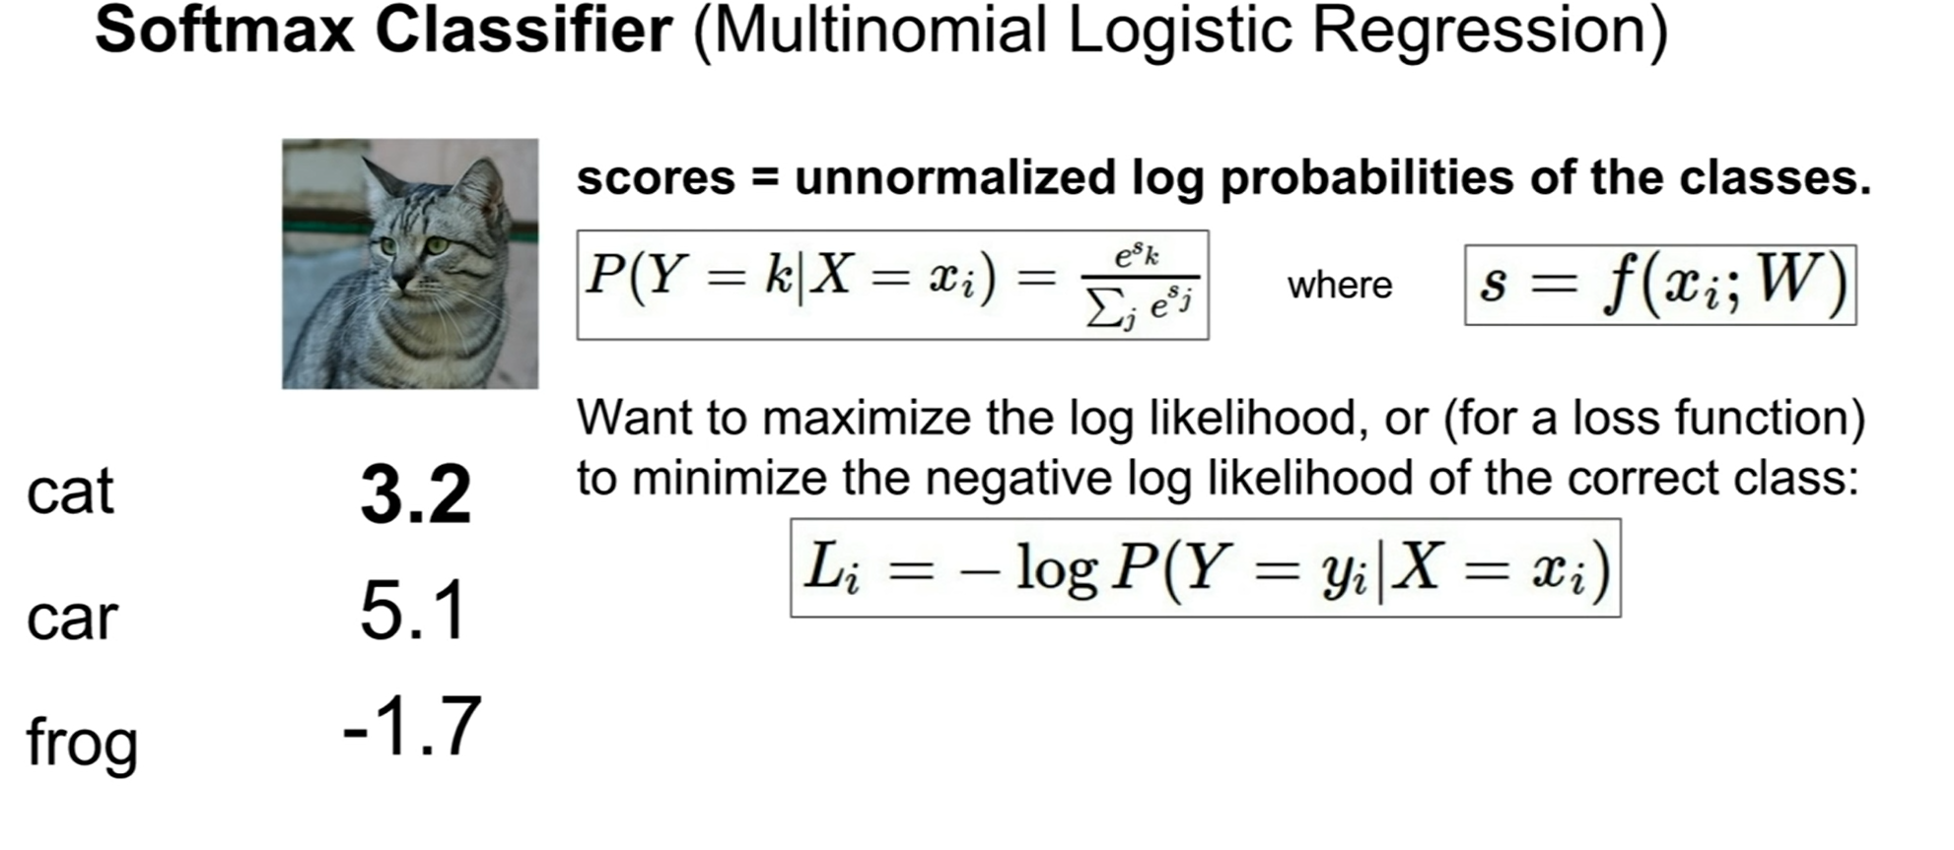

Softmax function is the fraxtion with ethe exponentials

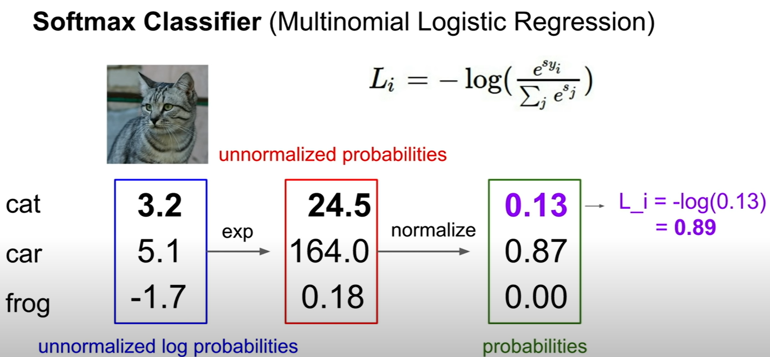

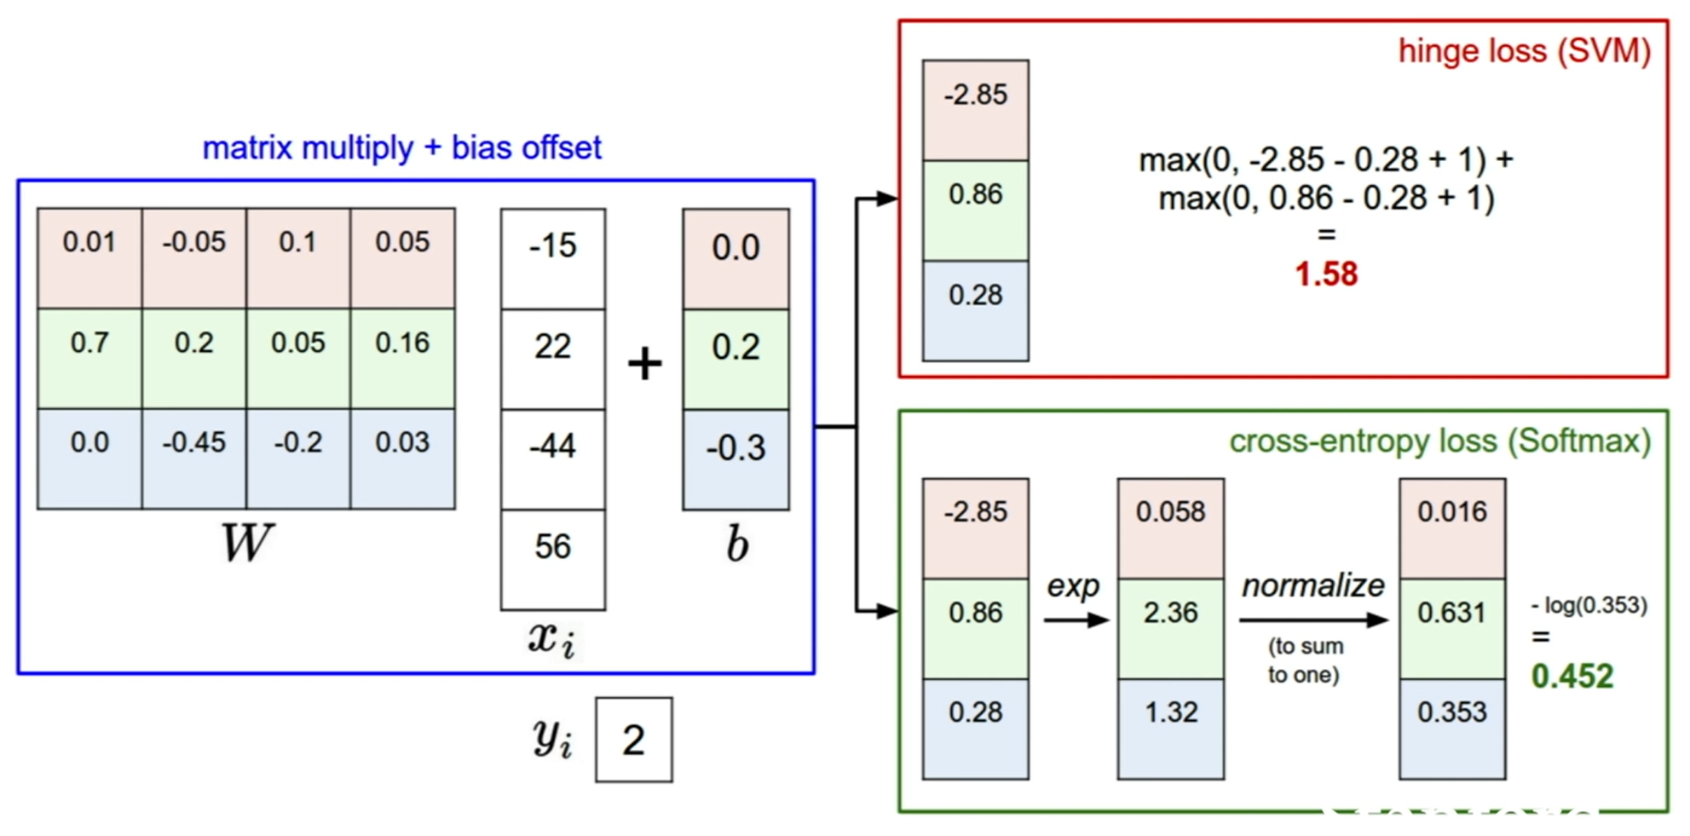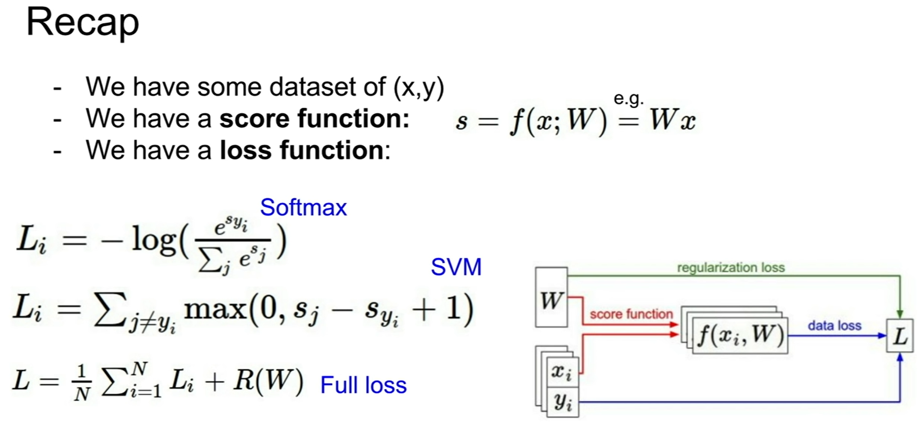

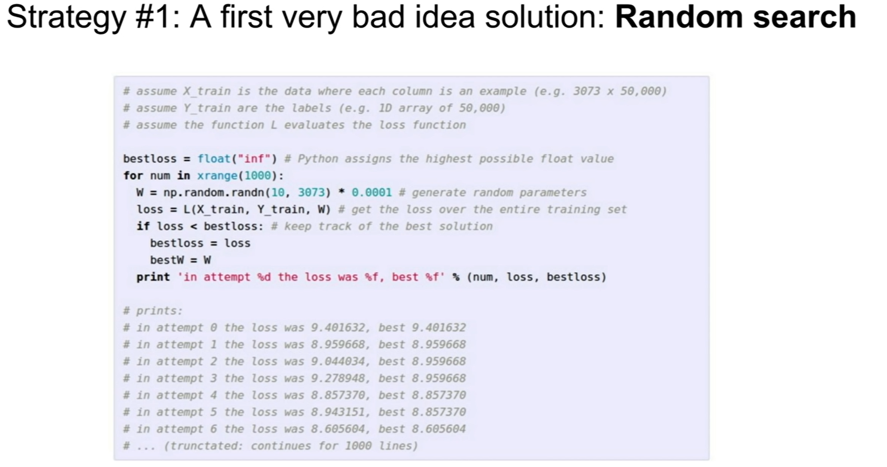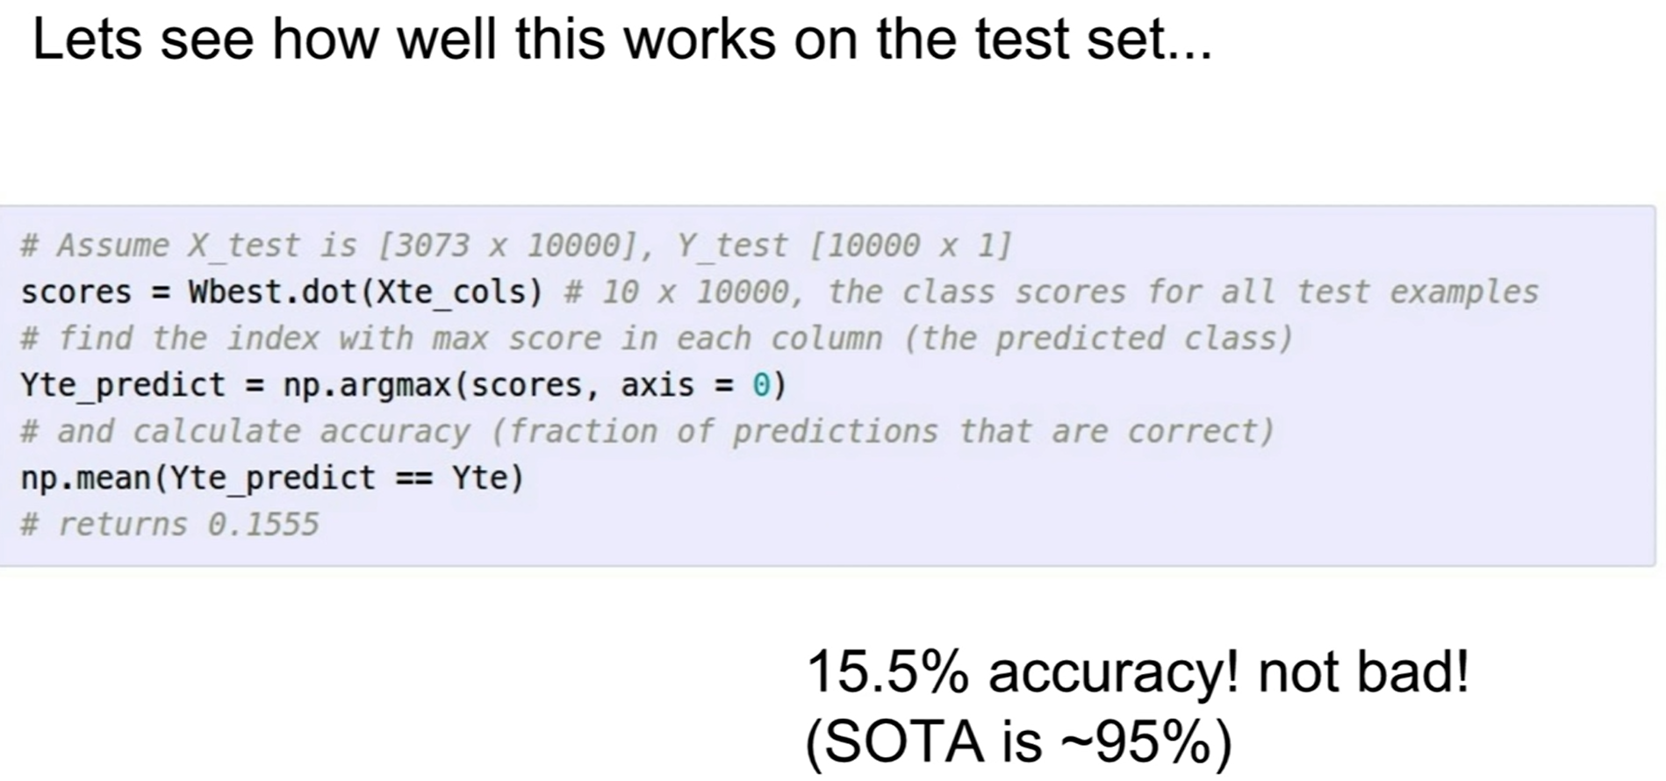

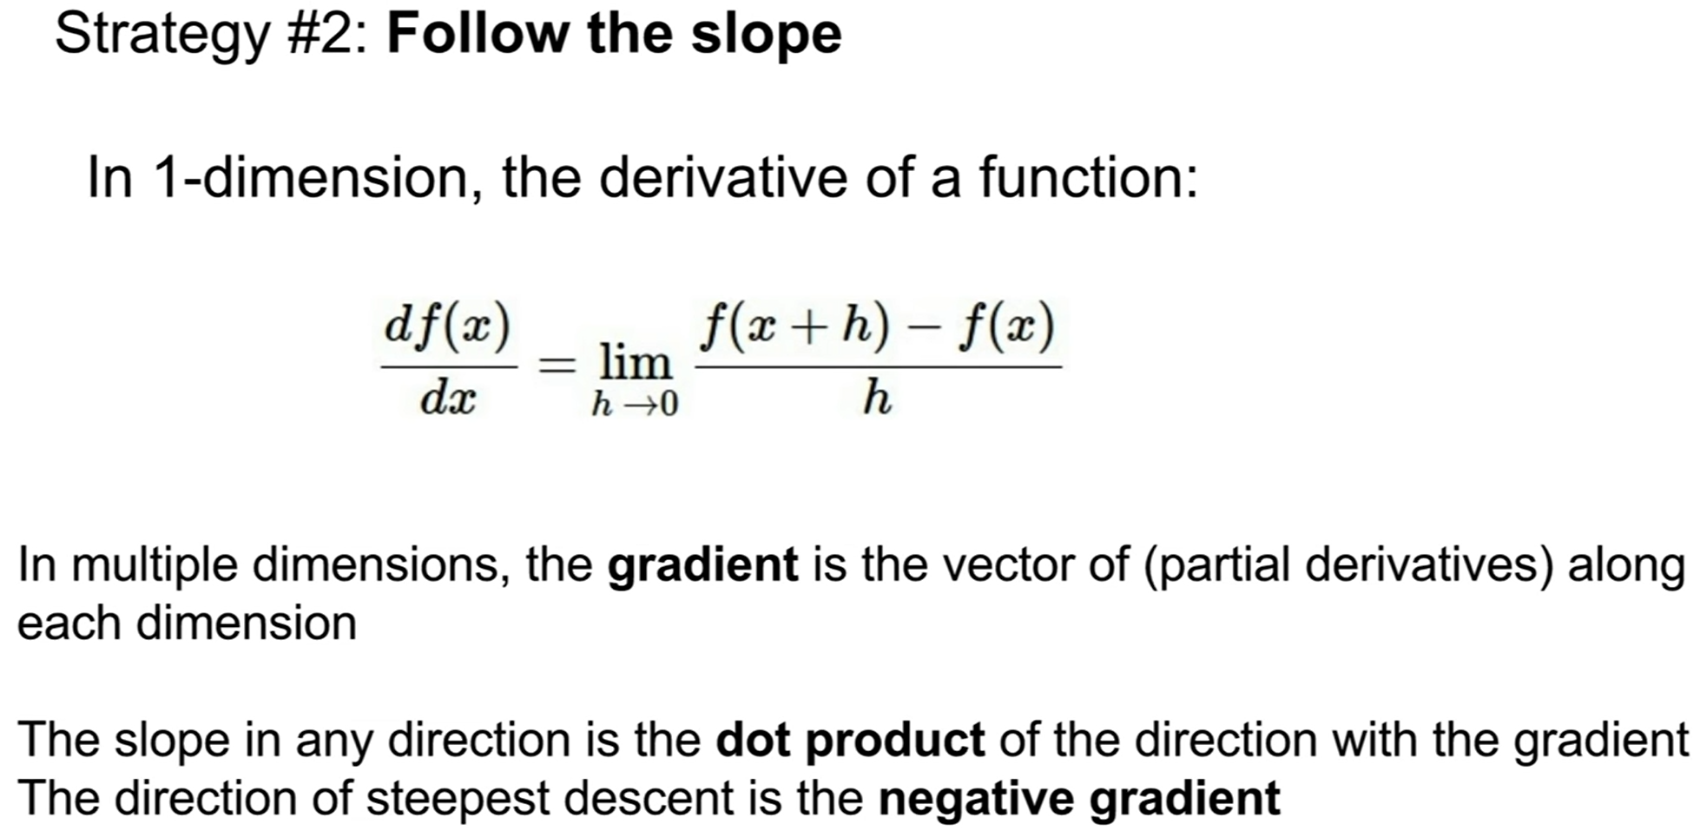

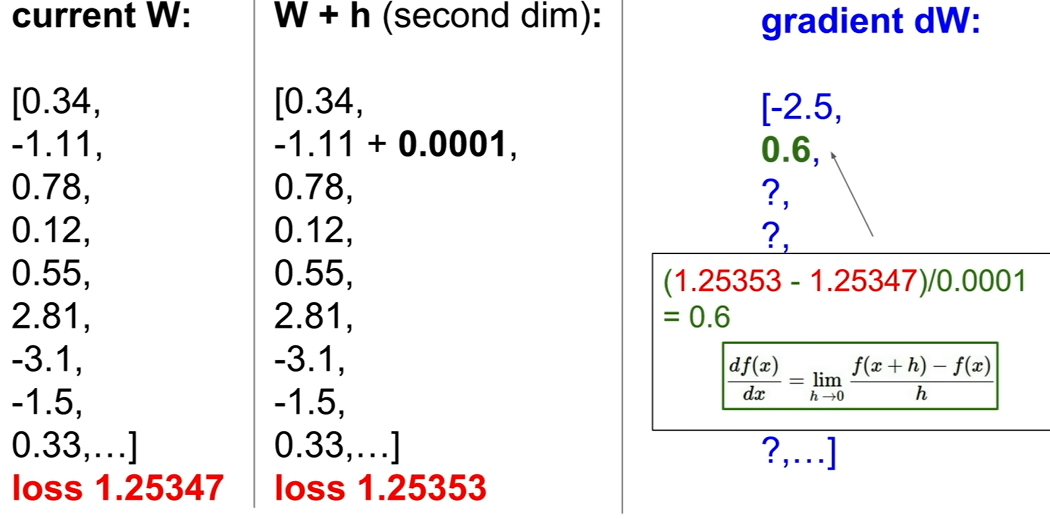

Super slow though

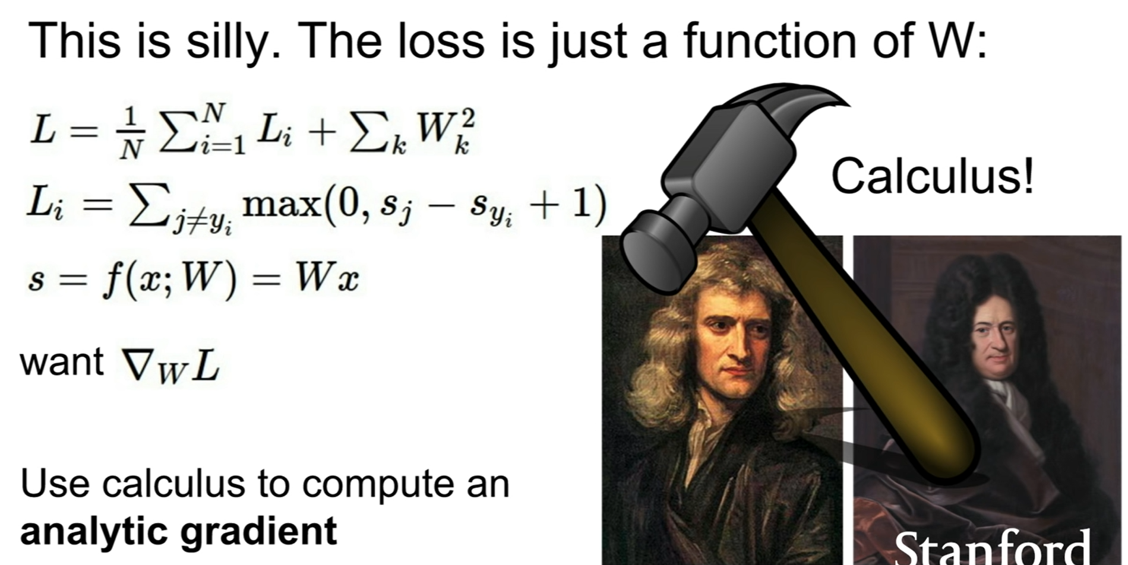

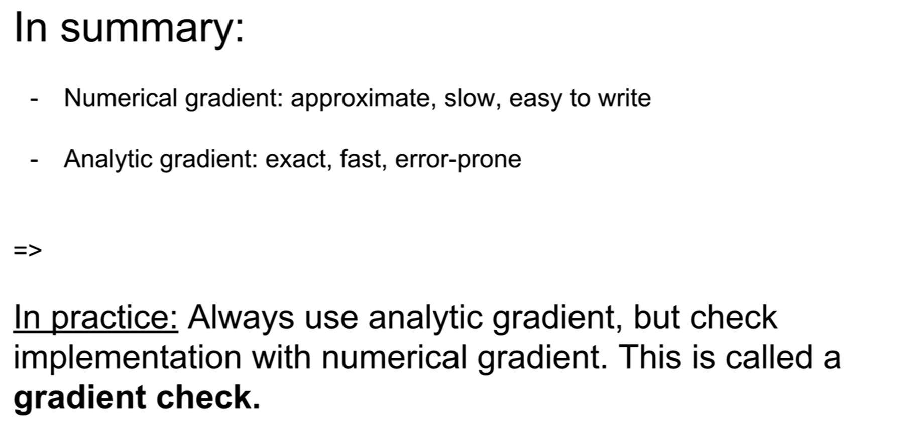

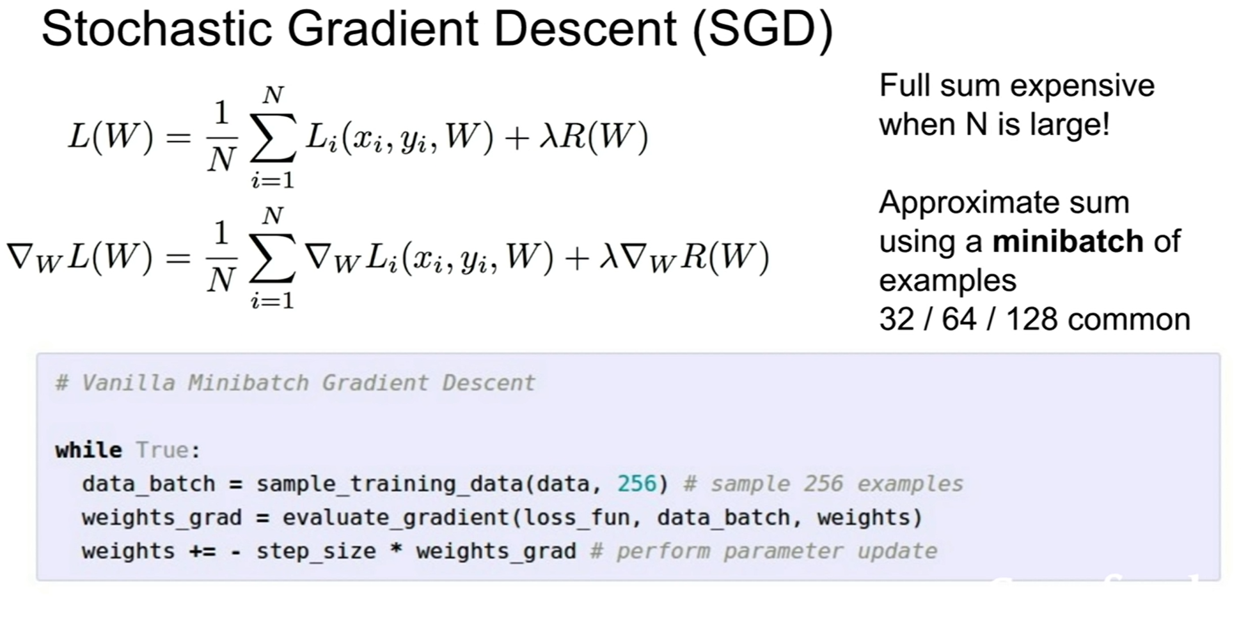

Until now xe just worked with pixels we we also have other data in an image: It is kinda the old way of doing it but still interesting.

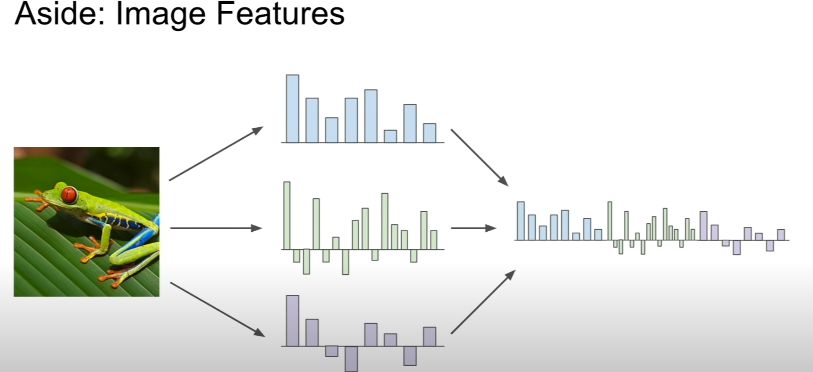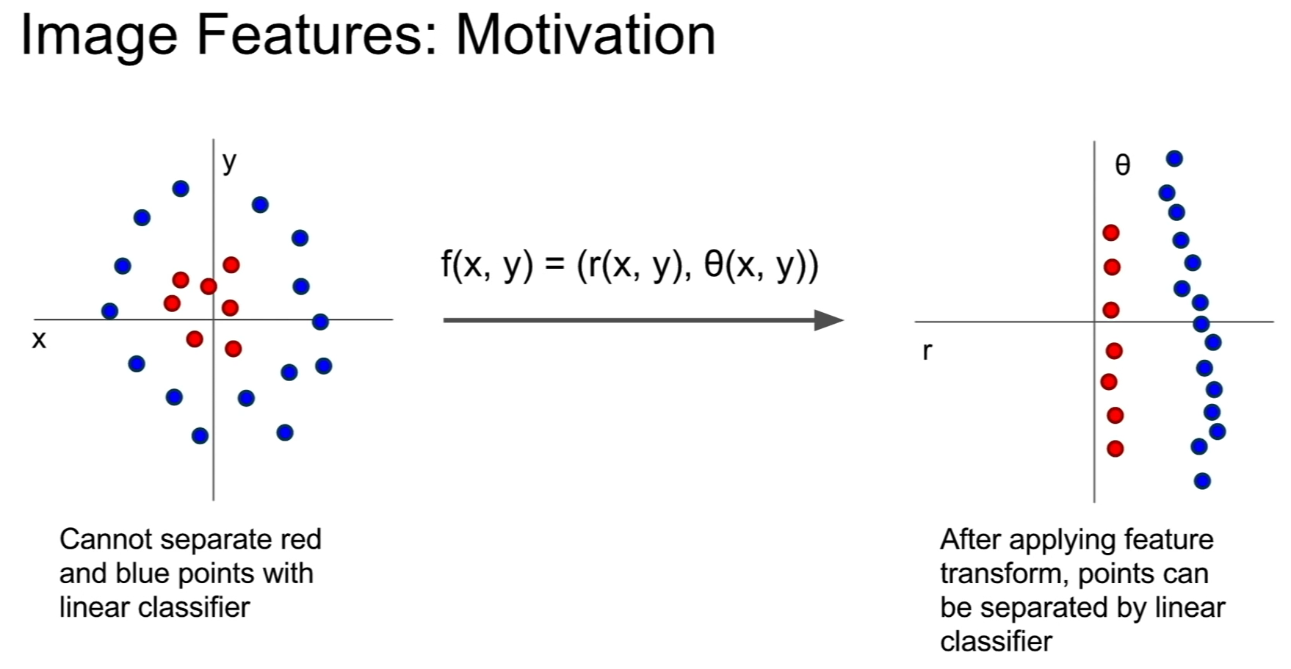

This feature division is also applyable to images:

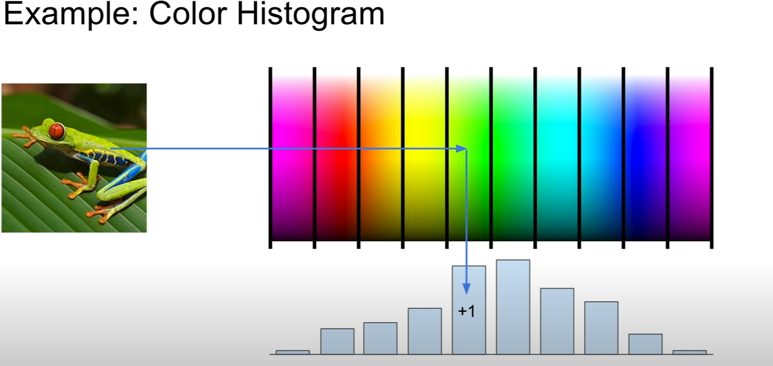

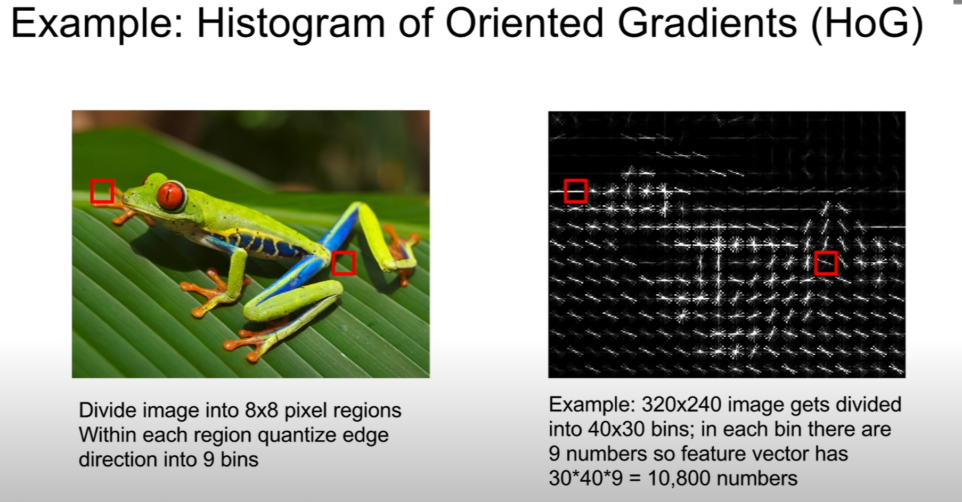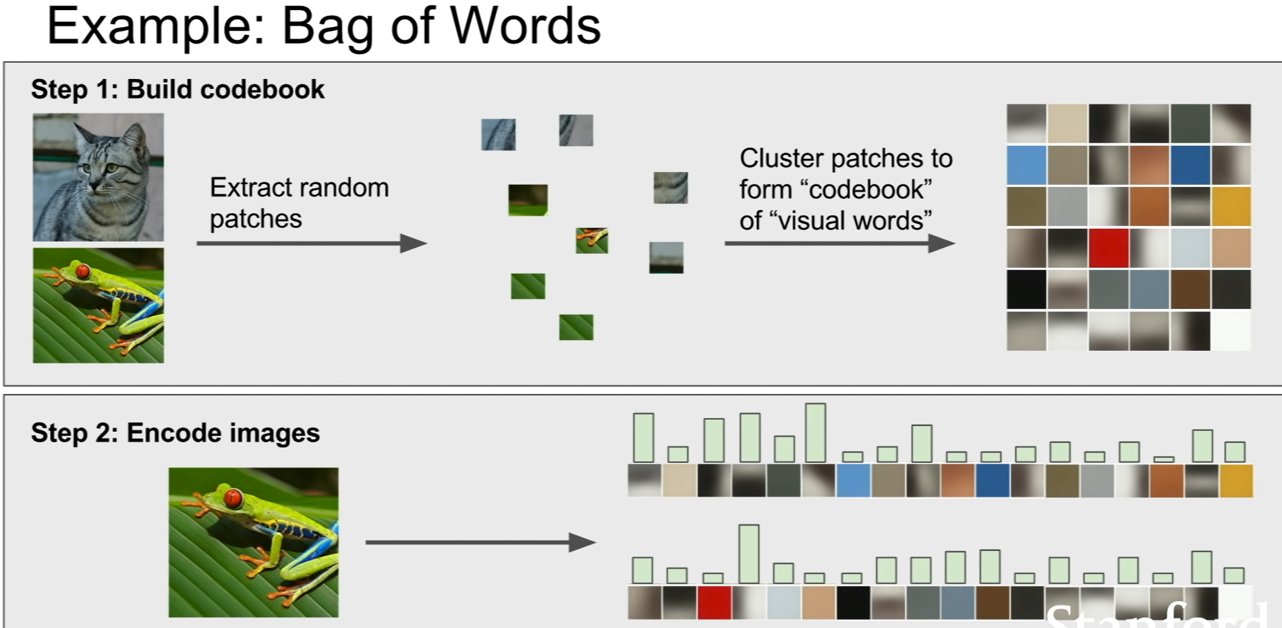

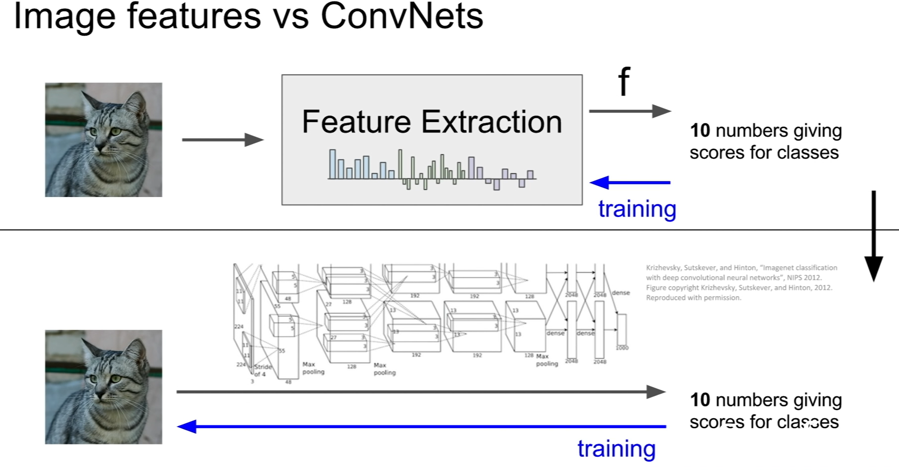

The difference is just that we figure out the feature that makes a cat a cat during training and not before.

## Lecture 3: Intro to neural networks

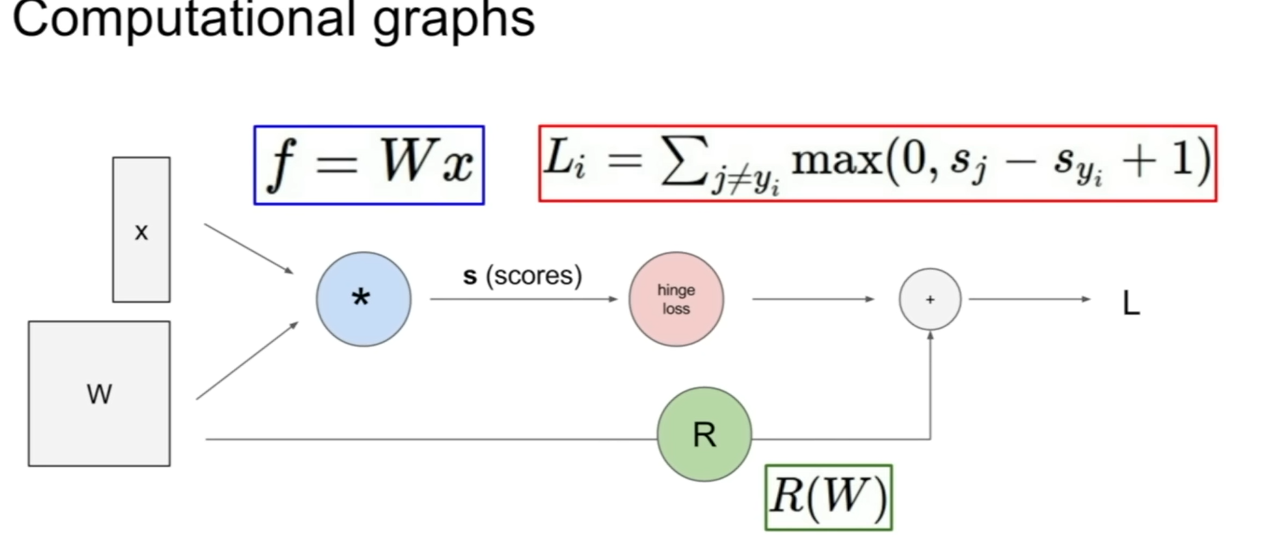

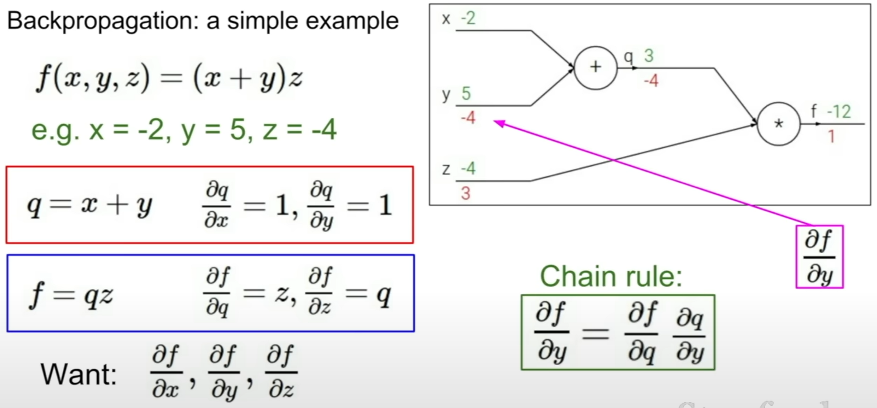

We take the result f and compute the differencial with the last variable (take df/df for right = 1. Take df/dz for z var and find 3 because from the expression, df/dz = q and q = 3 from graph.

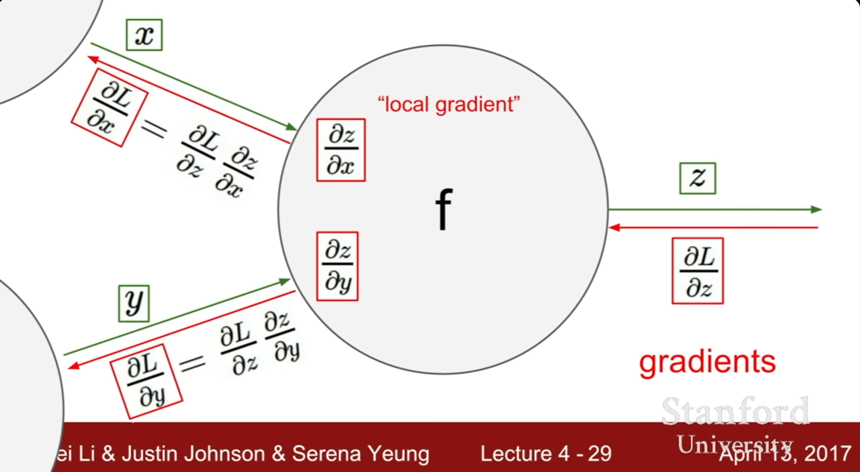

Backpropagation: compute end gradient and go back trough local gradients and send it back to varianble before. Keep doing that until reach the beginning.

Start by writing function as computational graph

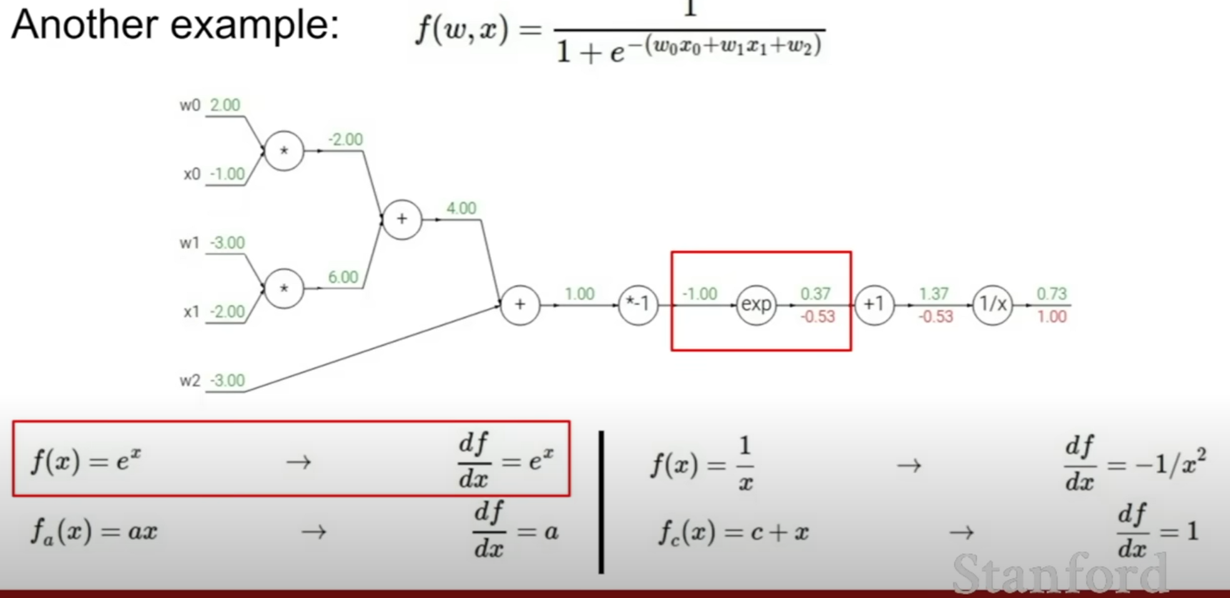

Then go back. Last function is inverse function so derivative is -1/x^2. Put the last value of x (1.37) in and you find -0.53 (oublie pas de multiplier par le 1.00 qui correspond au df/df (chaining) . The last variable is always 1 because it is df/df.

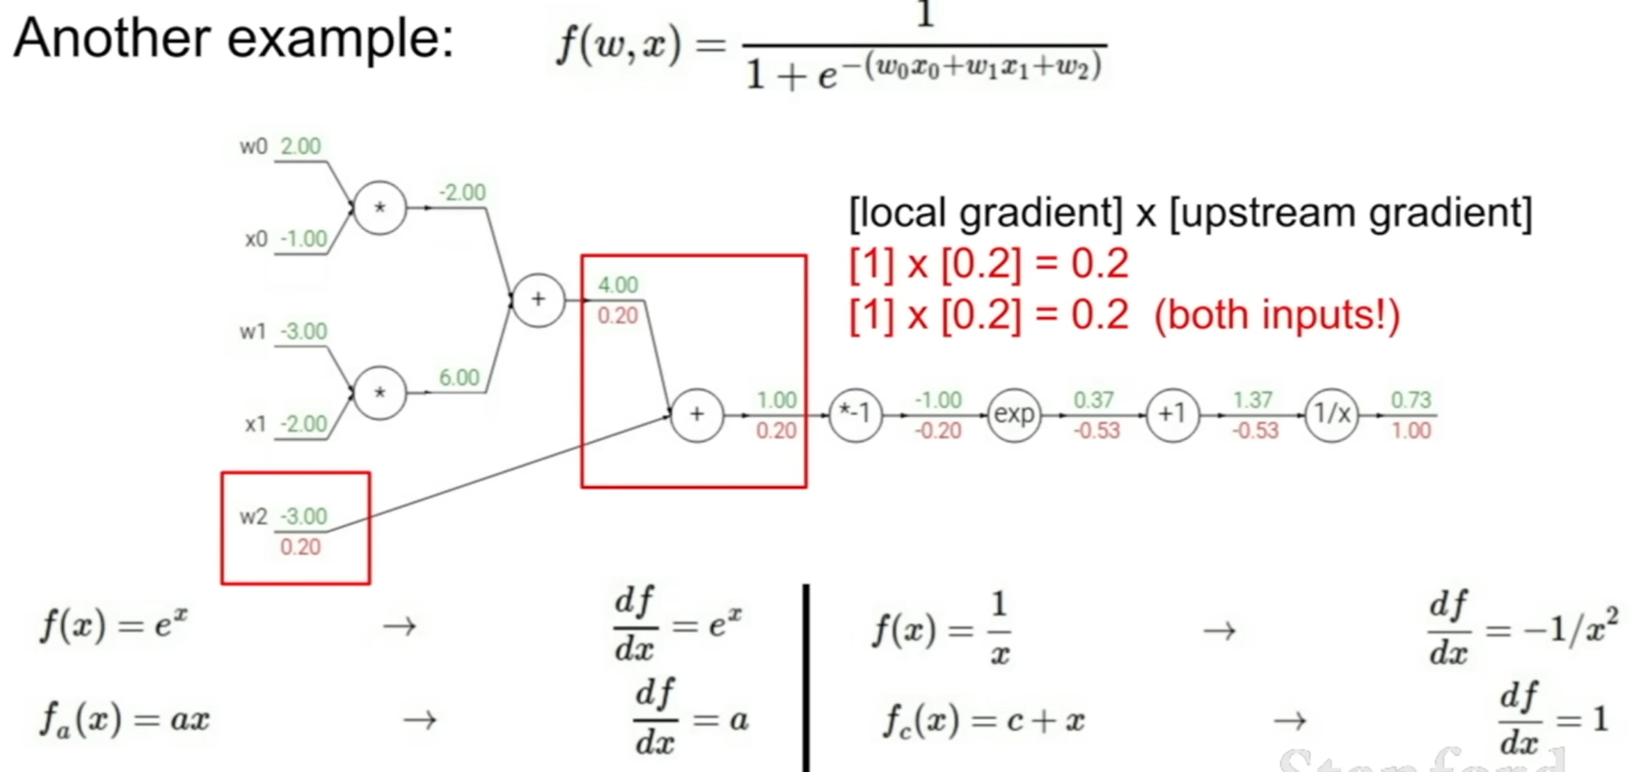

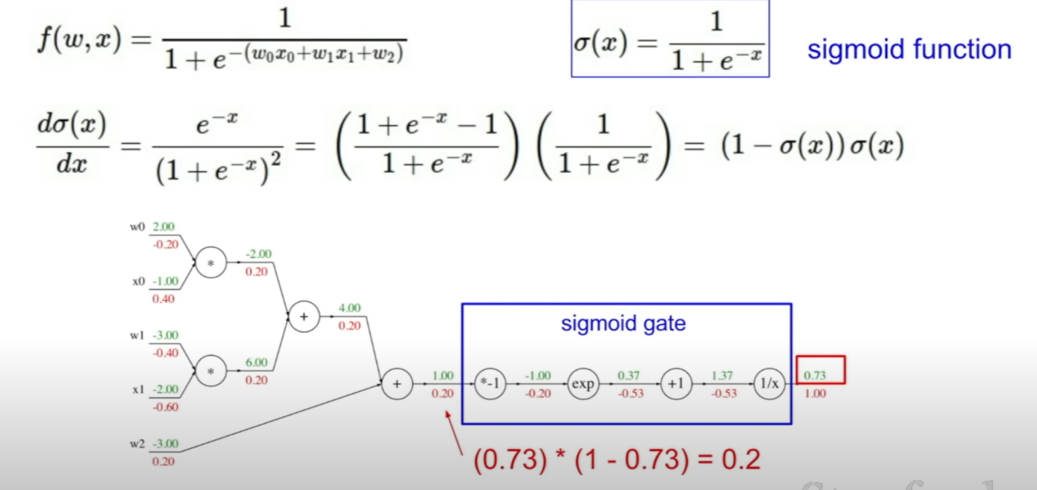

We divided everything into smallest units. But we could break into groups like sigmoid if we can predict those groups.

You can see patterns in operators too:

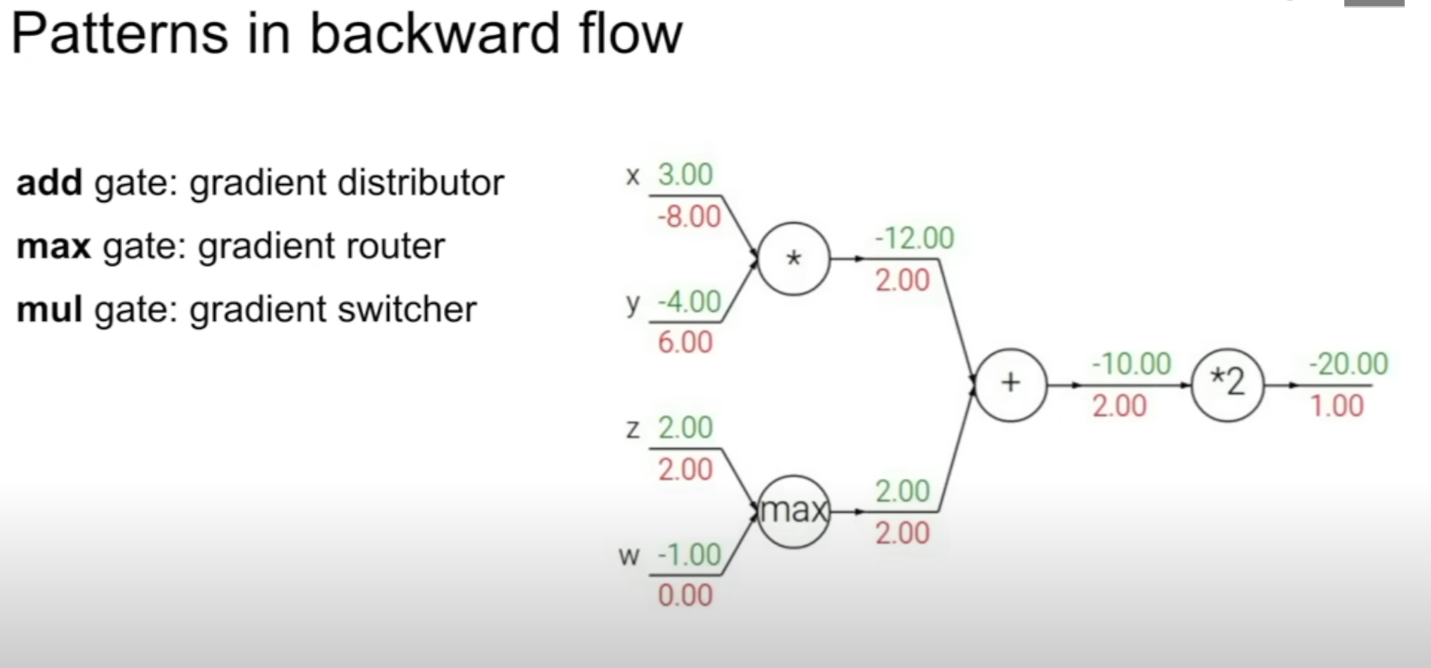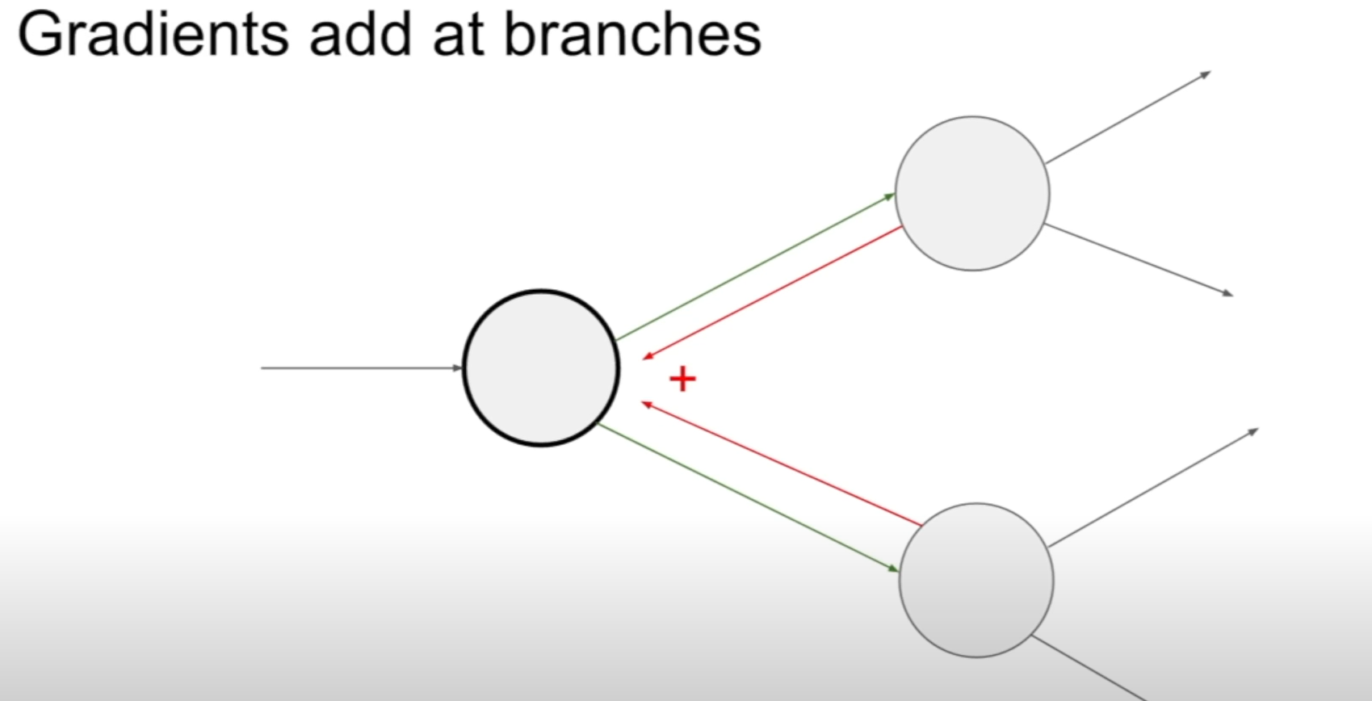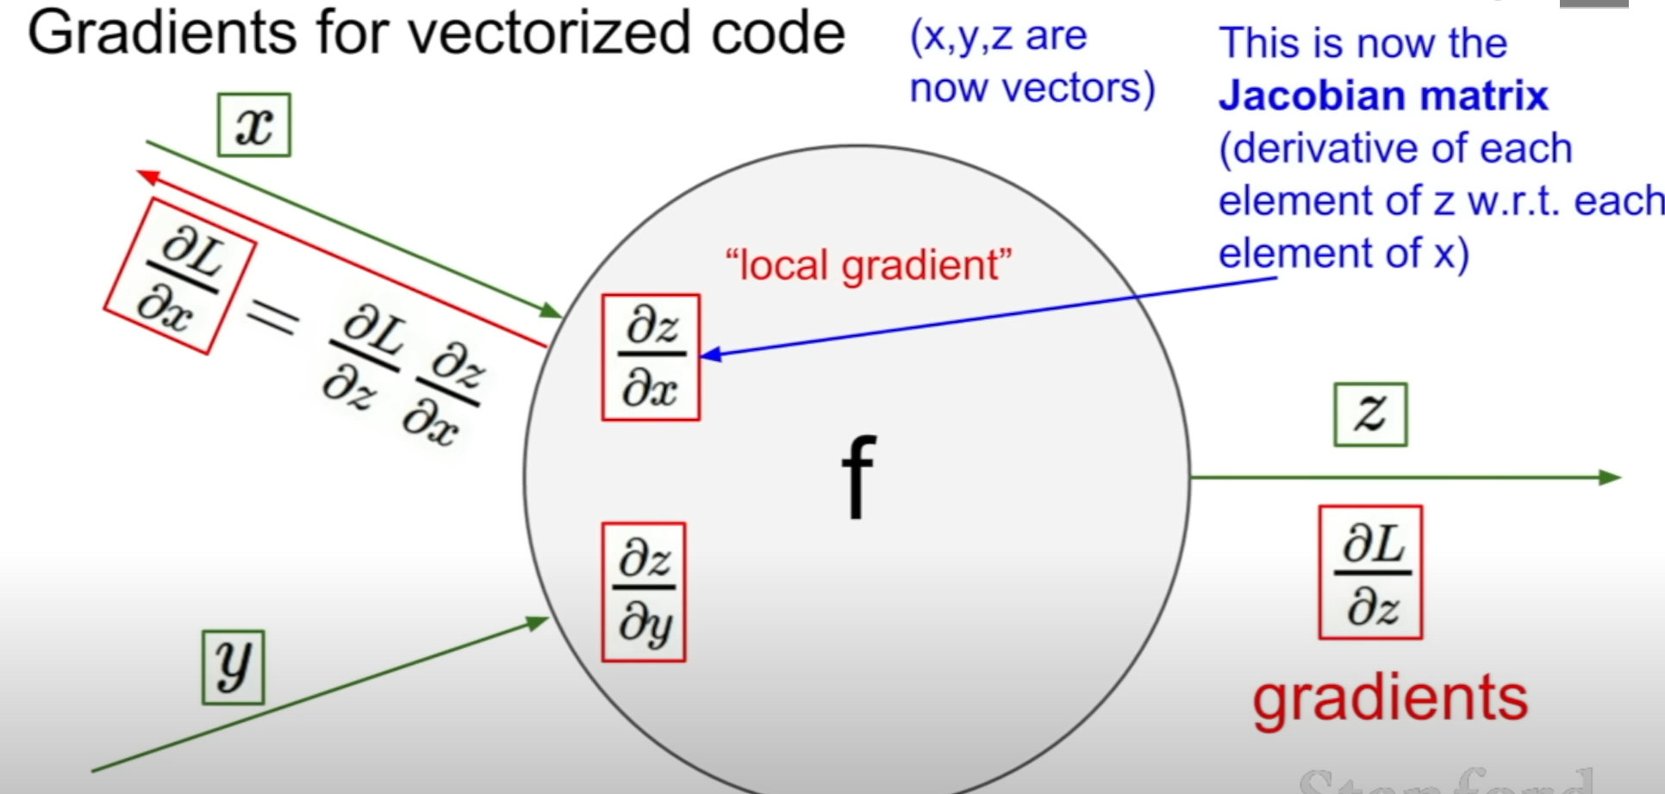

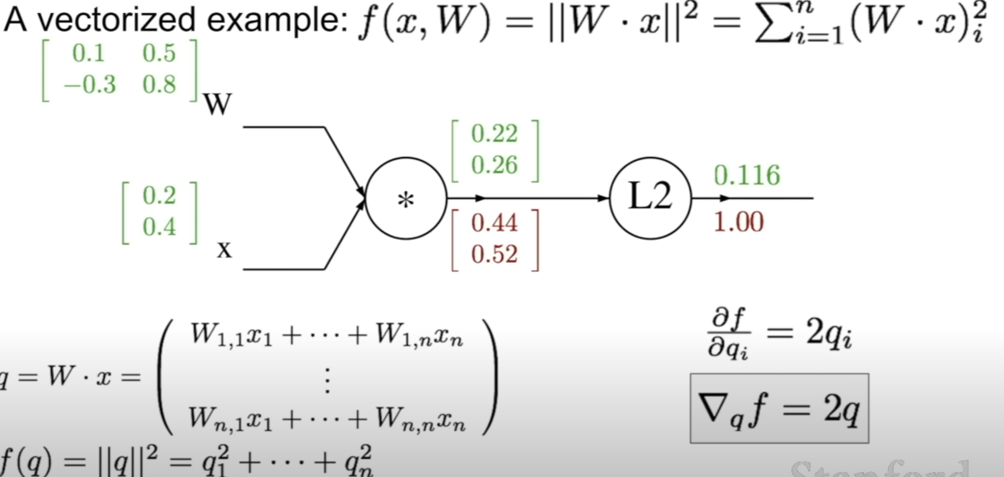

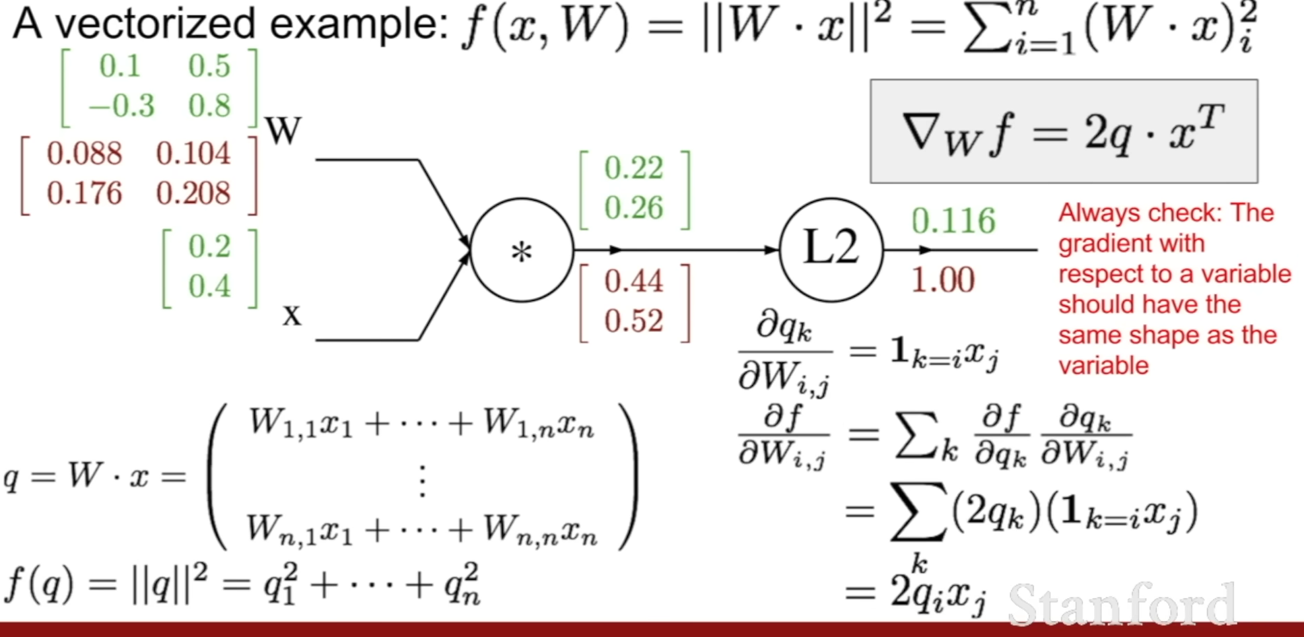

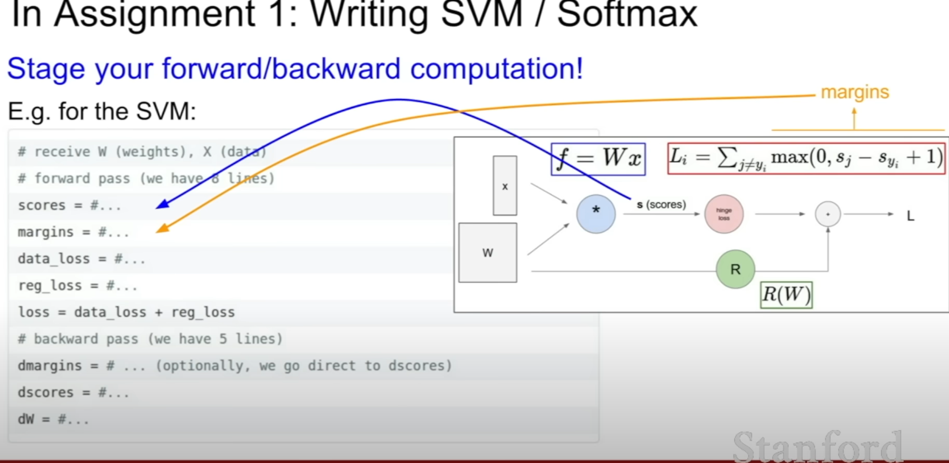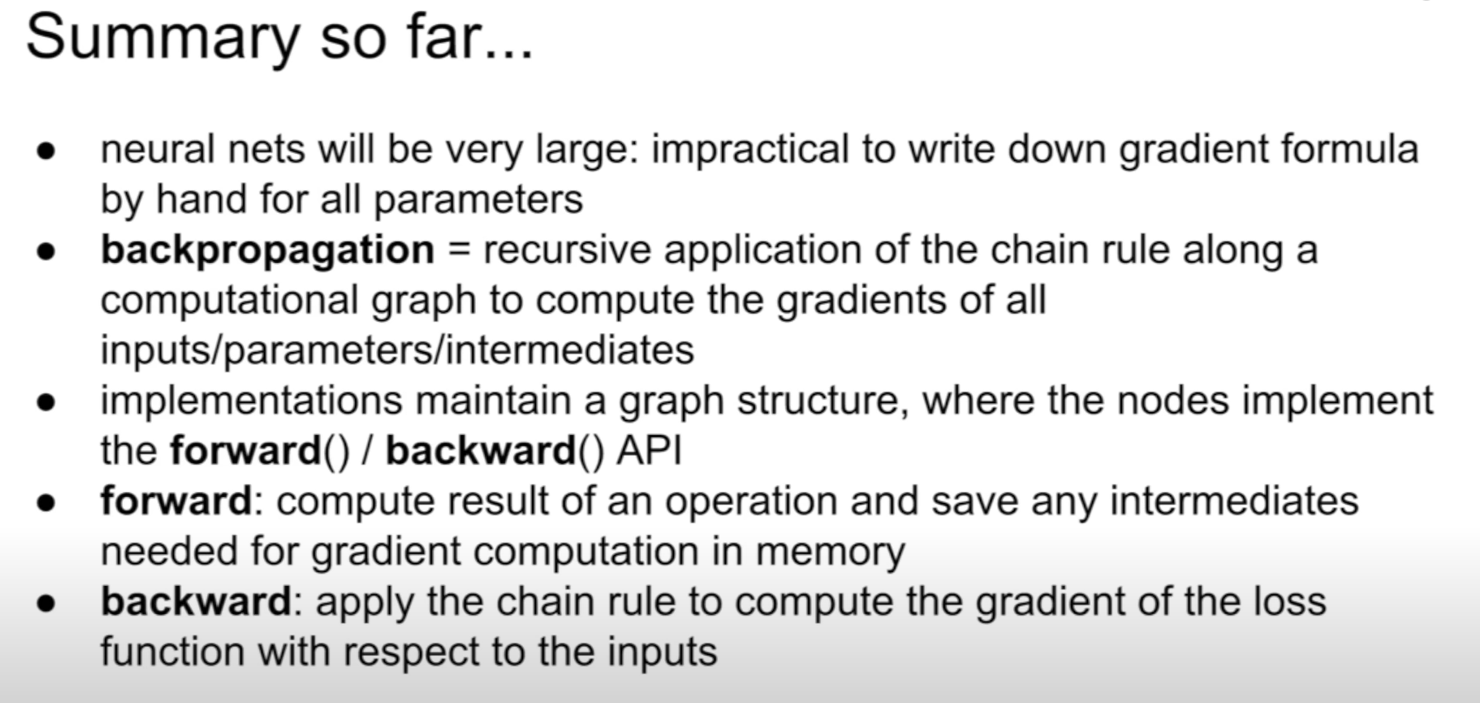

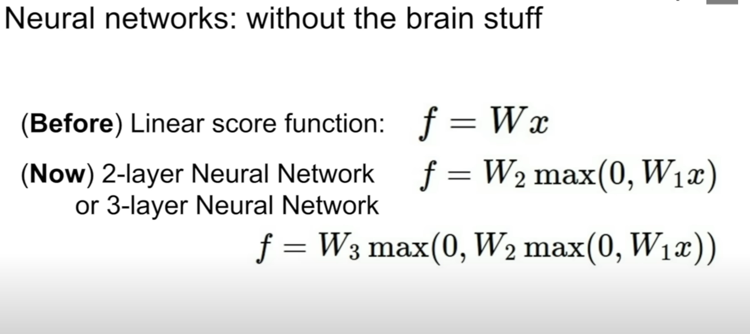

Deep neural networks comes from stacking these networks.

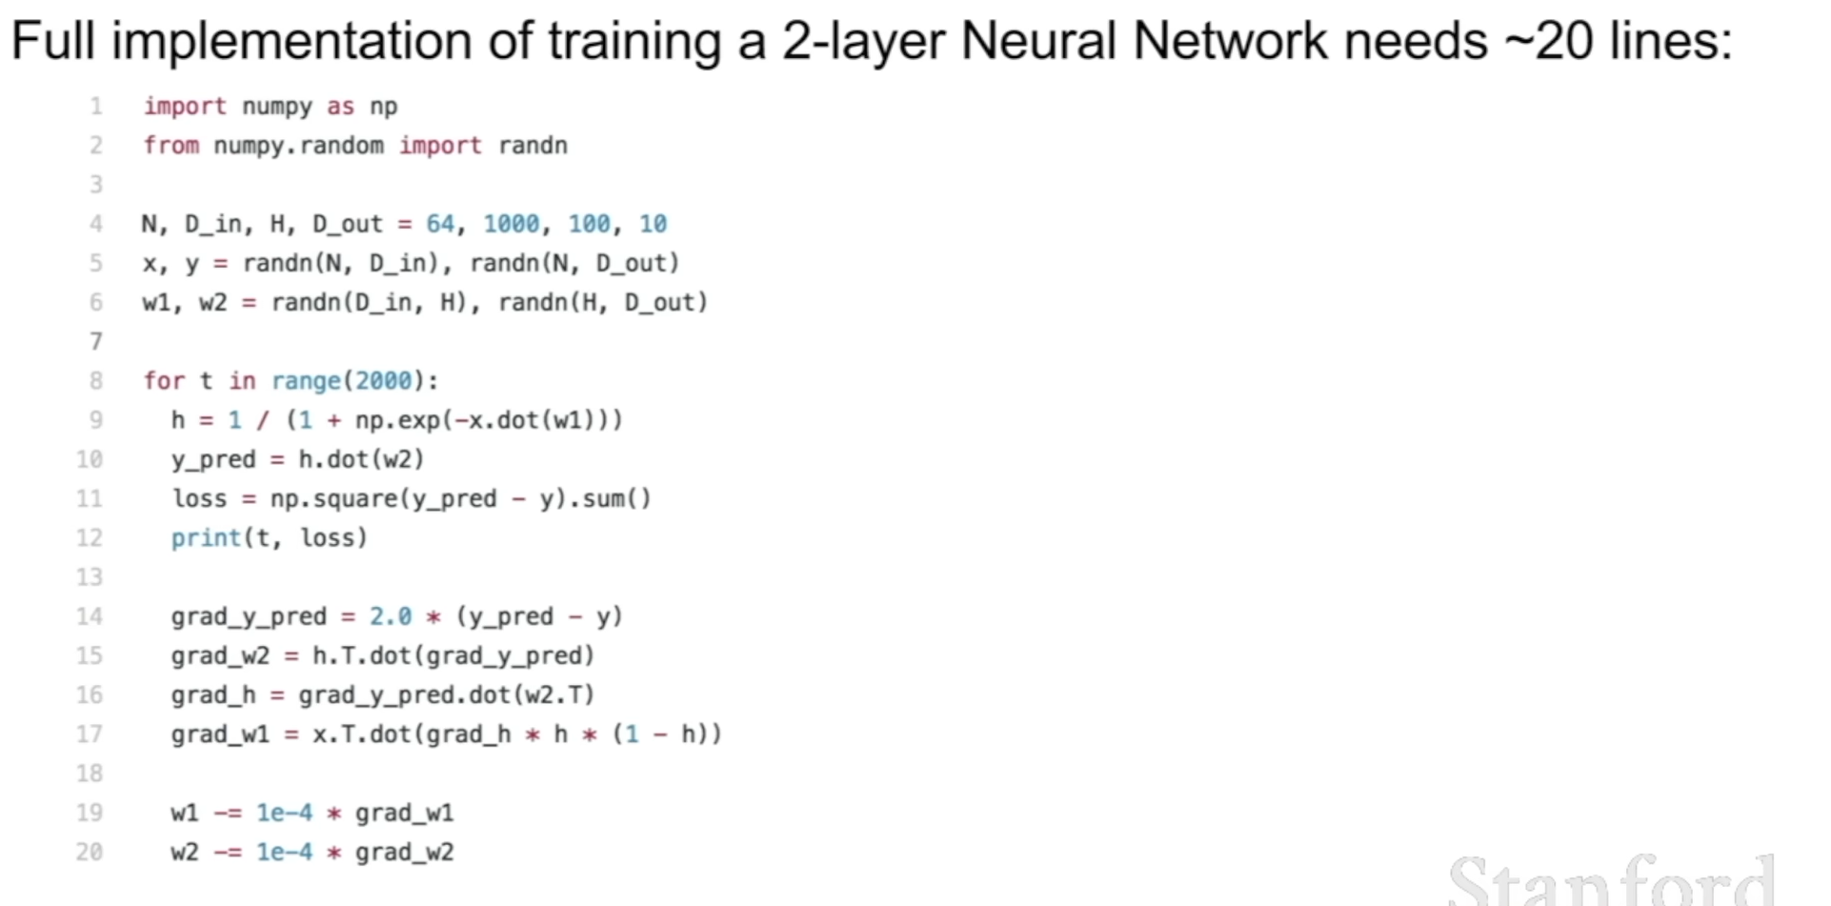

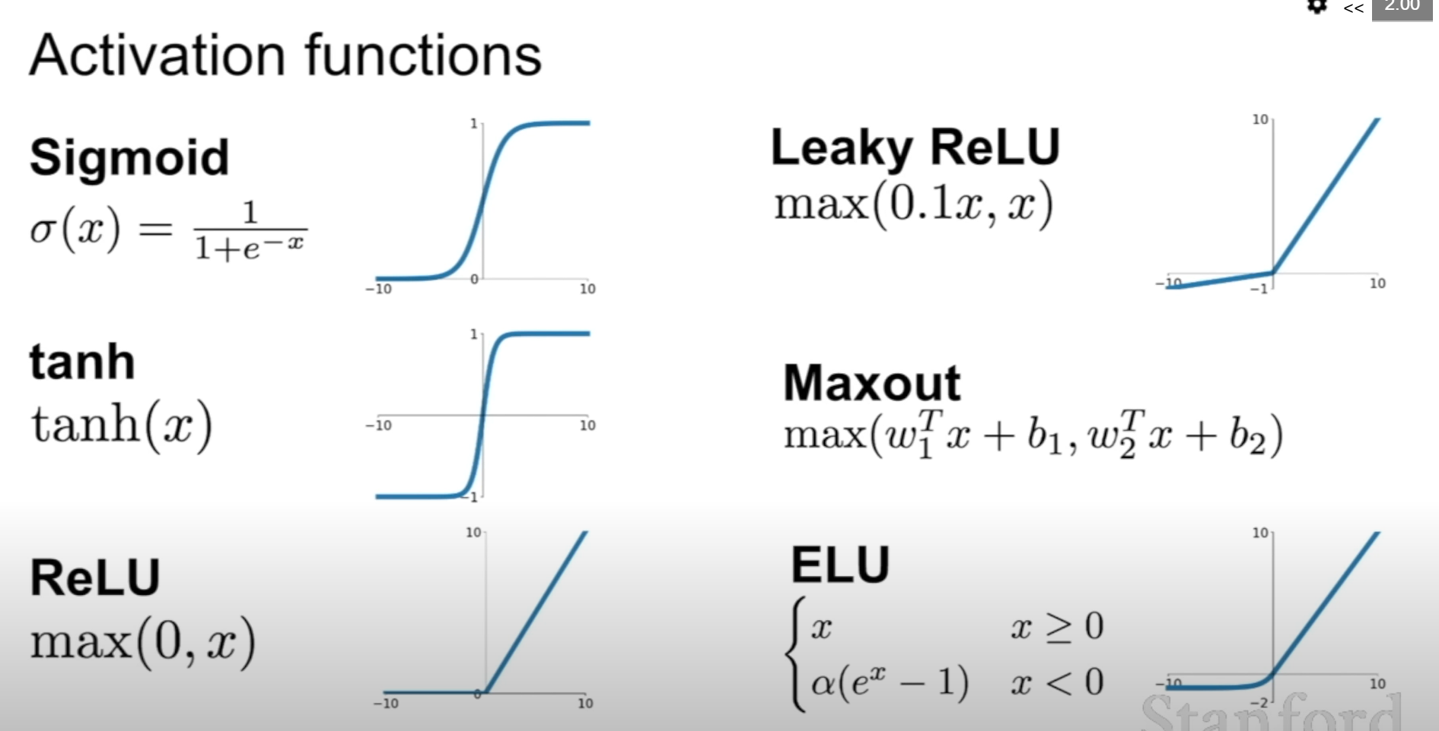

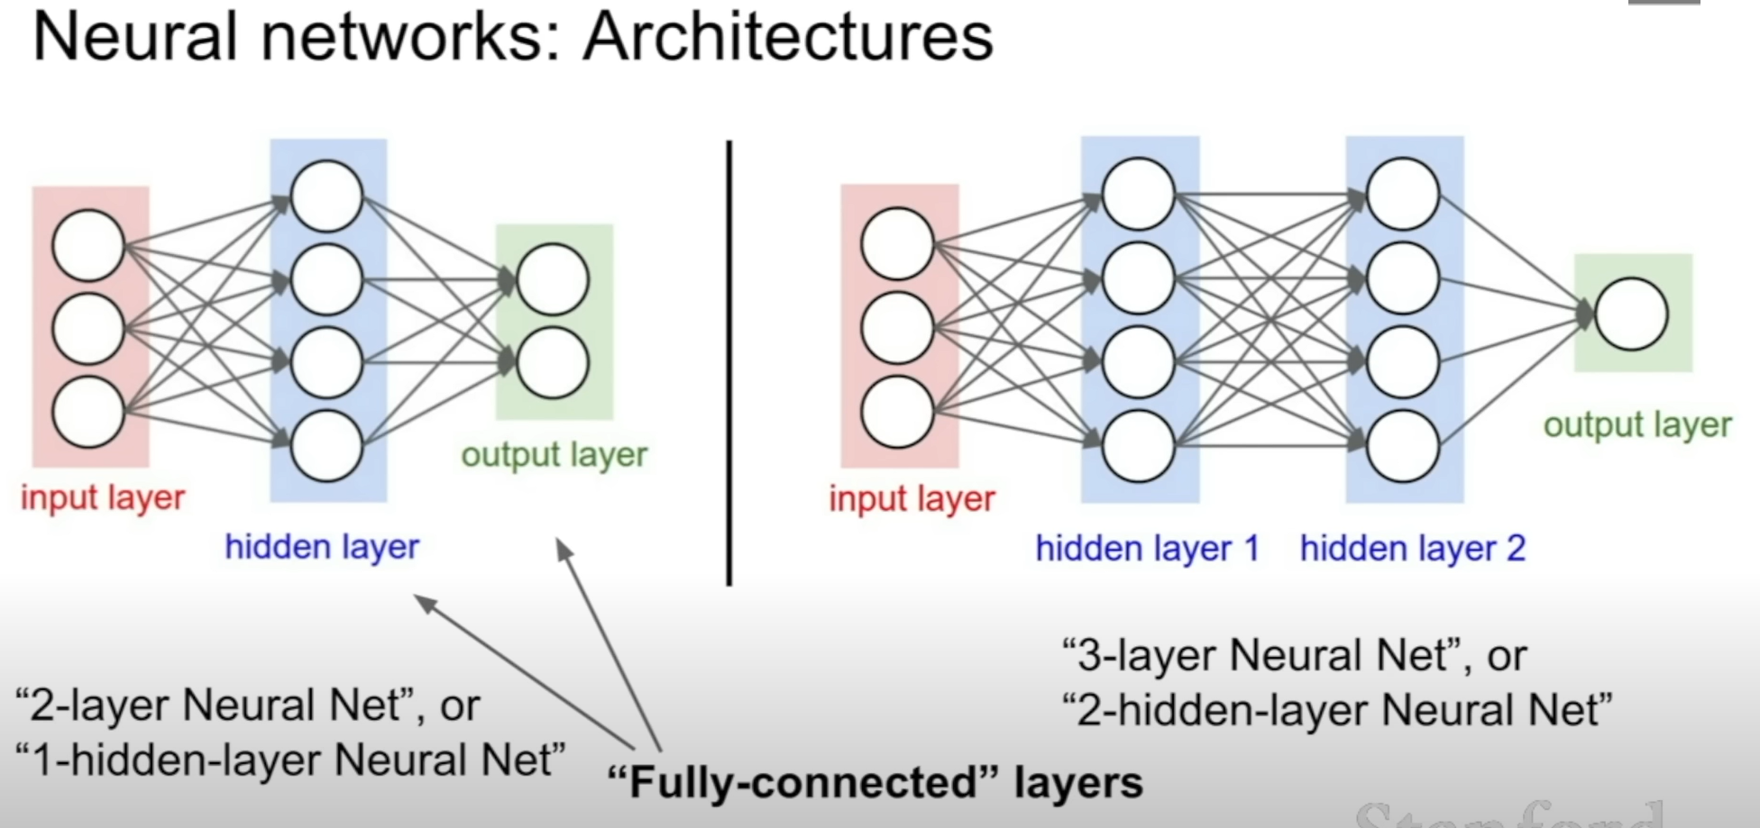

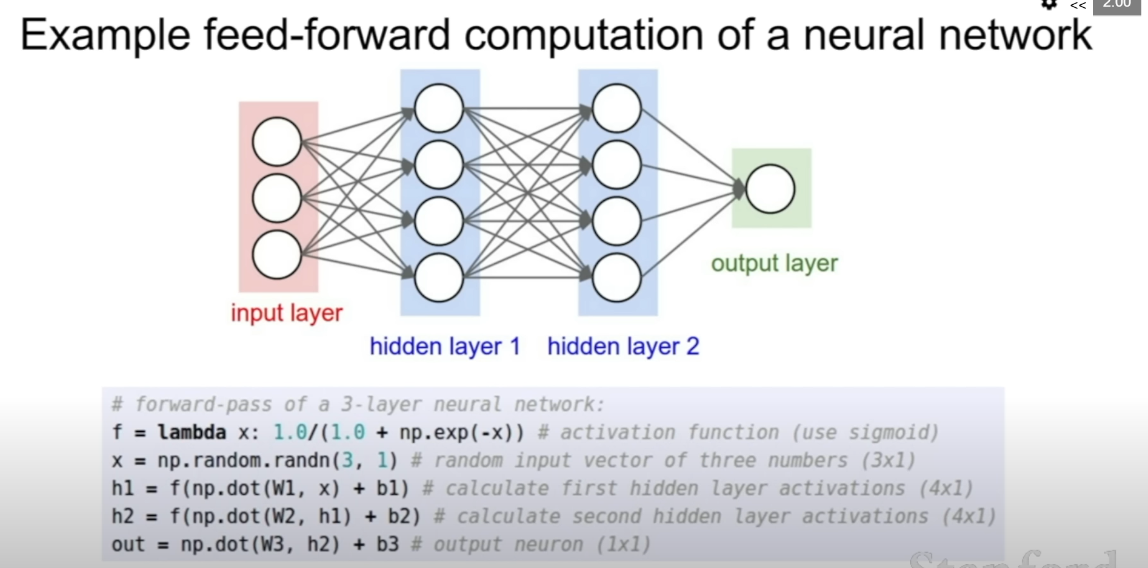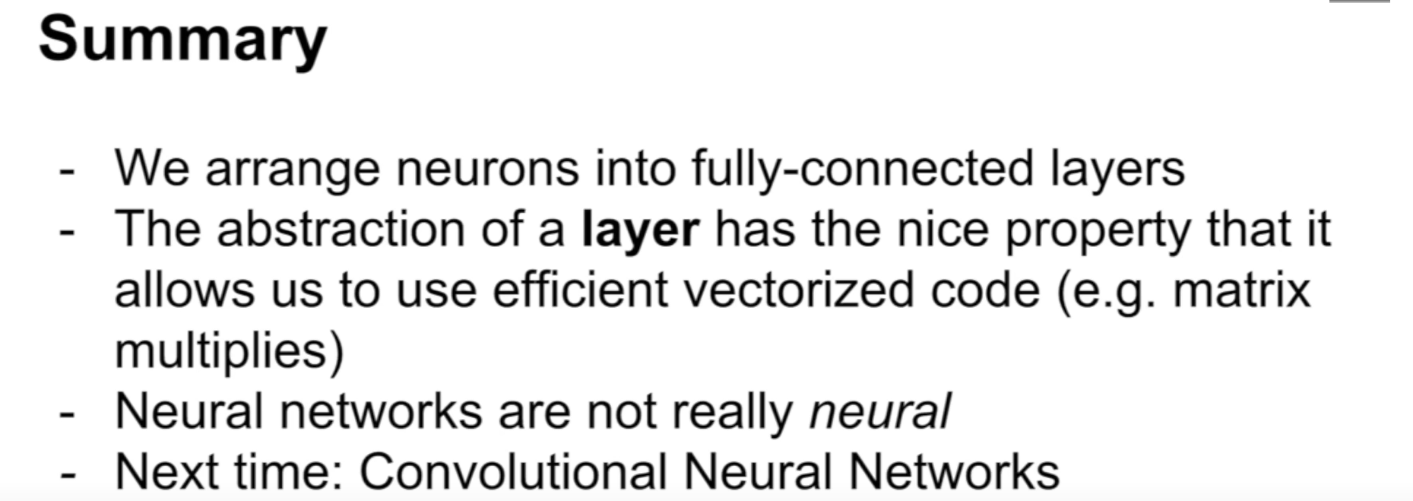

## Lecture 5: Convolutional Neural Networks

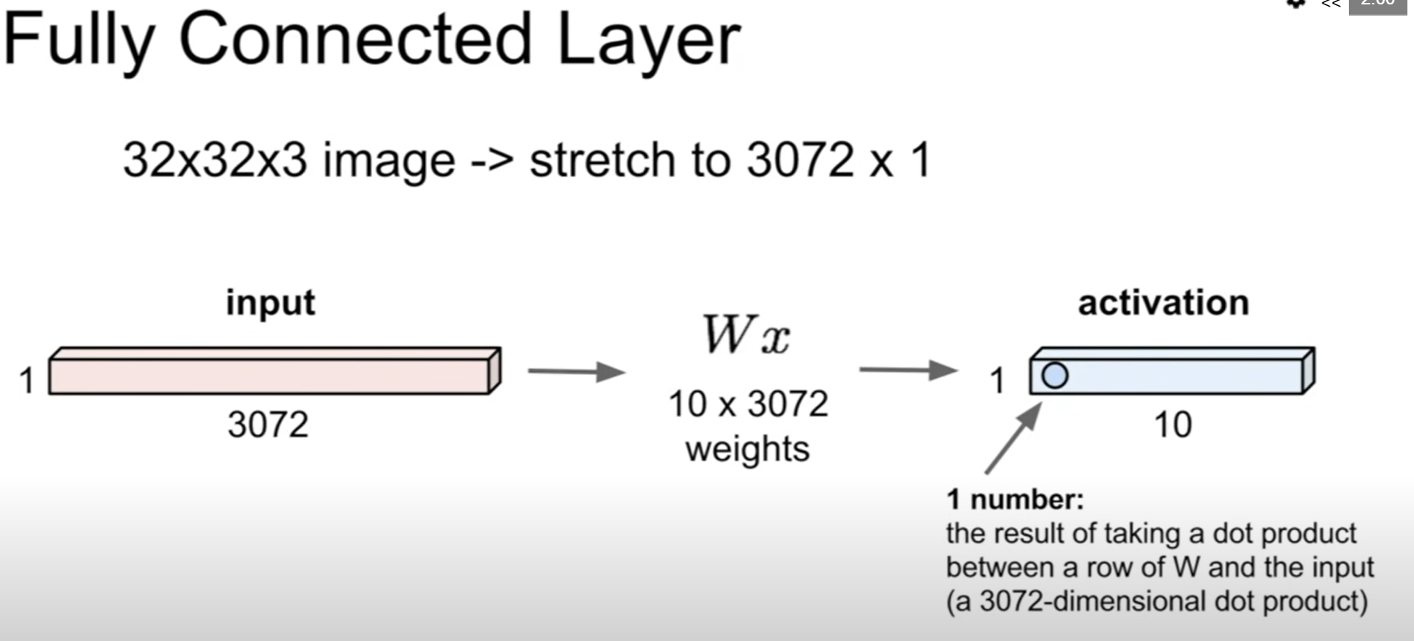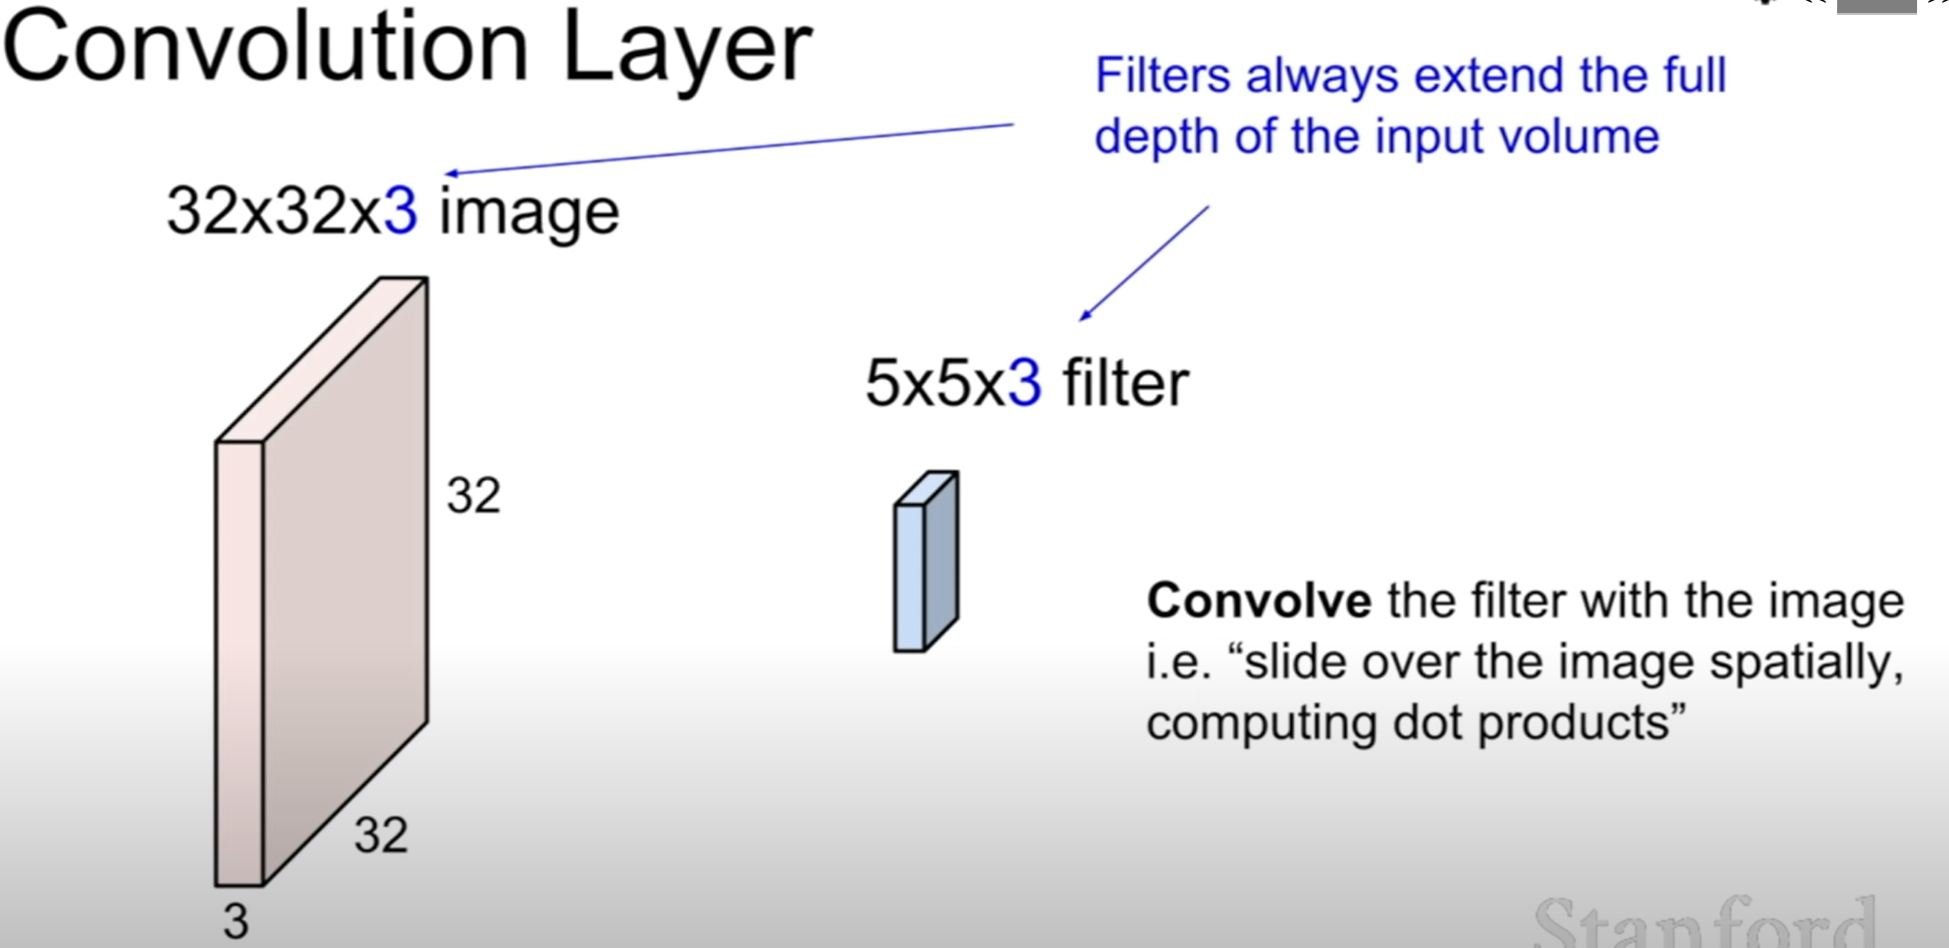

Instead of one dimensional, theses are muti dimensional. Or at least preserve the structure of image. (pixel matrix made linear OR kept a matrix)

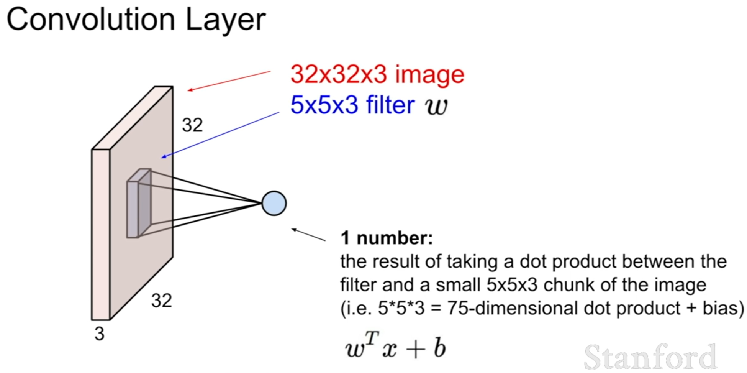

Take the filter and apply it to area of image.

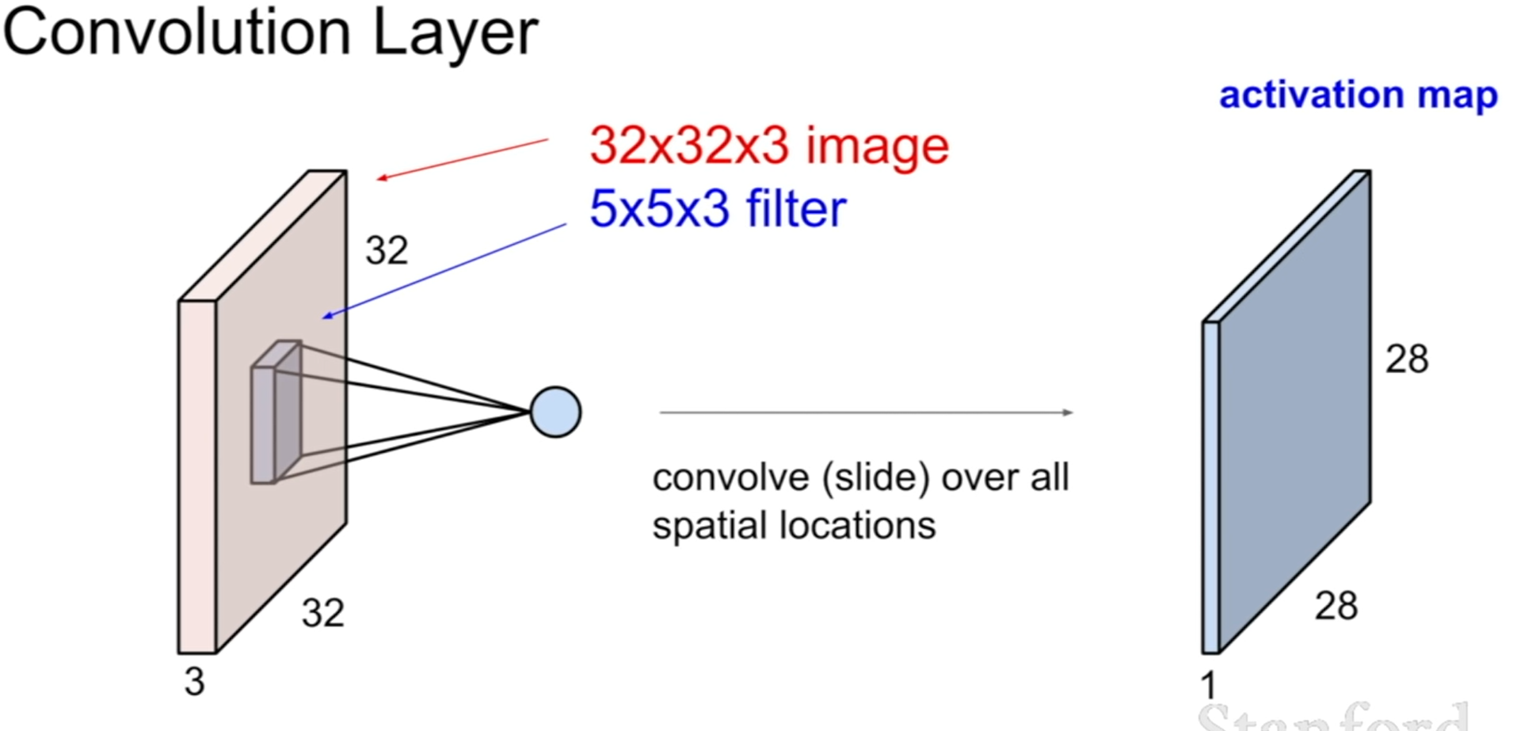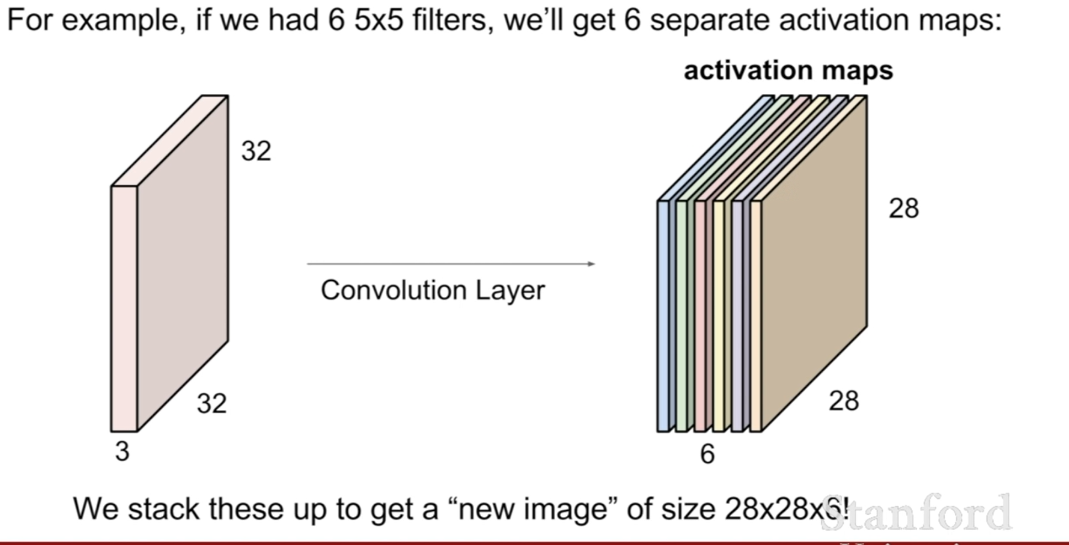

Stack filter to create a layer. Apply new filters:

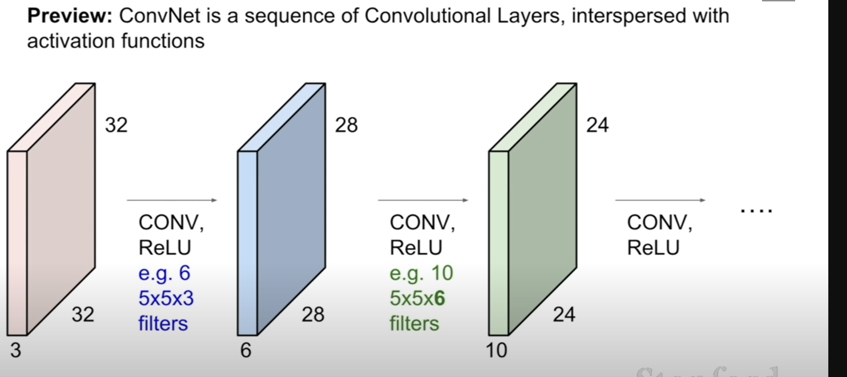

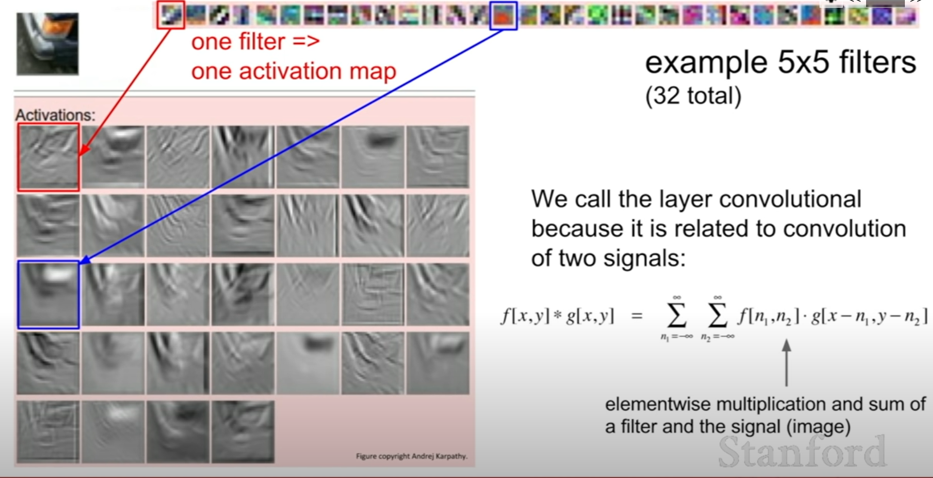

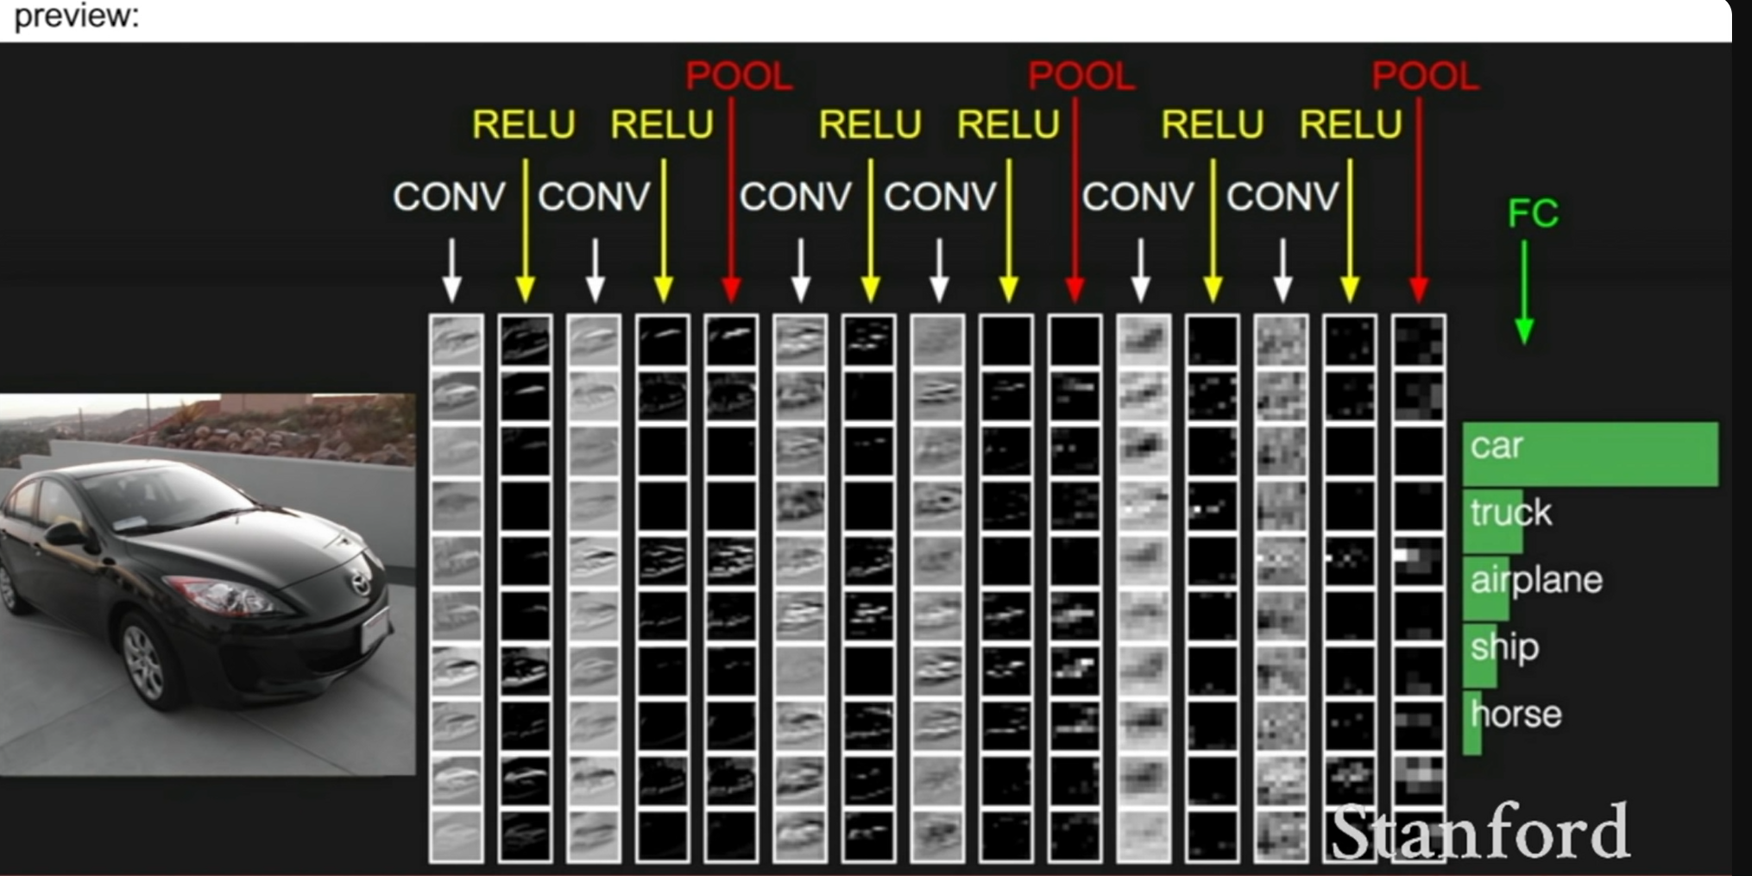

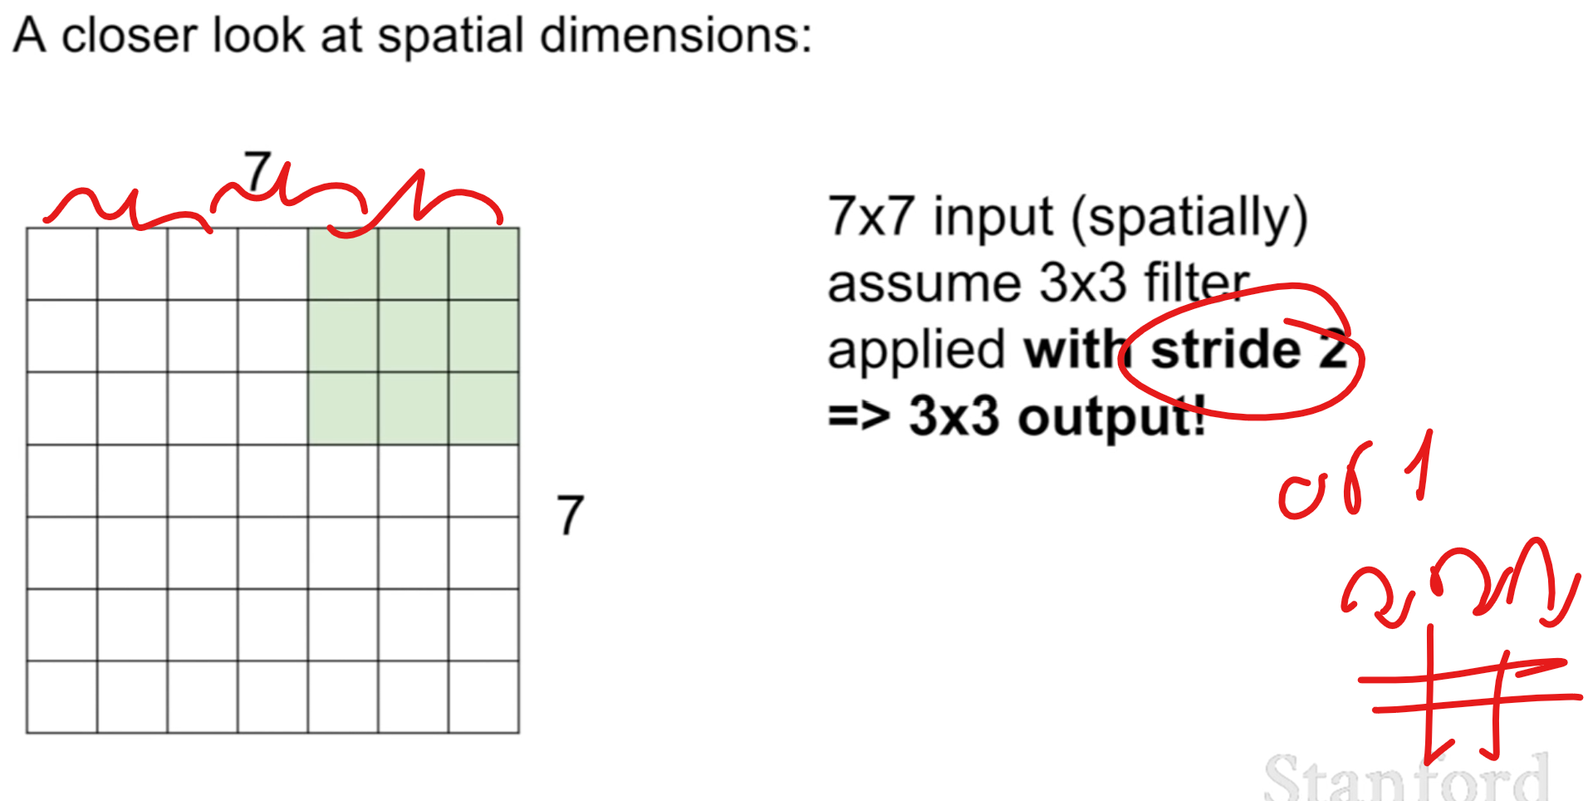

If stride of 3 missing 1 pixel column so don’t do it. 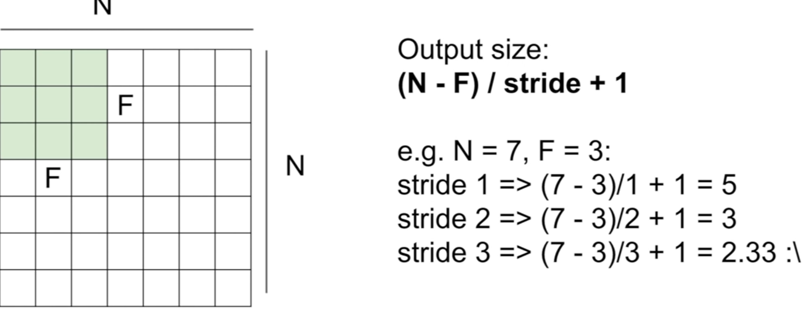

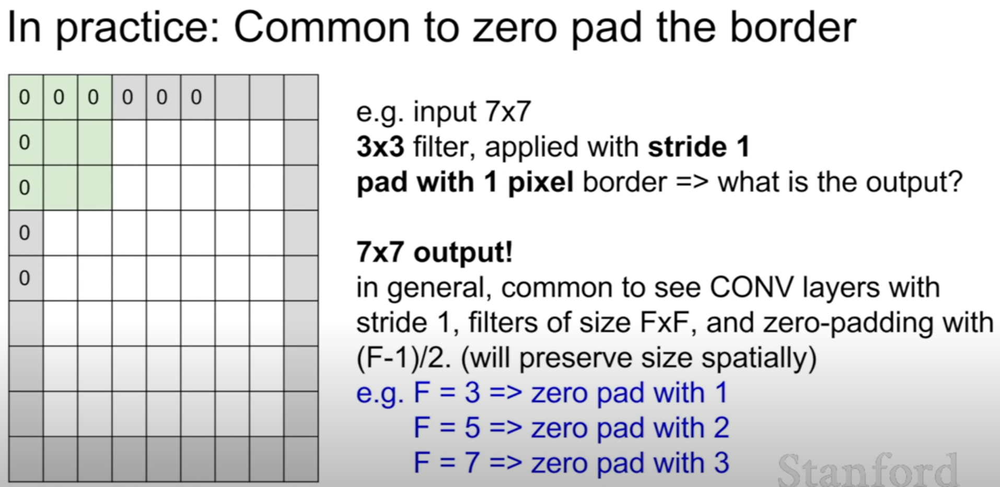

But we can 0 pad the borders because almost no information there. So filter can fit.

If we don’t have padding, the size of matrices in conv layer keep shrinking. Se we need to pad.

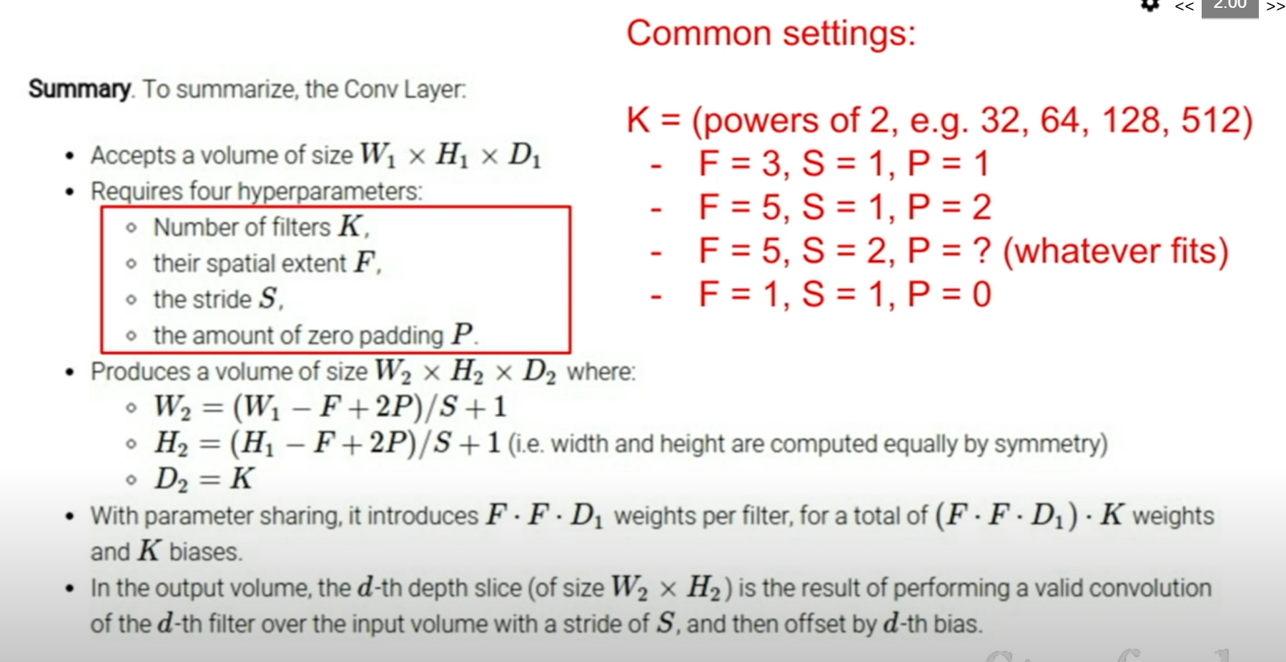

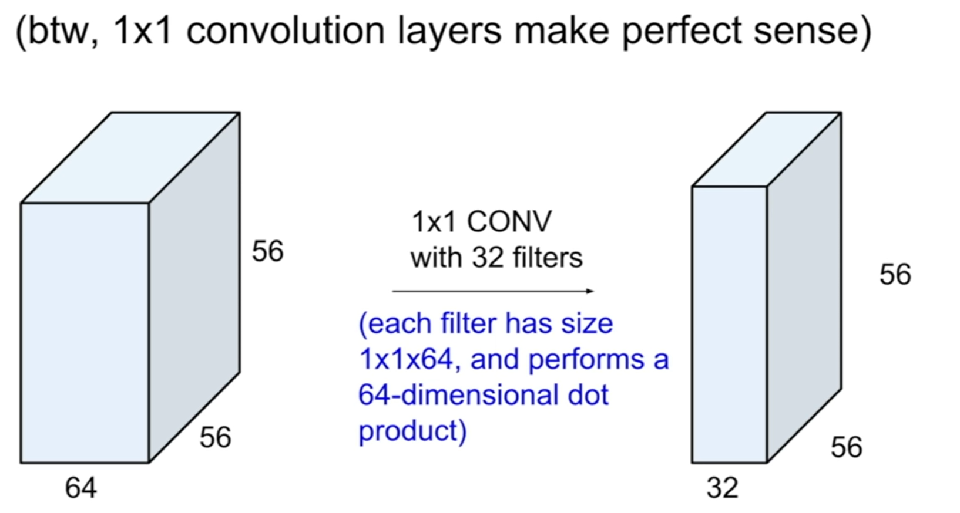

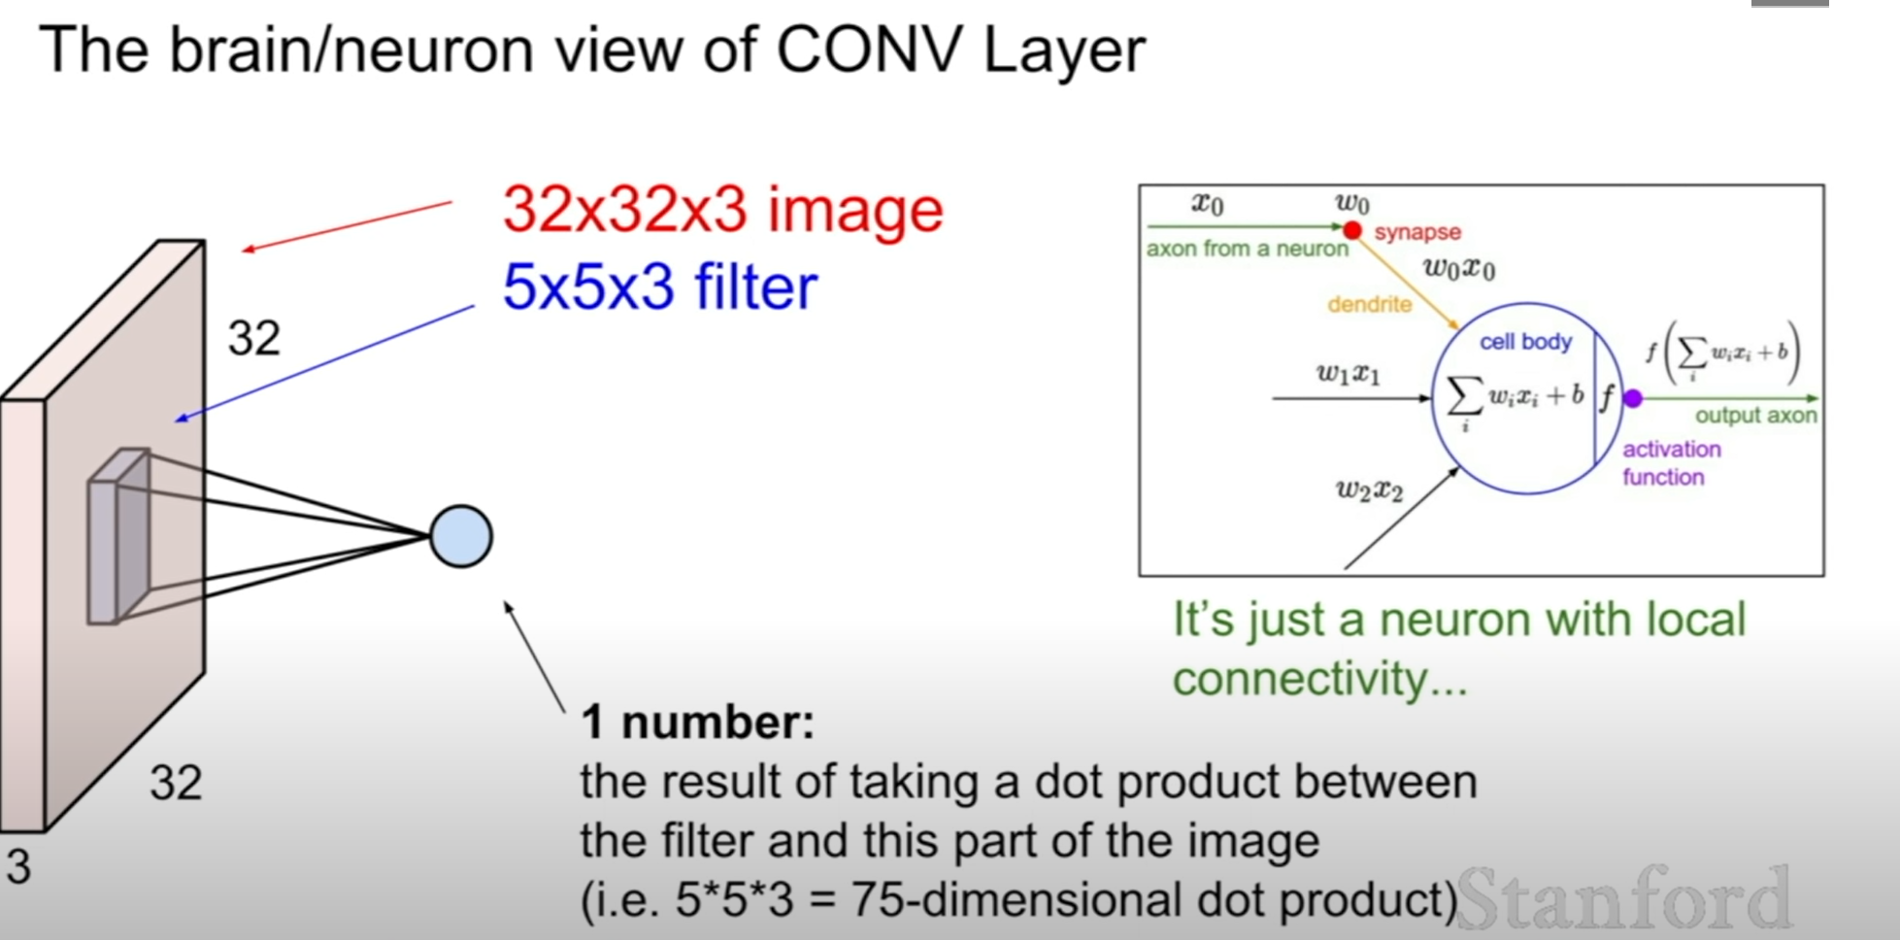

Same as dot product before just that we have a local vision. 5x5 filter = 5x5 receptive field for each neuron.

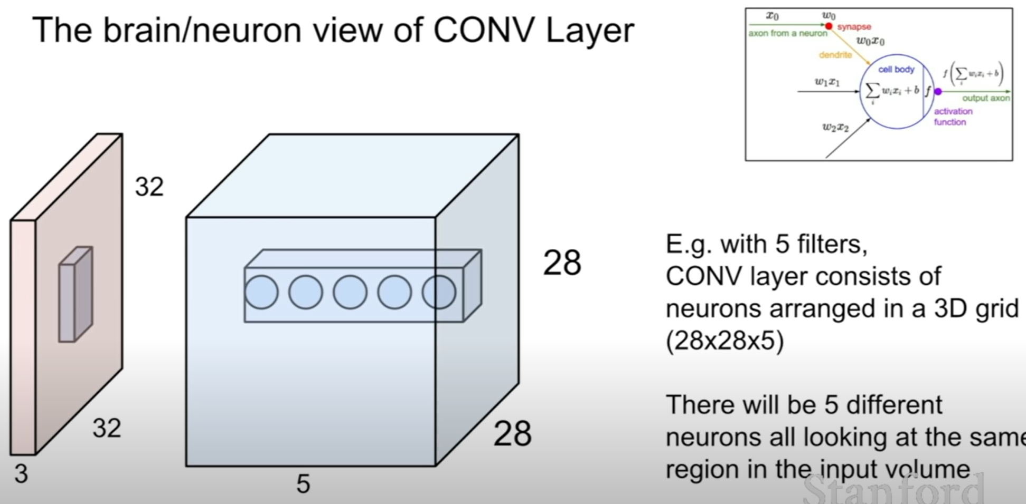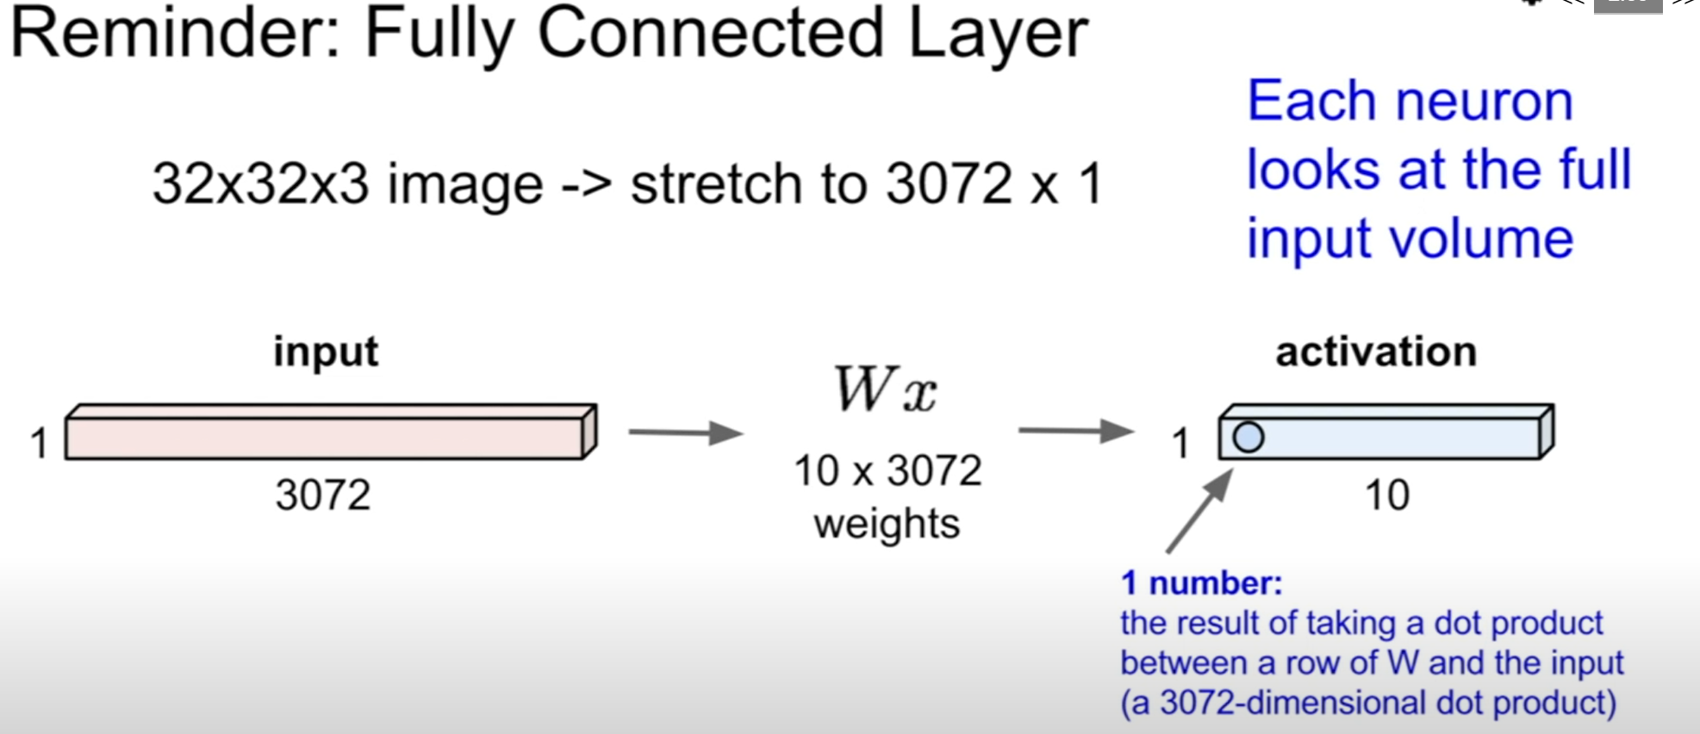

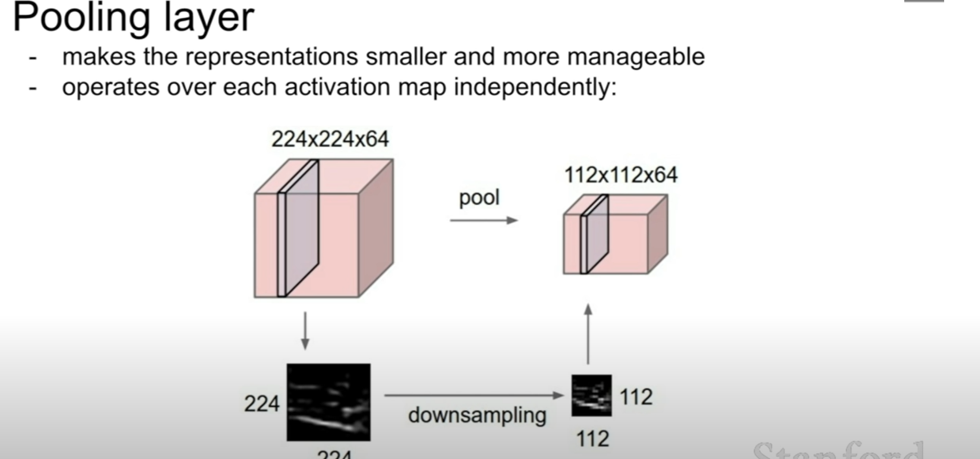

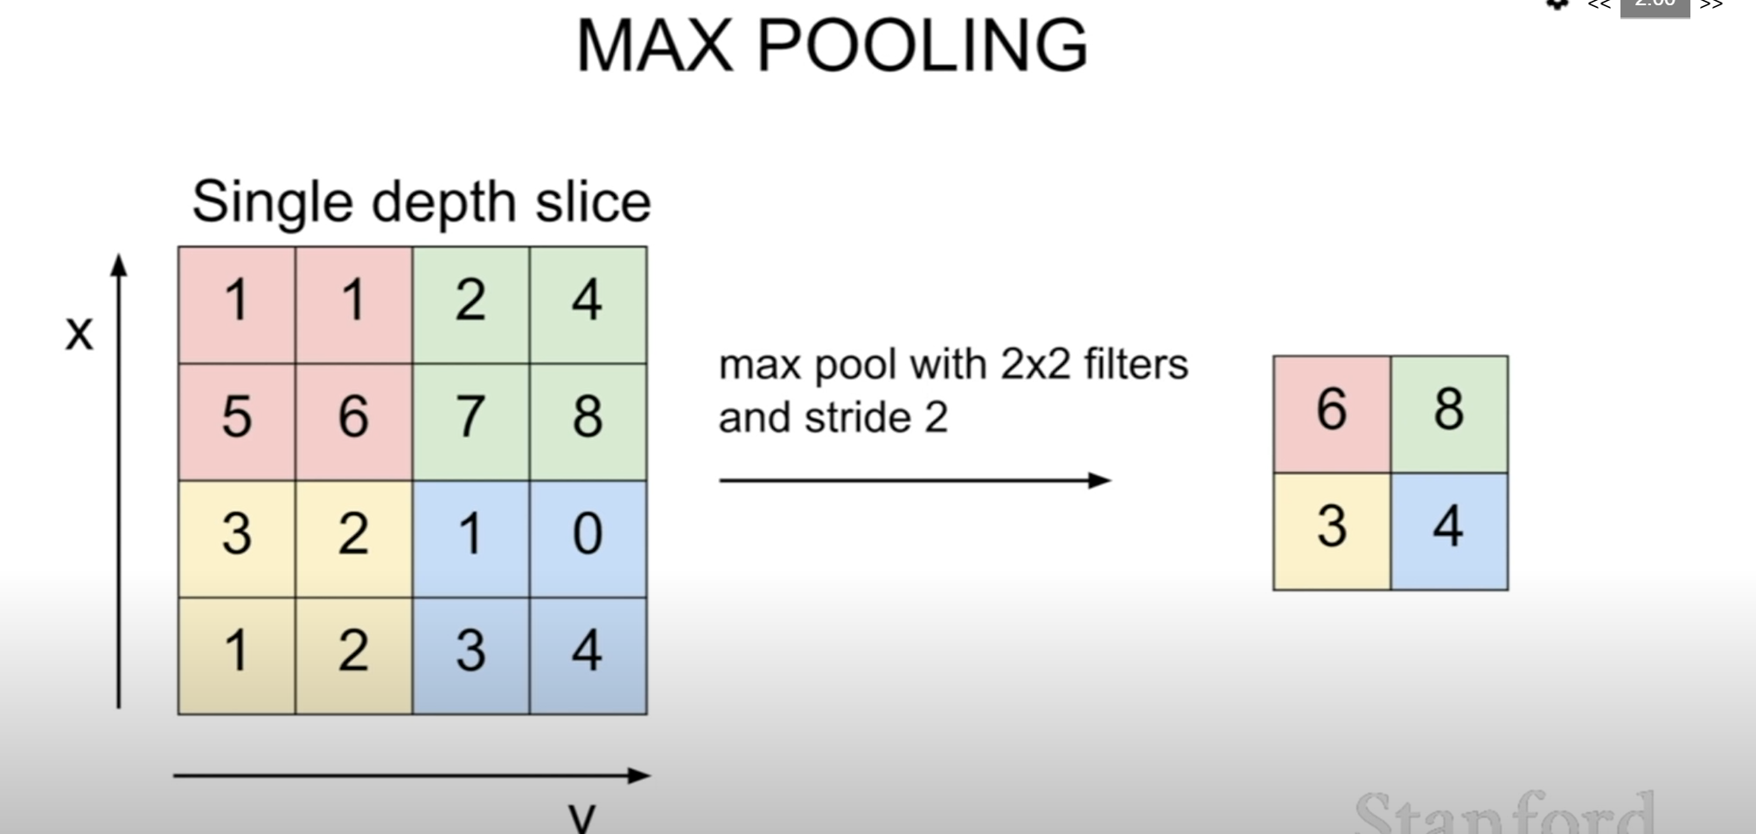

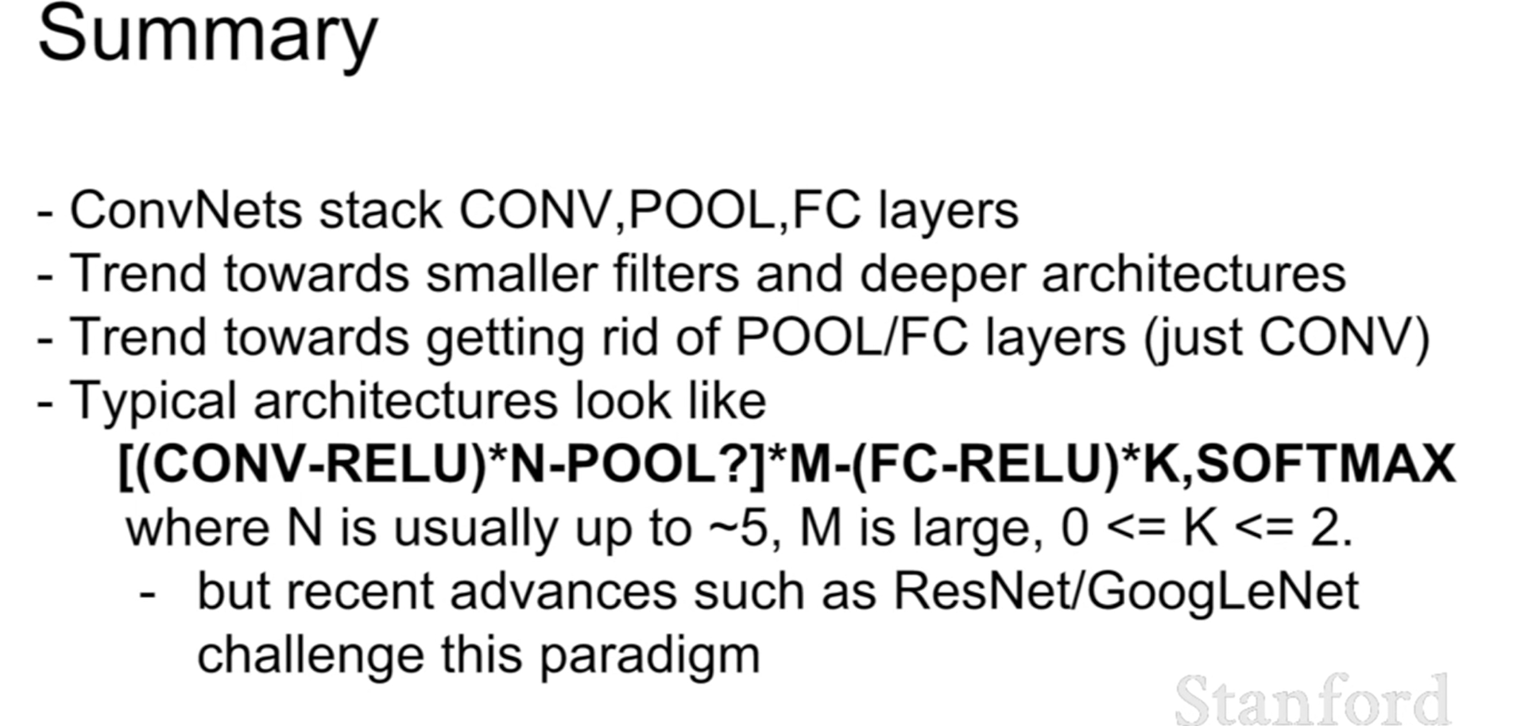

## Lecture 6: Training Neural networks

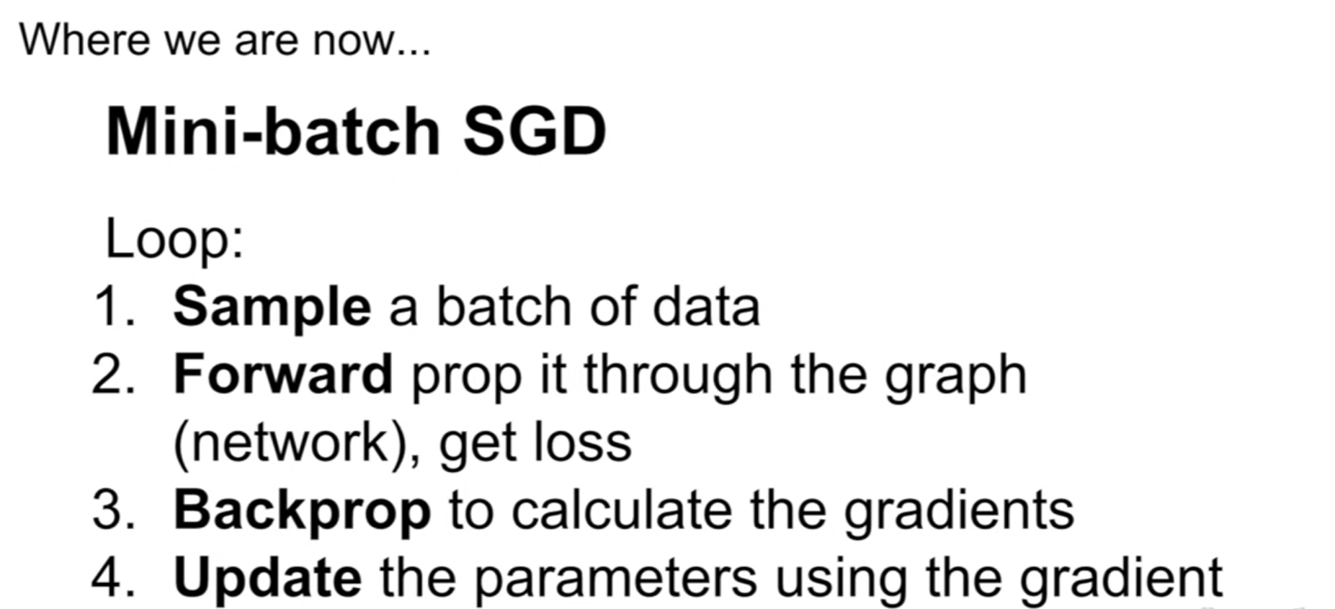

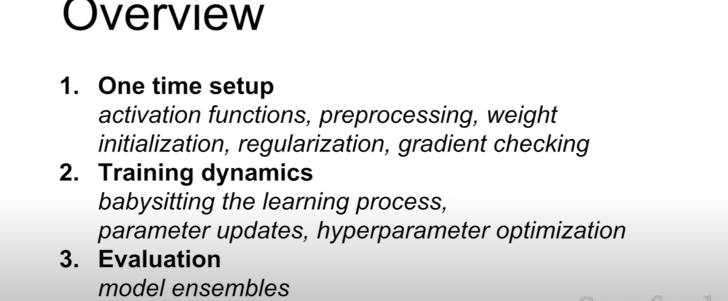

Today:

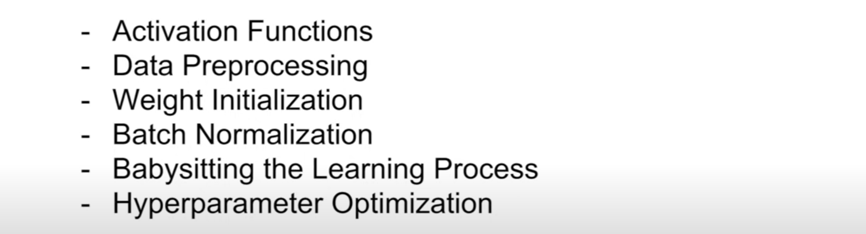

|  |  |
| --- | --- |
| +exp() is computionaly expensive |  |
|  |  |
|  |  |

ReLu are data points that never update even though they should.

Could happen because of bad initialization. Or learning rate too high (changing weight foot fast). About 30% on average of dead relu. Still ok for training models…

People like to initialize ReLu neurons with a slight postivite bias (eg 0.01) so more relu fire in the beginning.

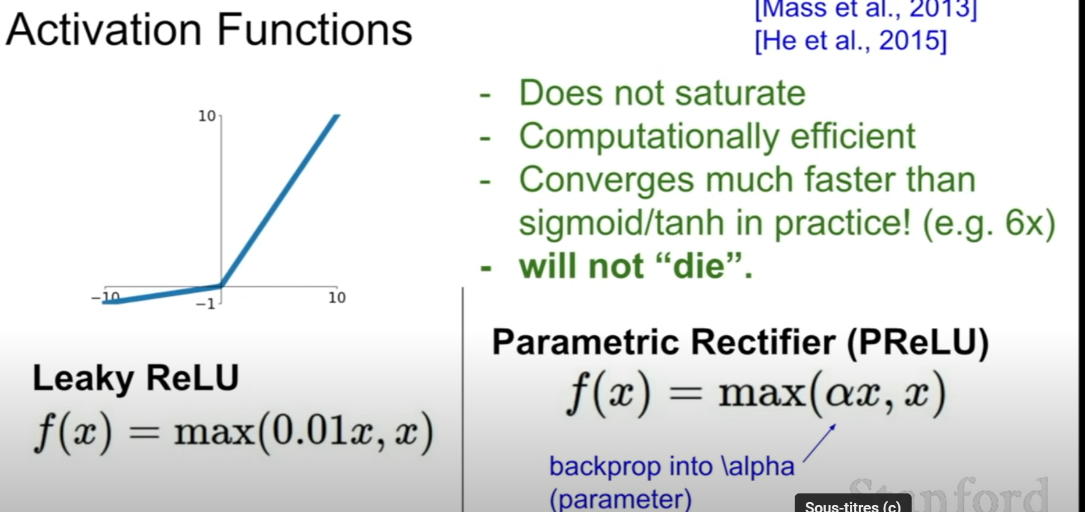

Adapted relu

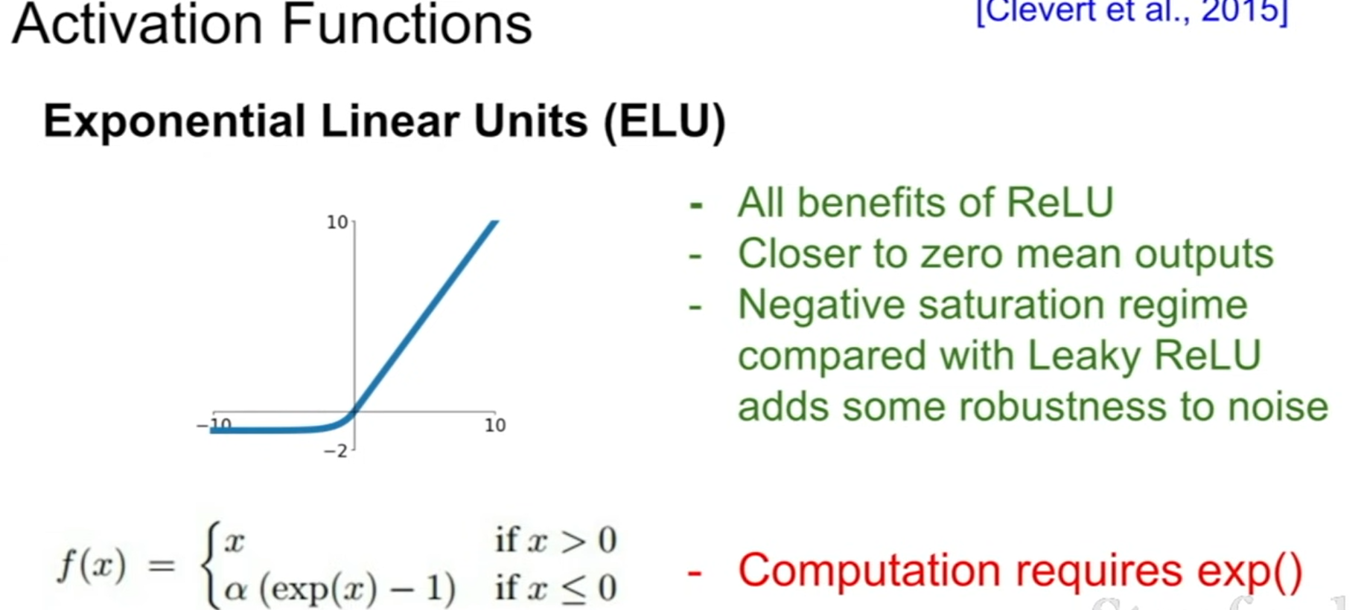

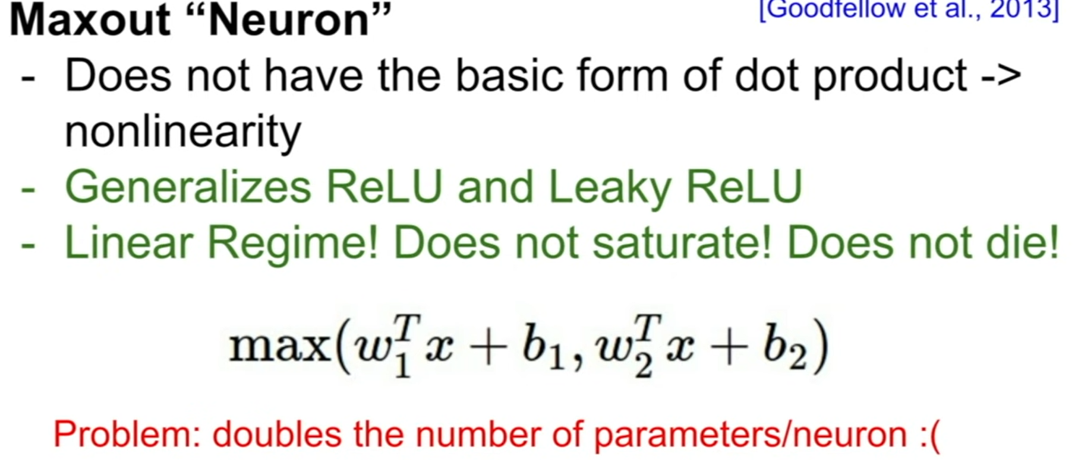

TDLR: In practice

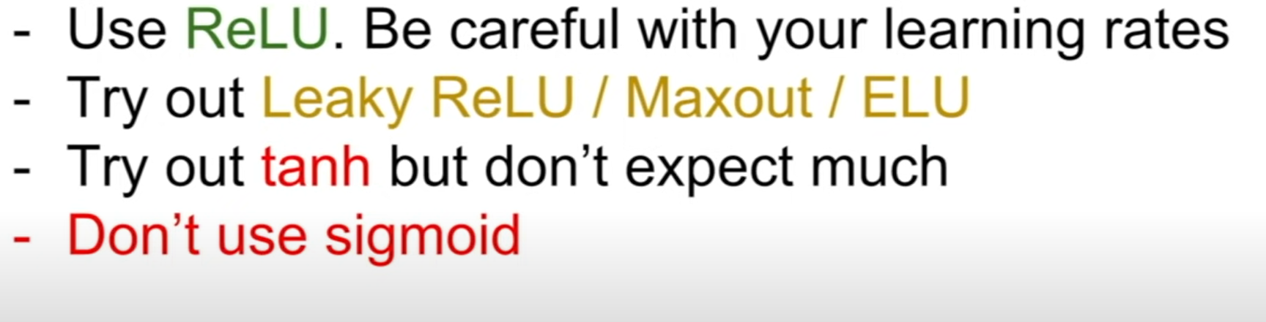

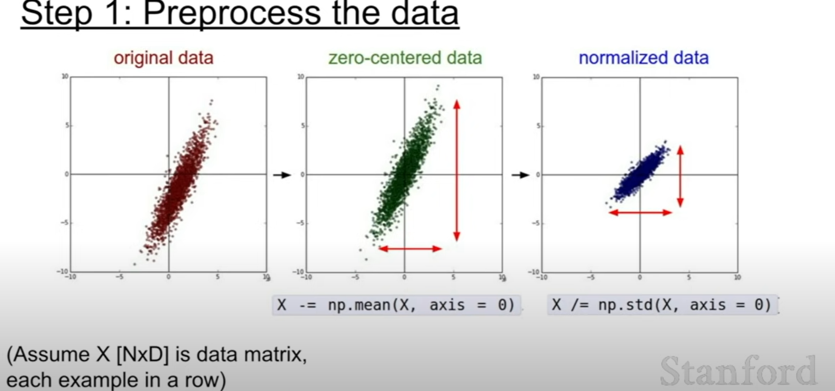

If not normalized, you get zig zag effect. Gradient not updating correctly/optimized

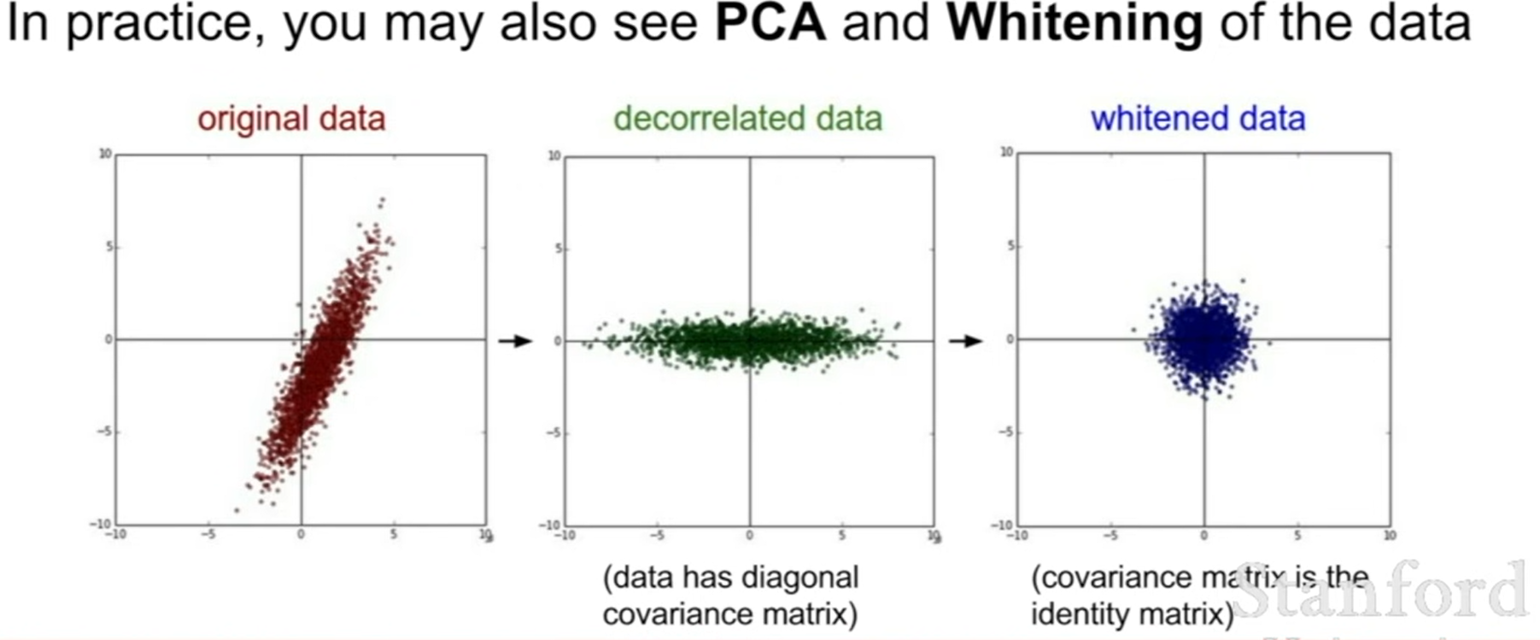

Bur problem is the deeper you go into the network. The more your data isn’t zero mean anymore. So relus … start to fuck up.

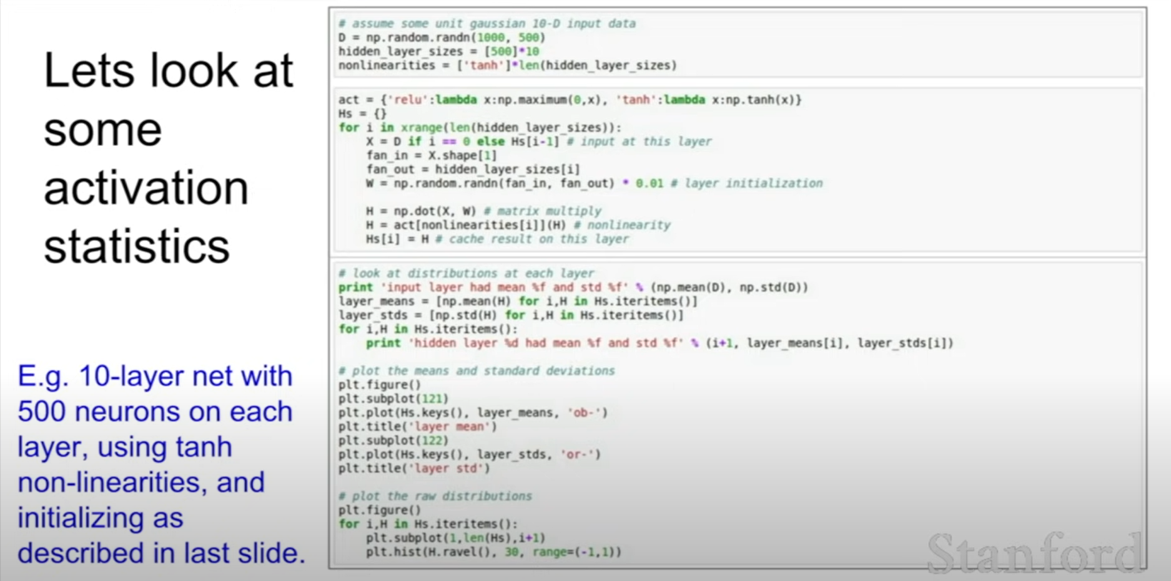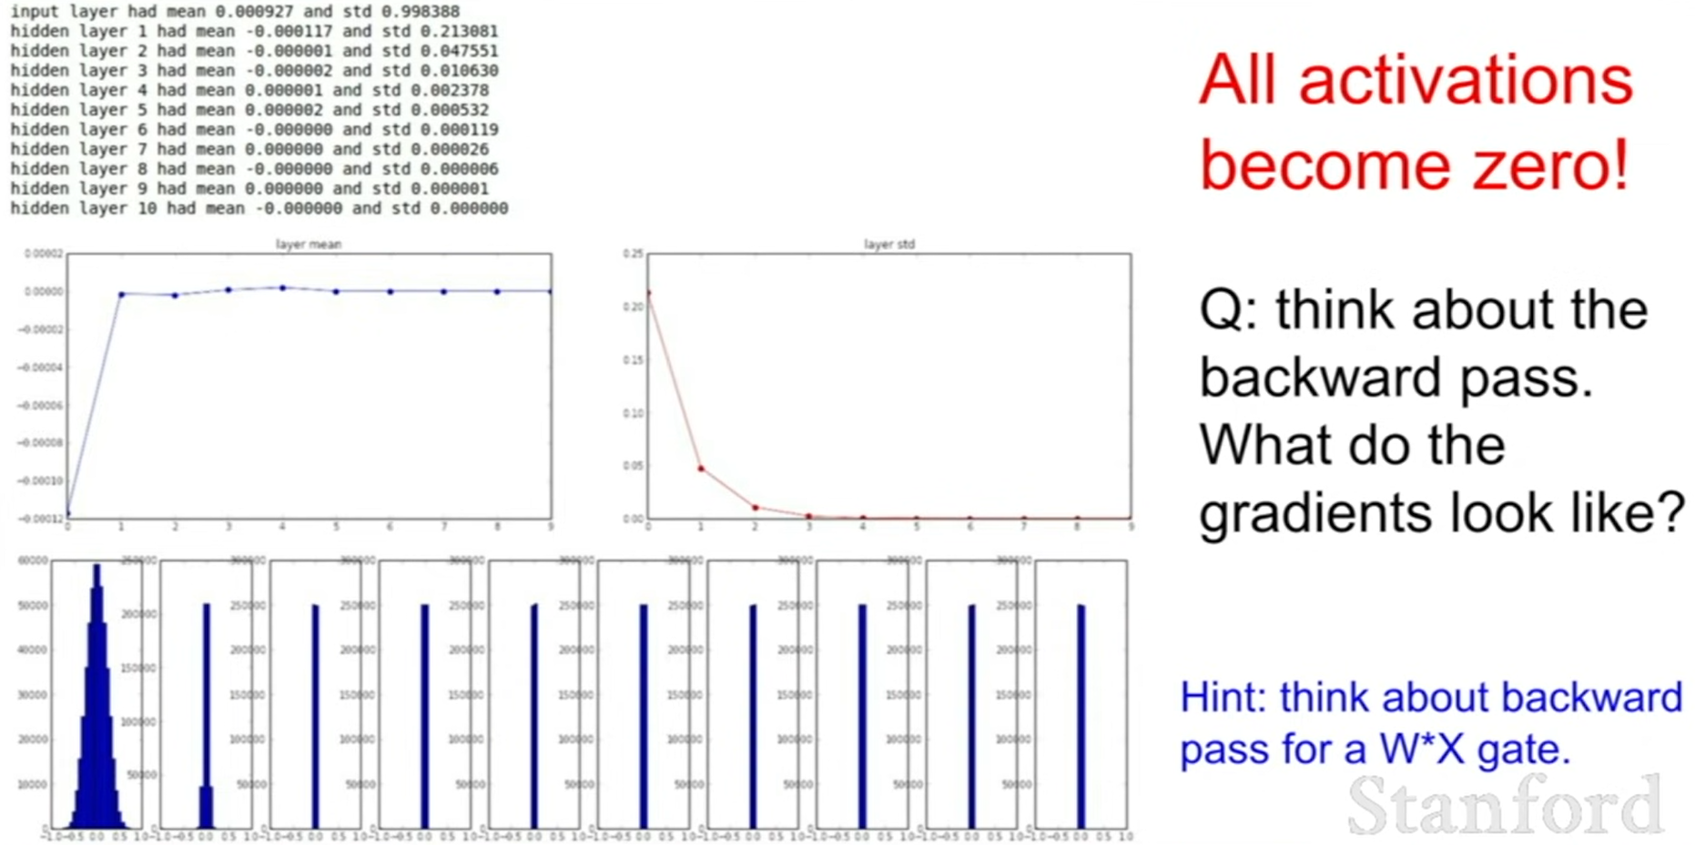

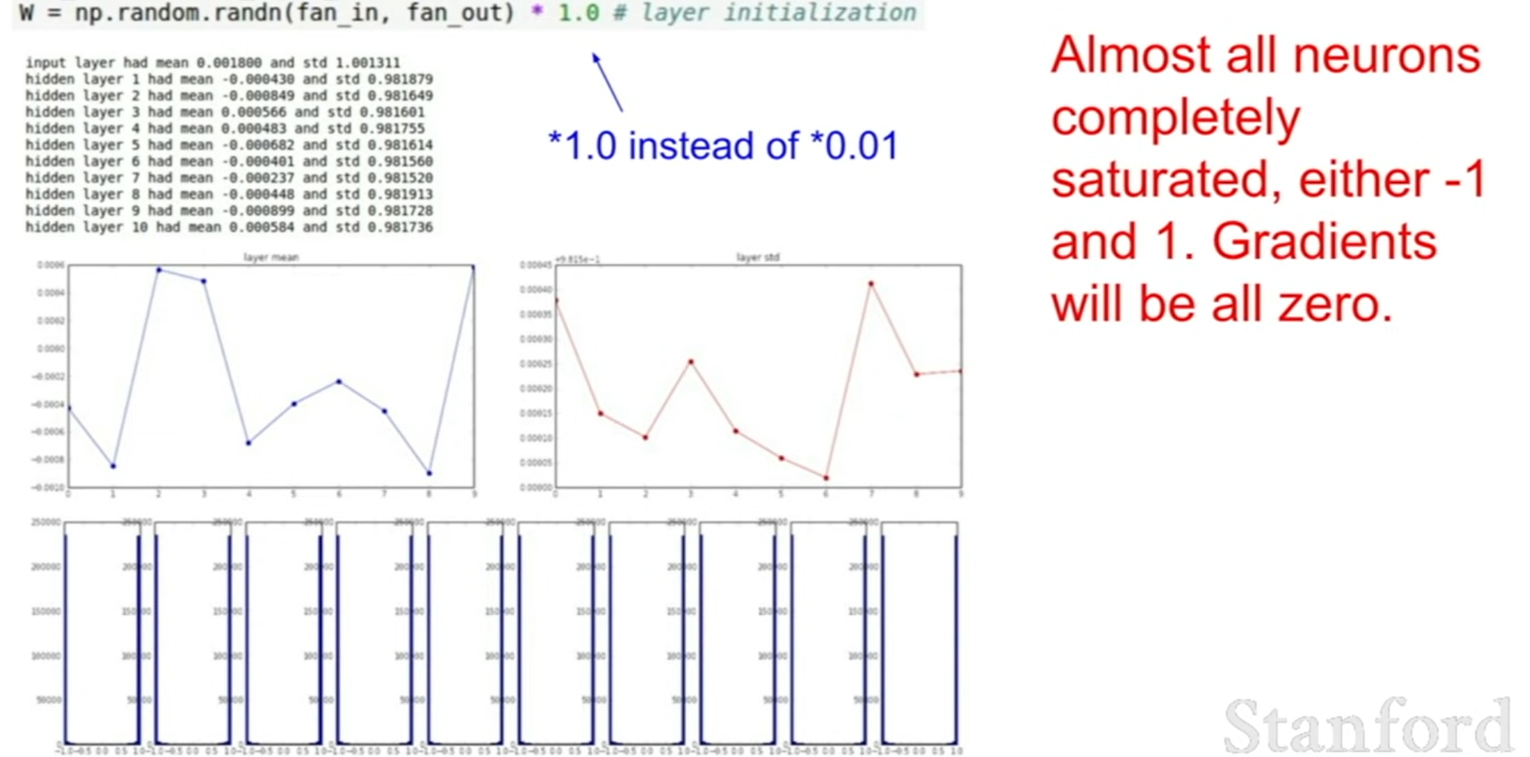

Zig zag effect now ? too big too fast so saturated.

So it is hard to find the right initialization weights. One that has been found is this:

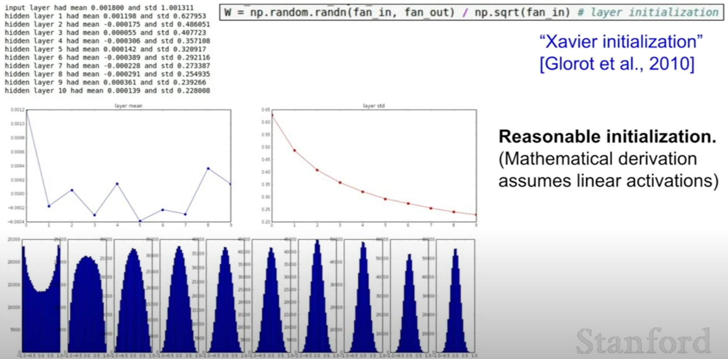

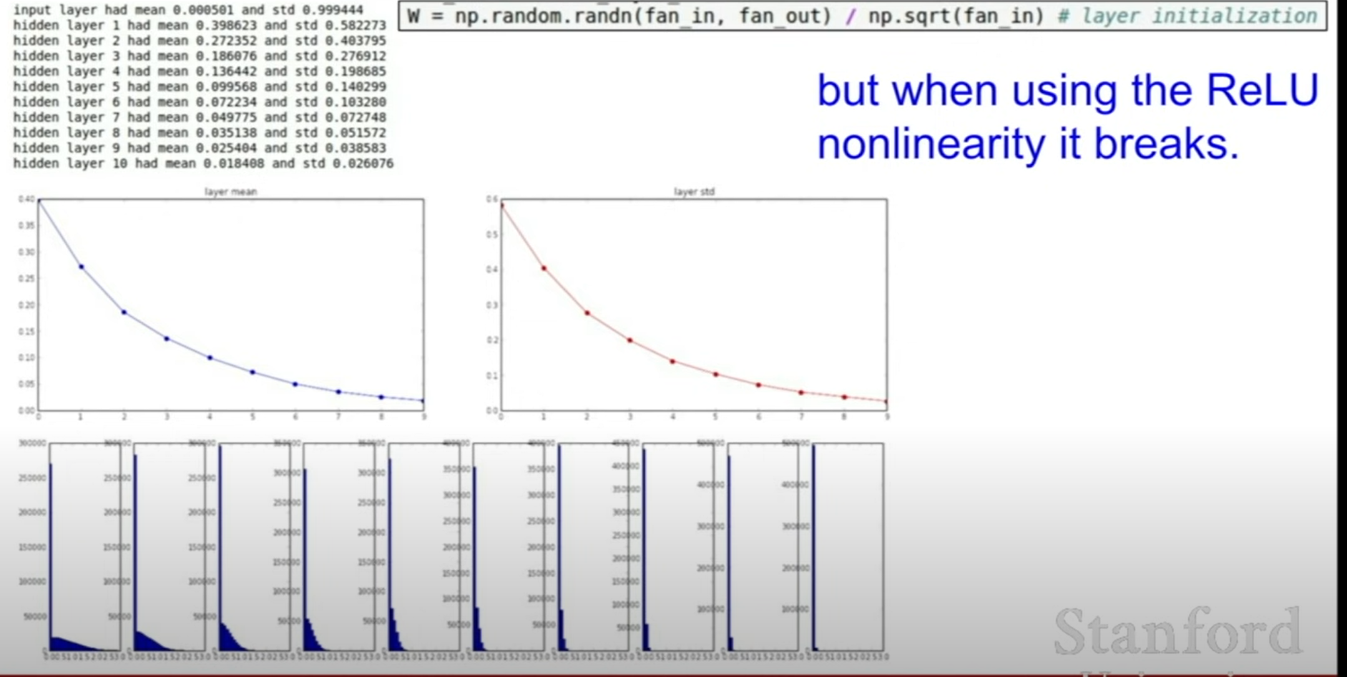

But it kills relu. Because half are being killed everytime. But you can counter act by dividing by 2 again:

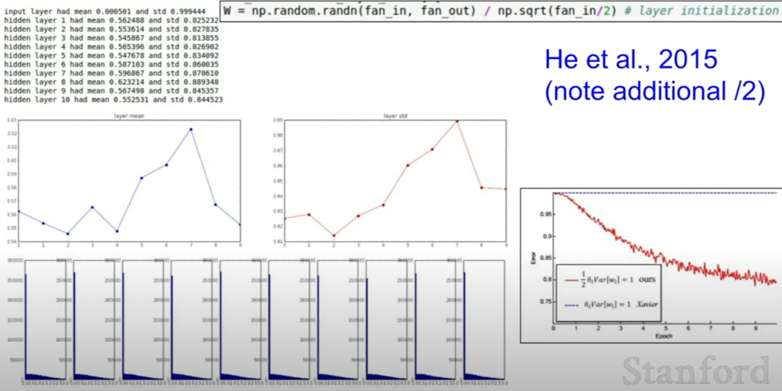

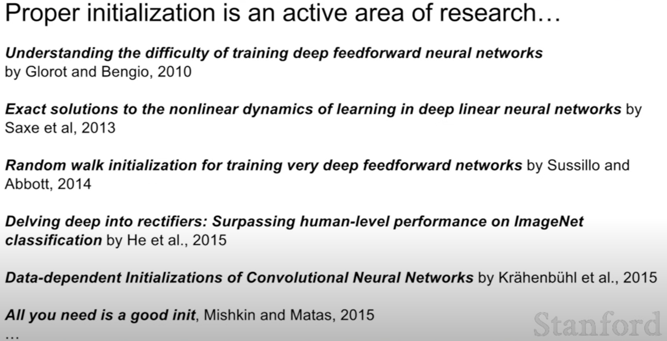

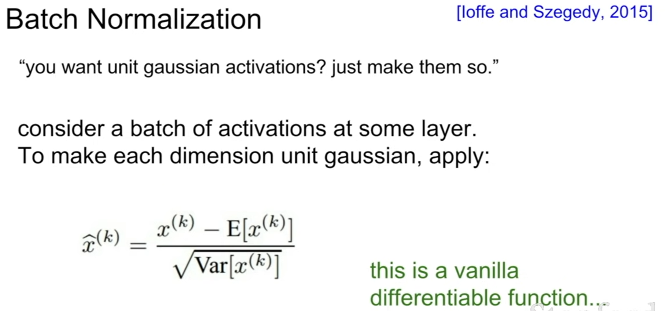

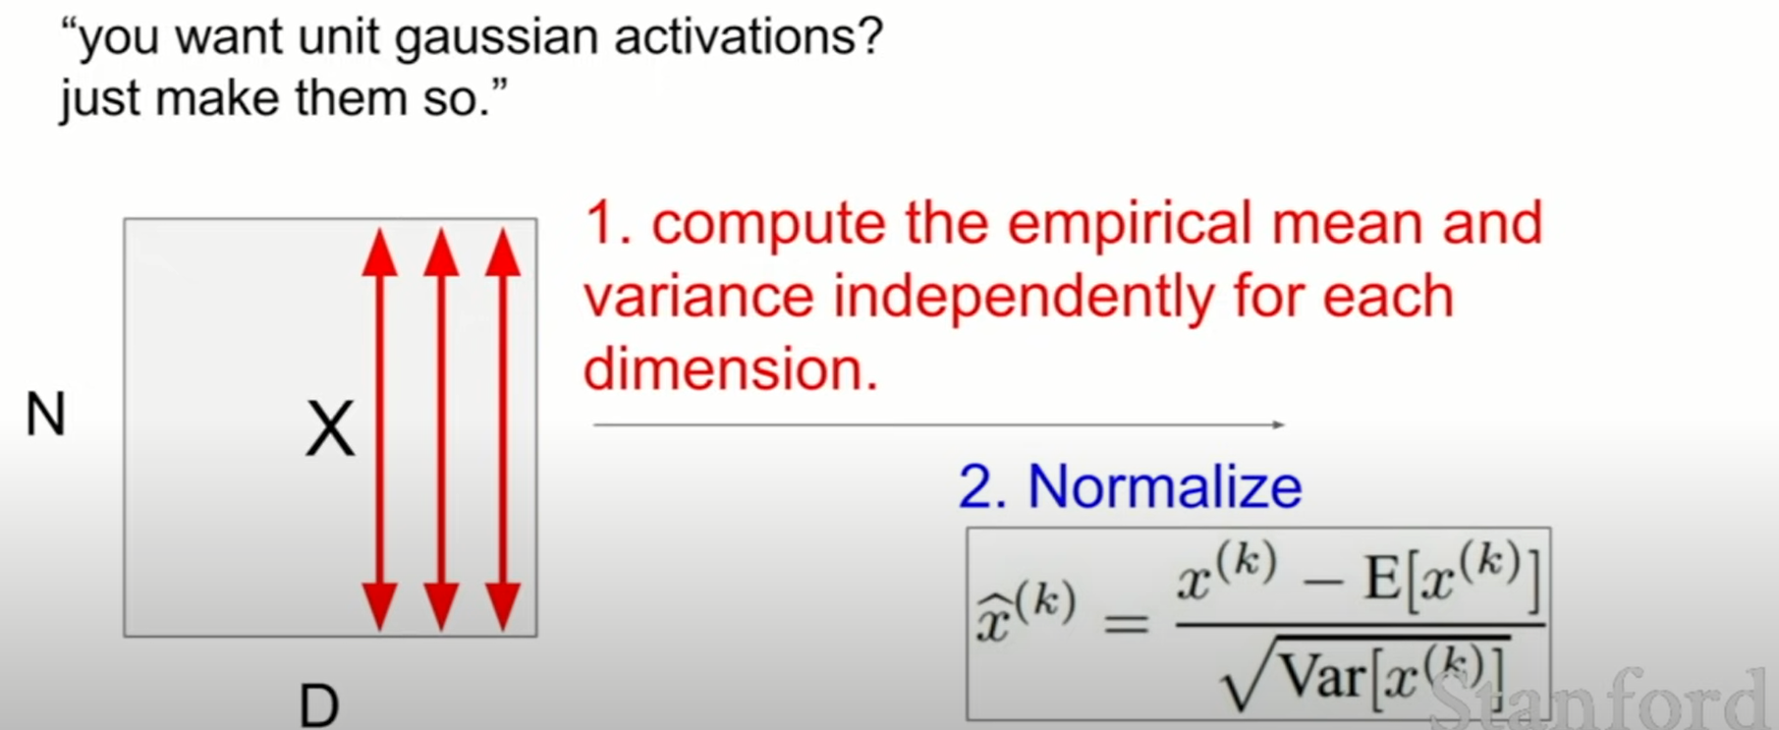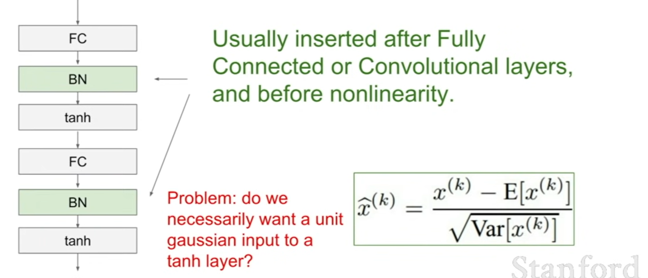

Solution:

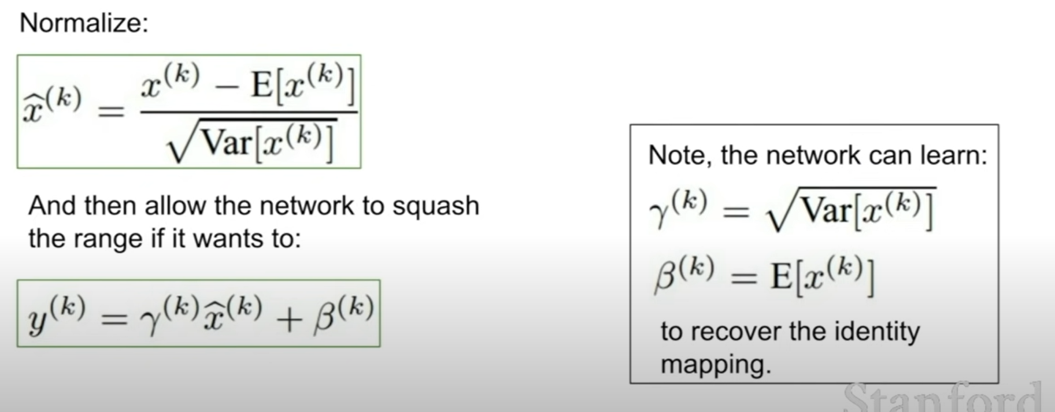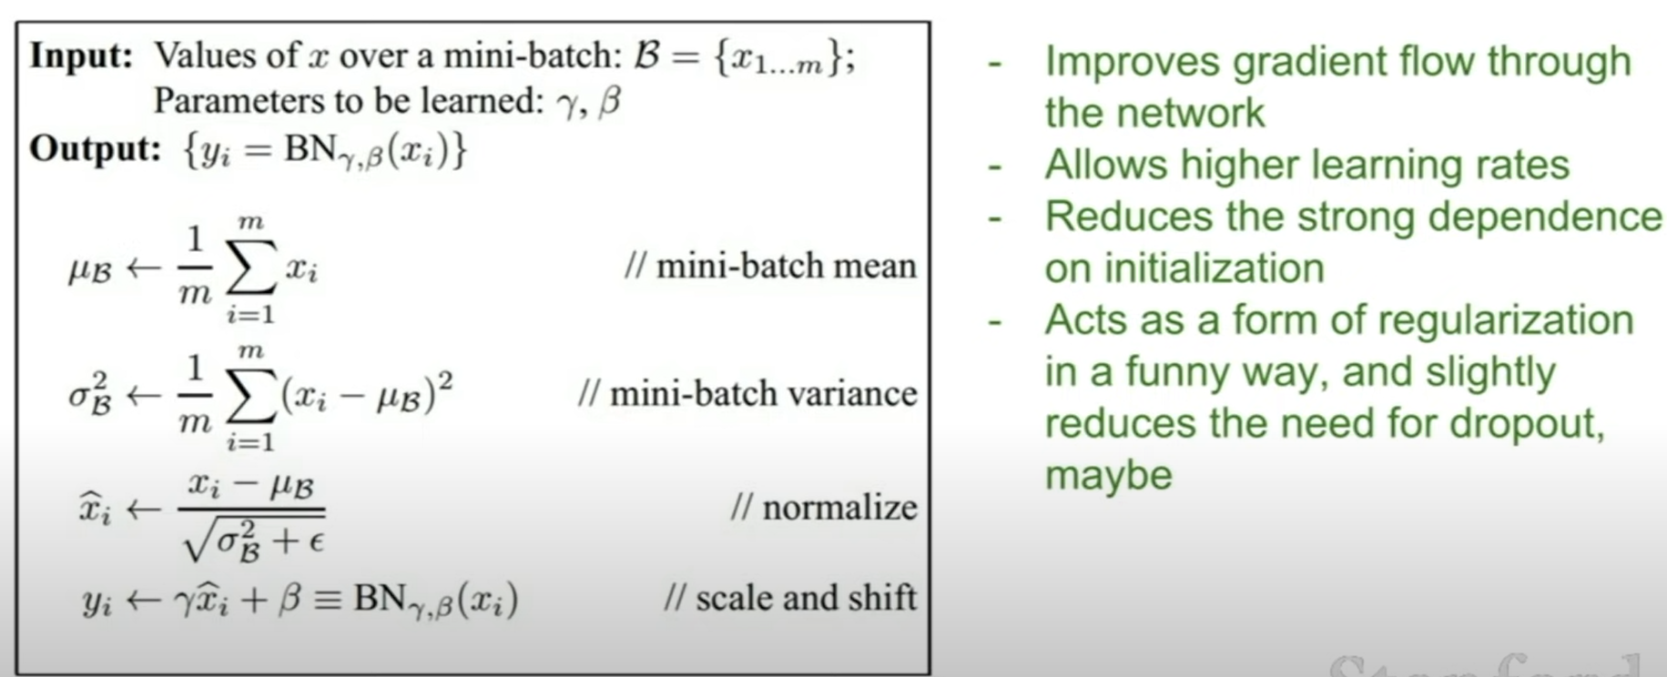

Babysitting the model

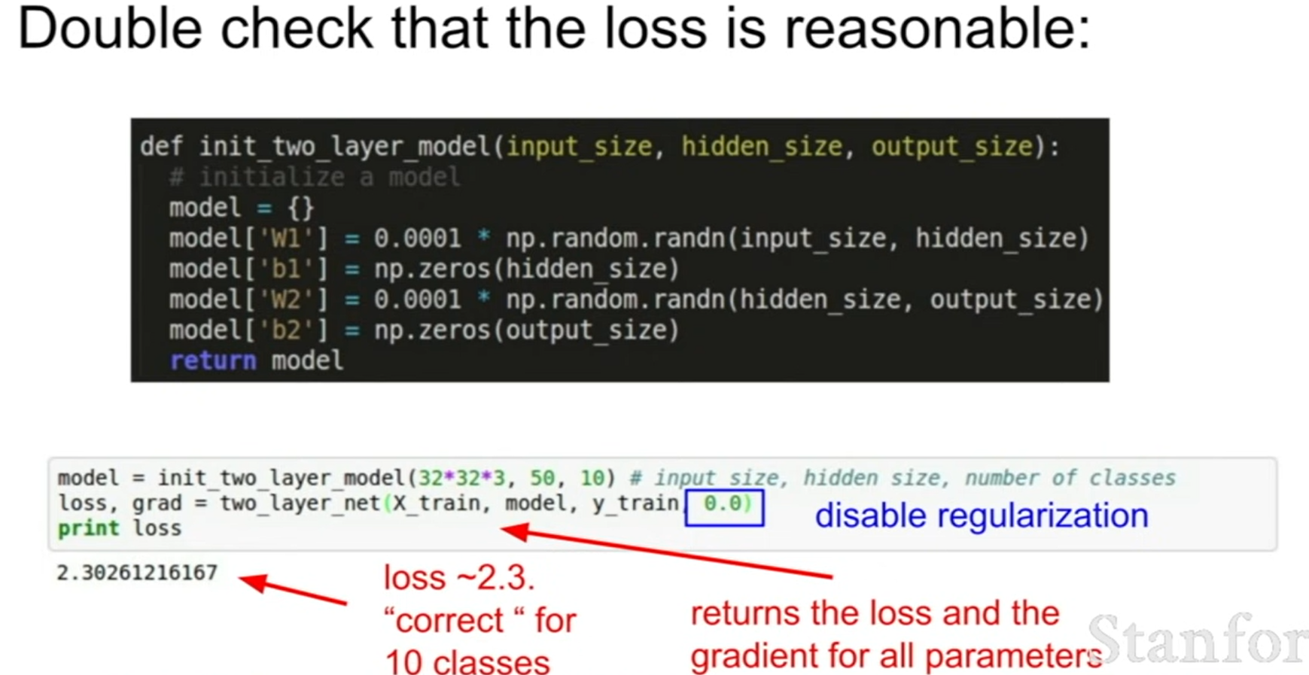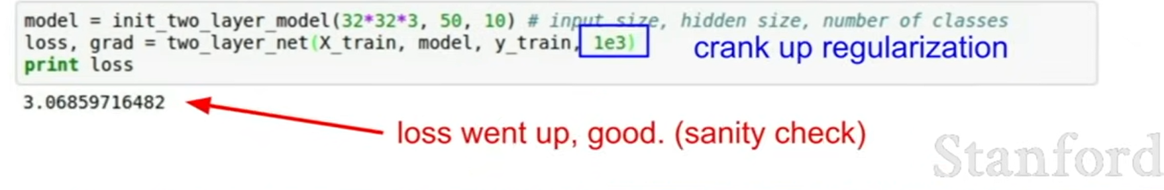

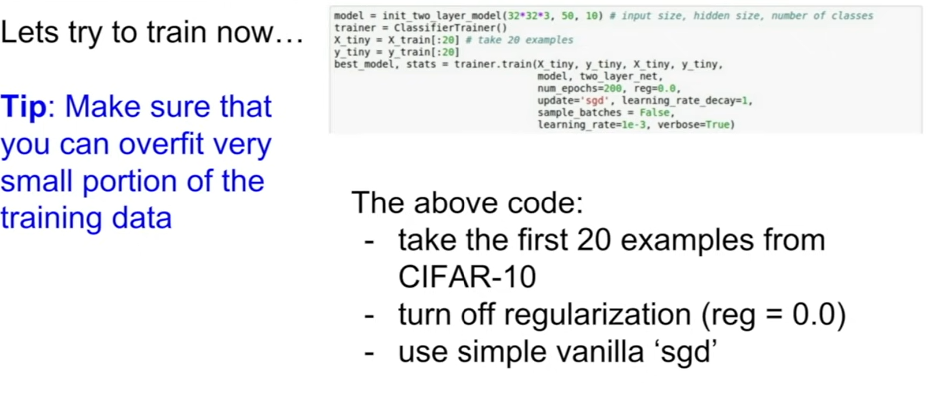

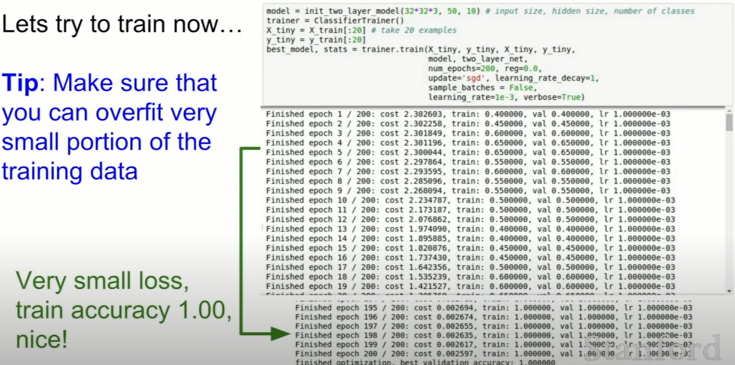

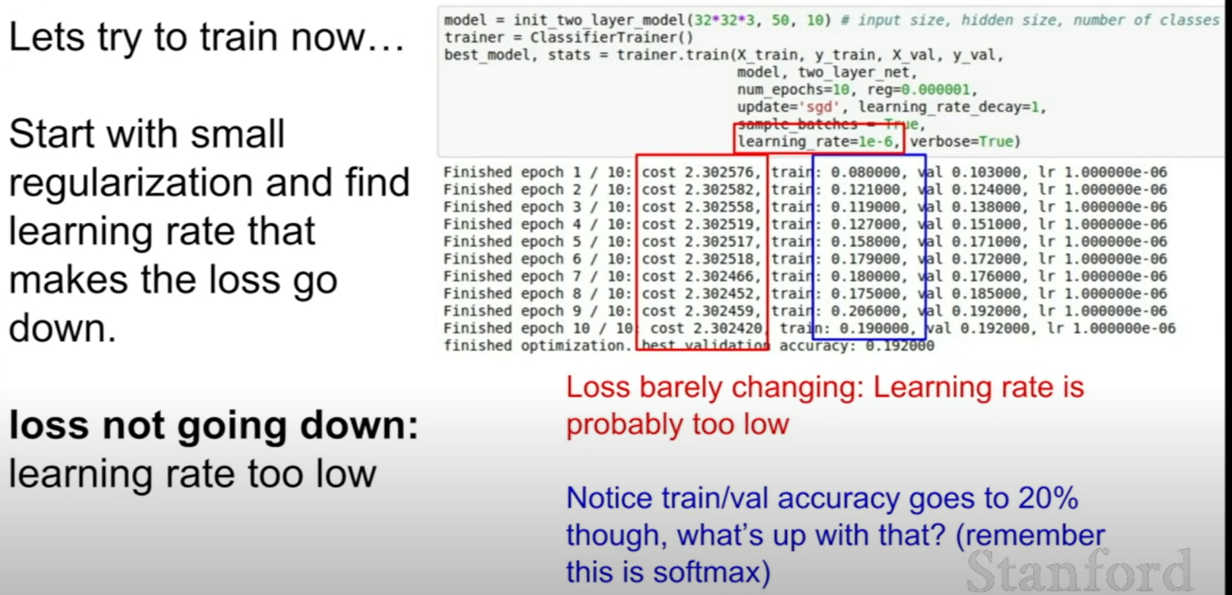

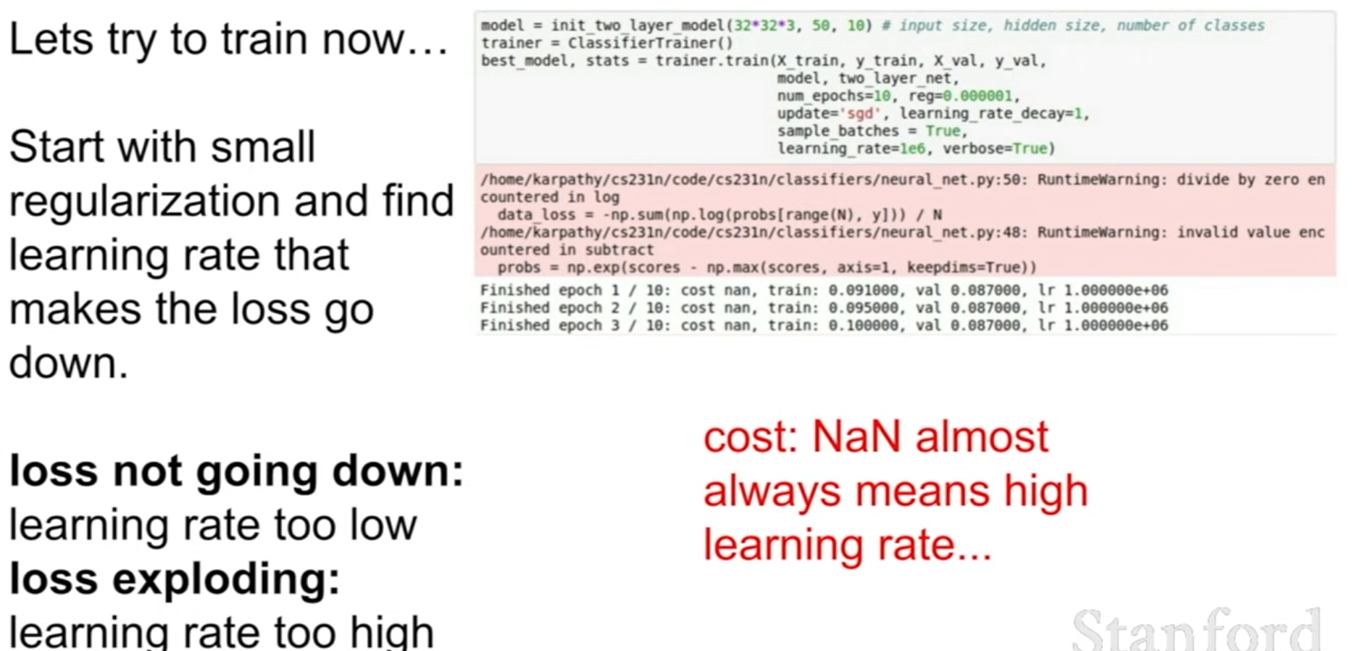

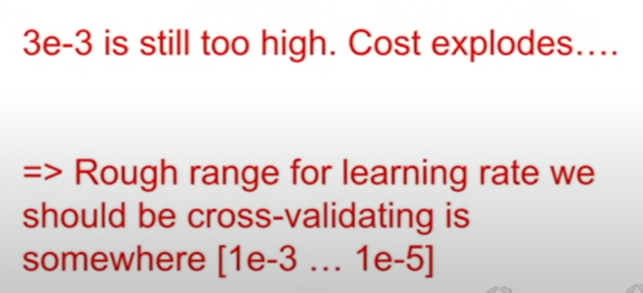

Hyperparameters optimization

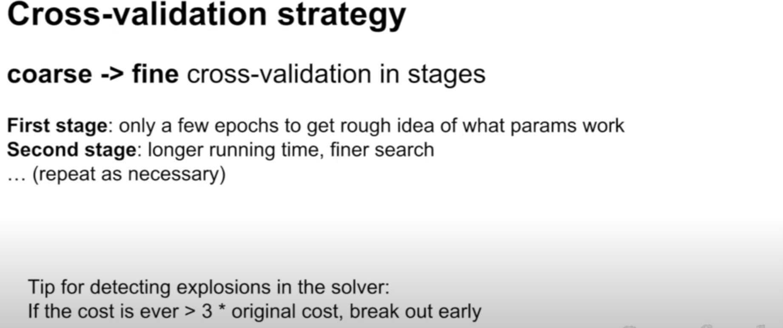

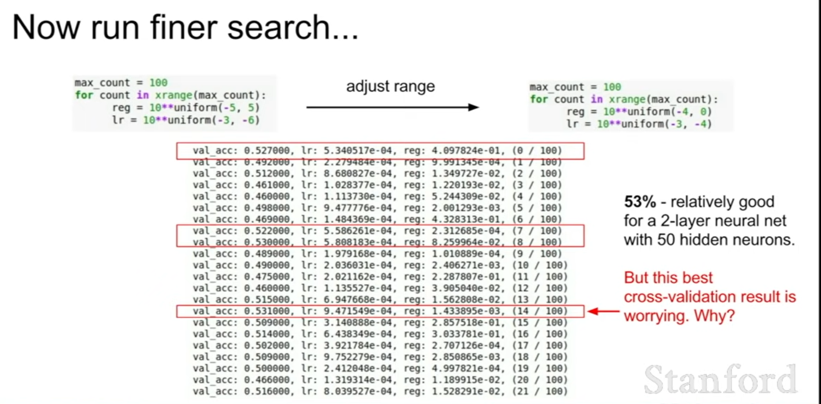

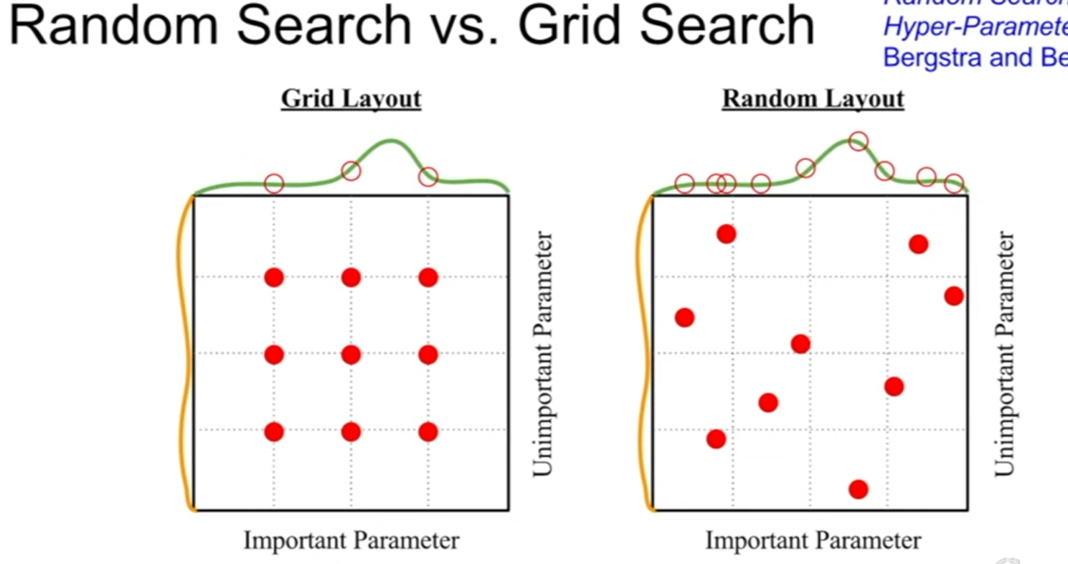

This means that it is better the sample randomly than in a grid layout. Because you can miss things with the grid. So optimize hyperparameters randomly ?

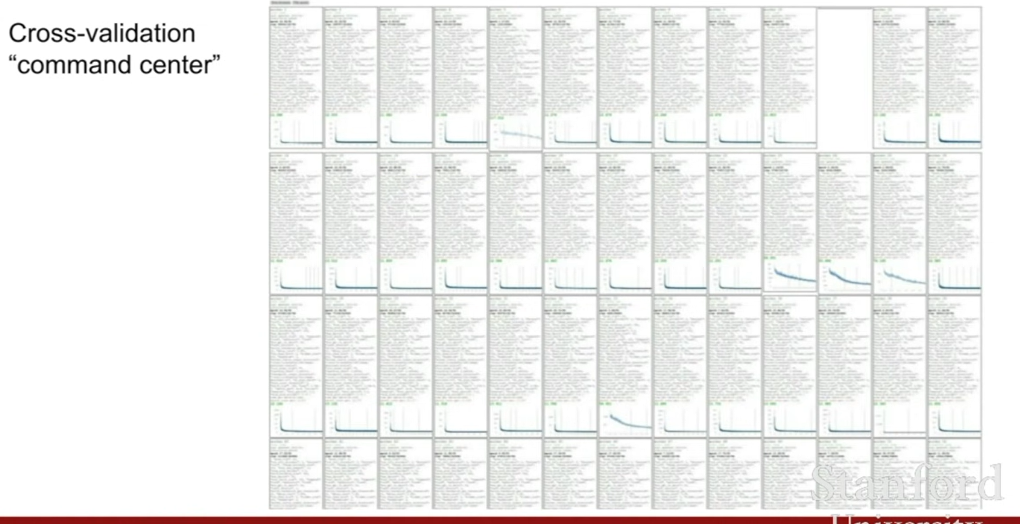

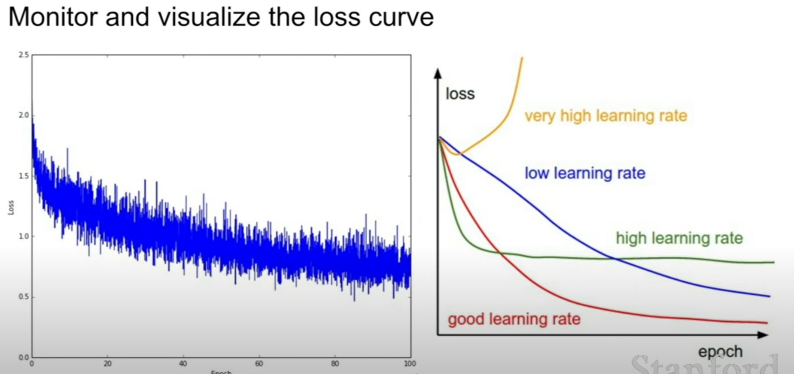this is what a good learning rate looks like. (left one)

This can happen too:

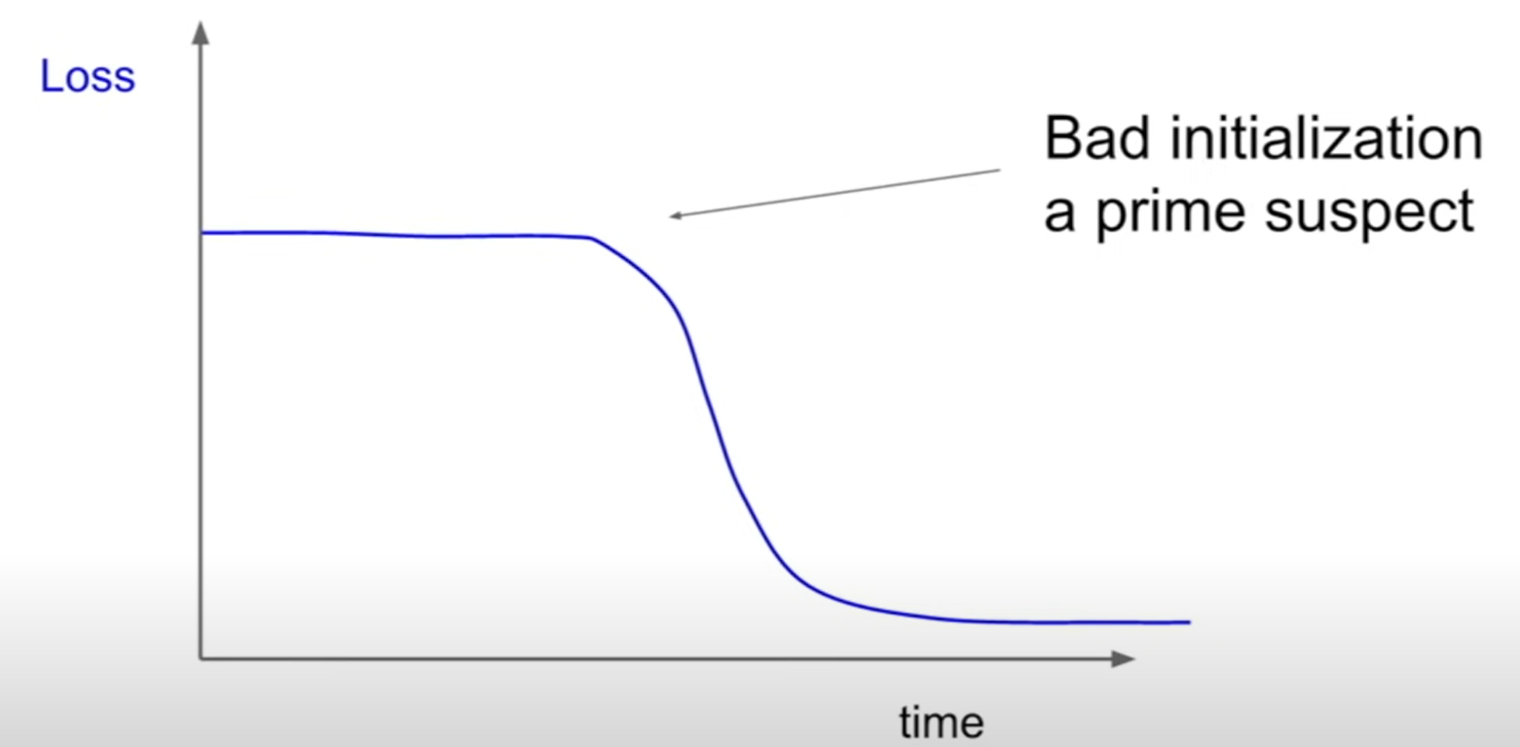

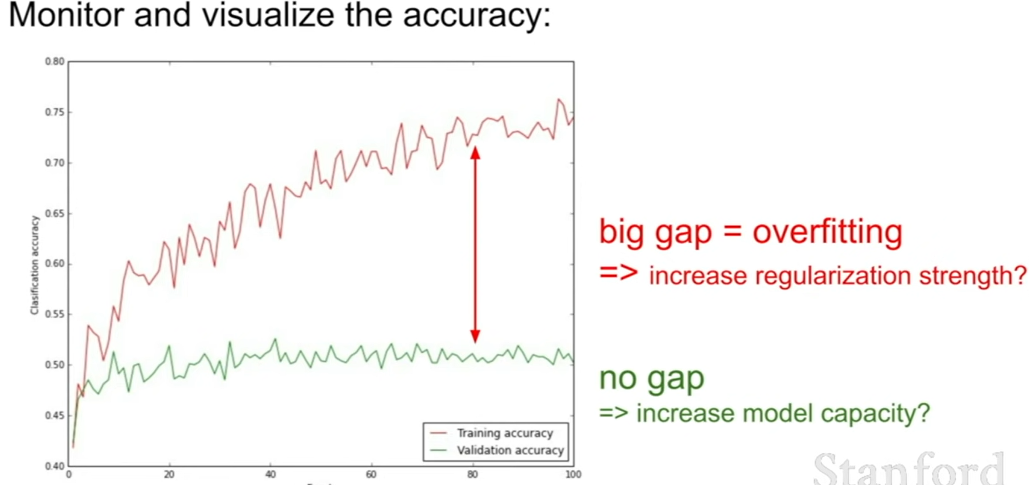

Epoch on abcisses.

## Lecture 7: Training Neural networks

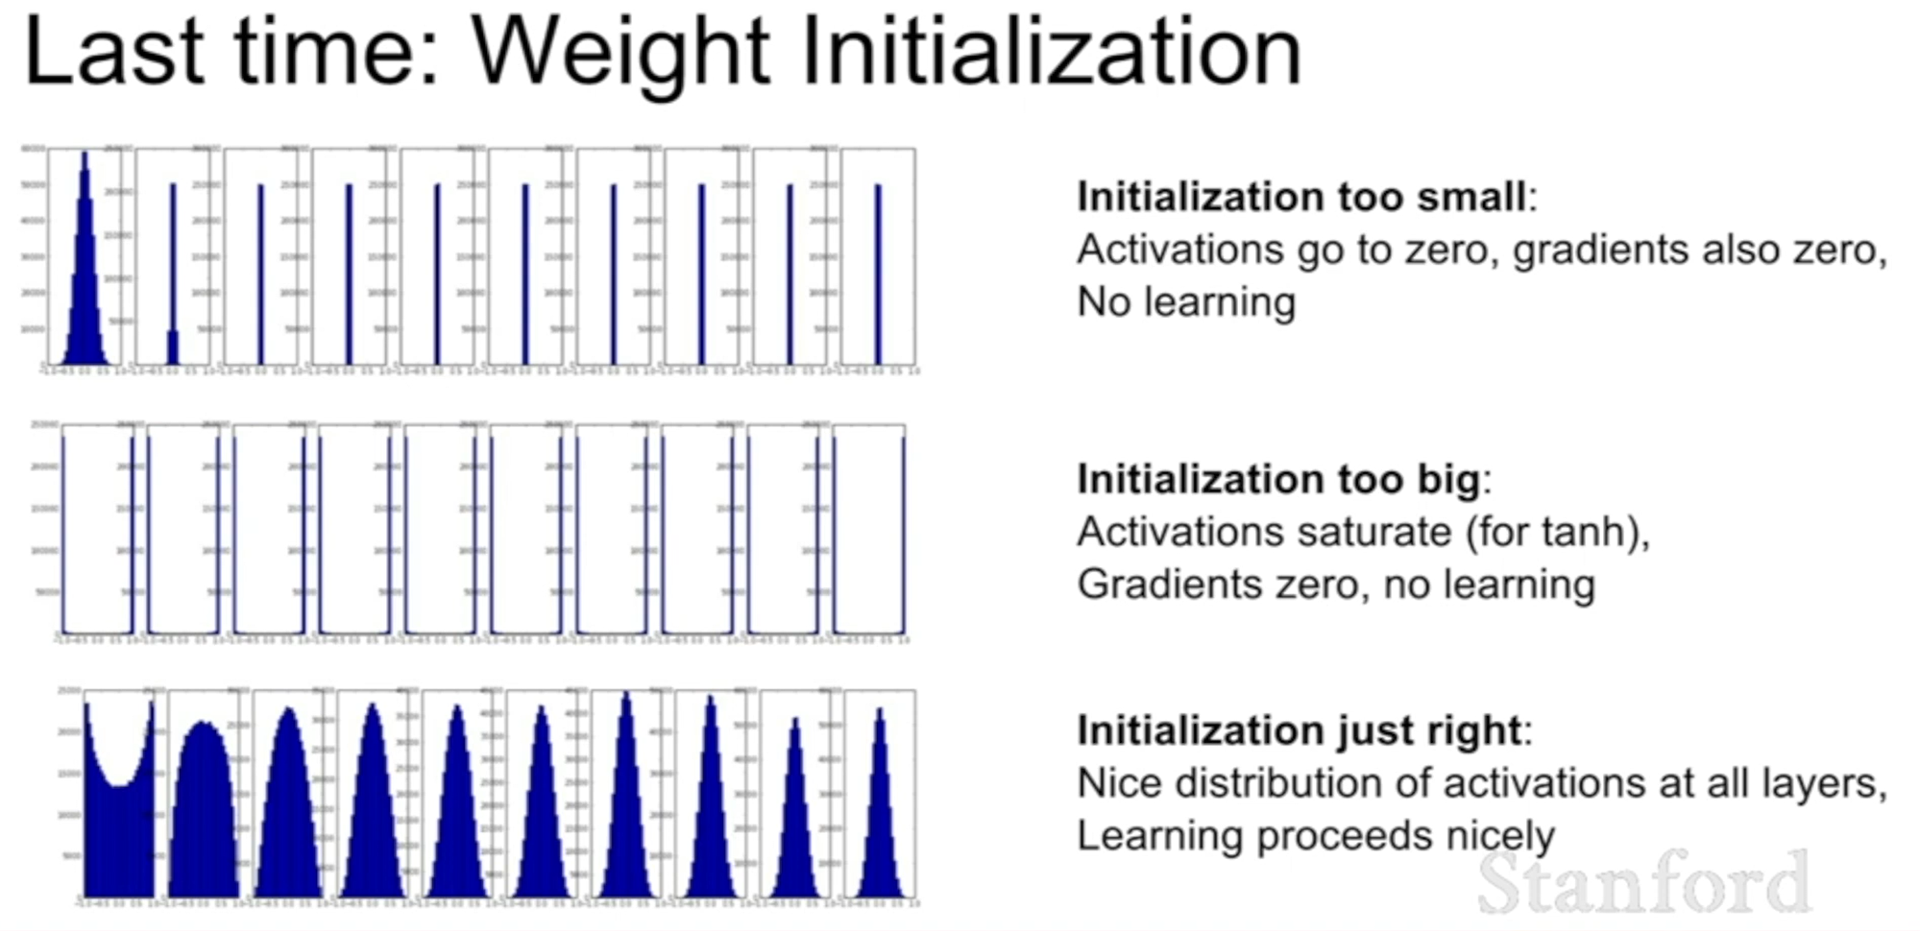

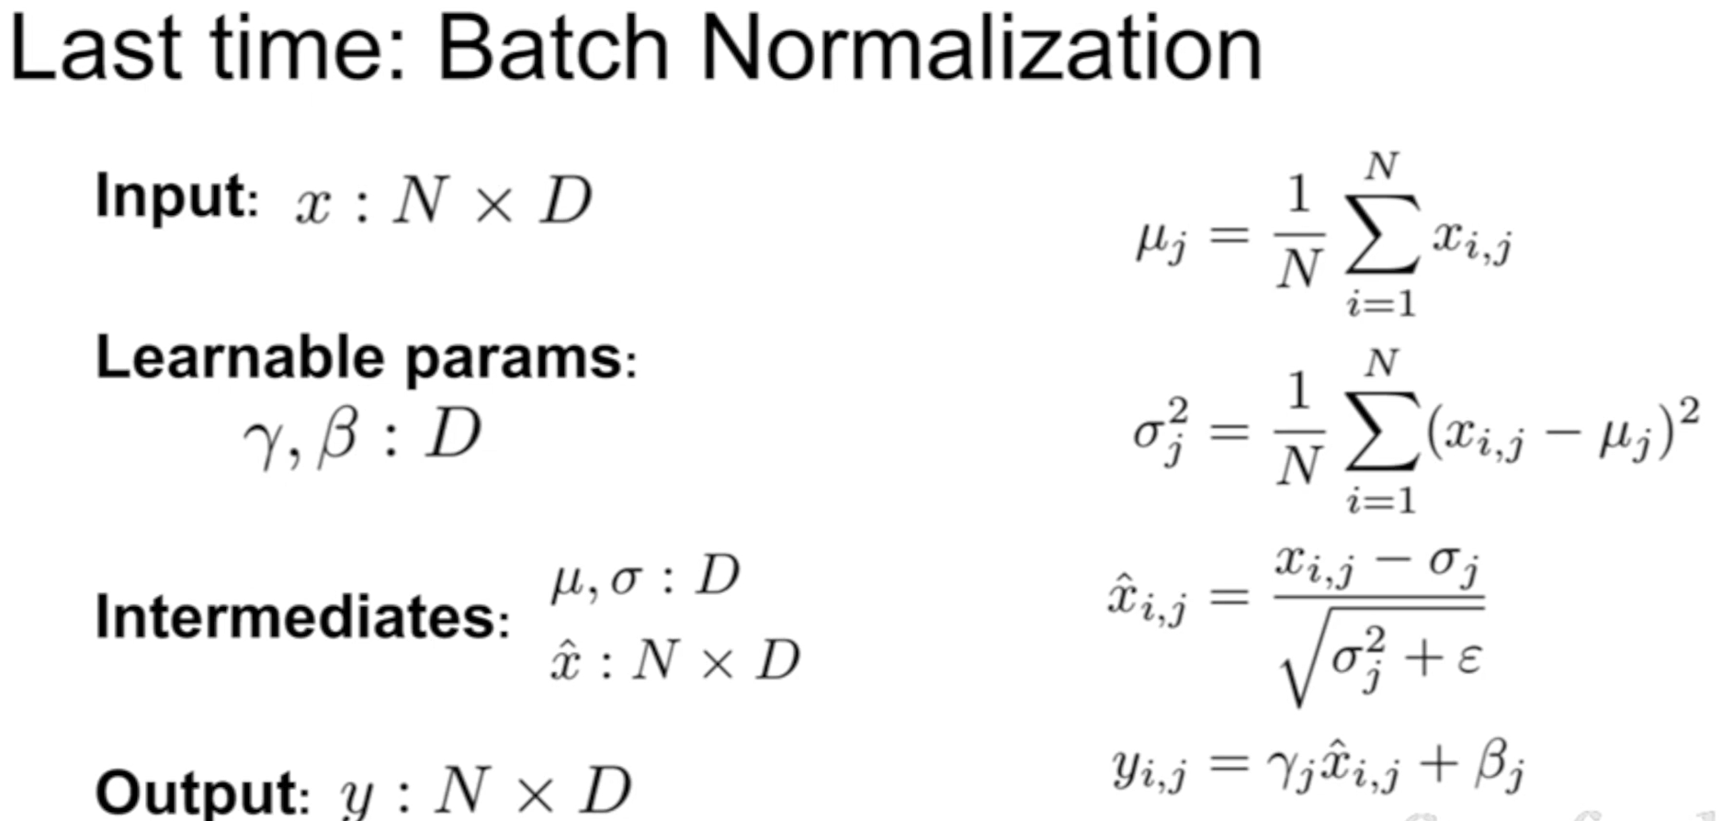

Baby sitting models:

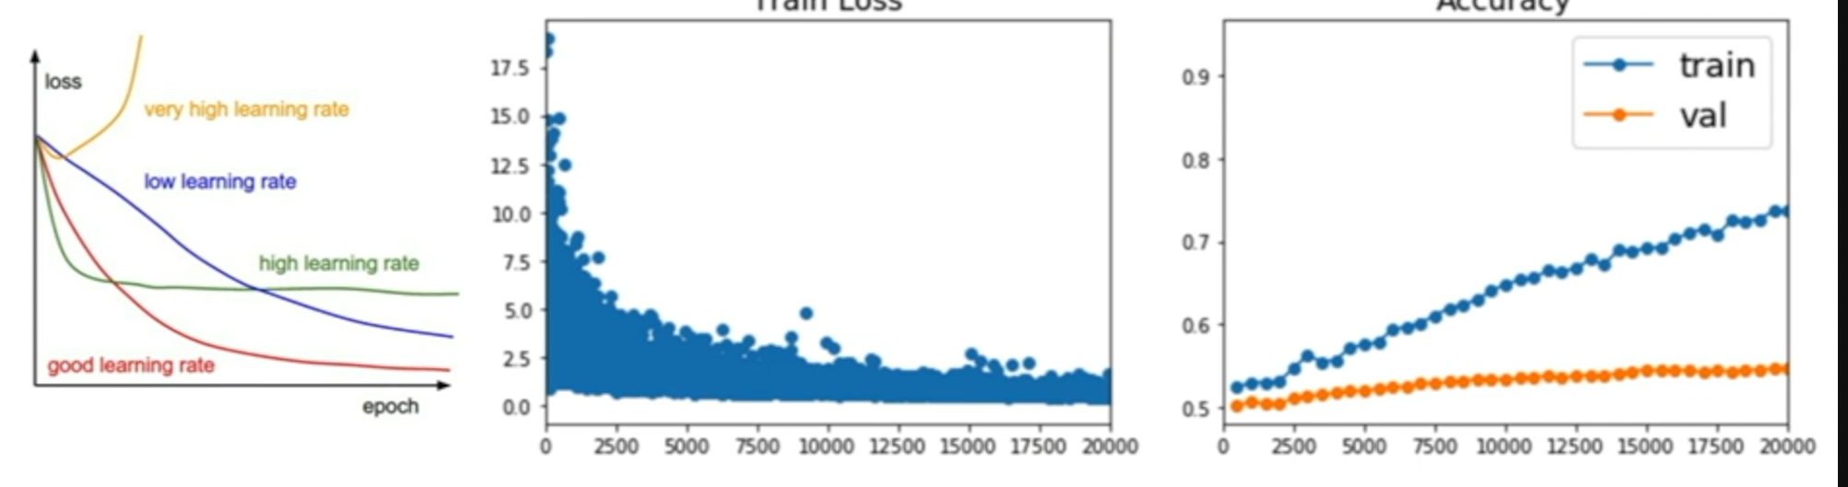

Here on right: we see training results goes up but not validation (over allowing the model): the model think almost every thing is the right thing.

At the beginning of training, your hyperparameters should be so wide and not reasonable.

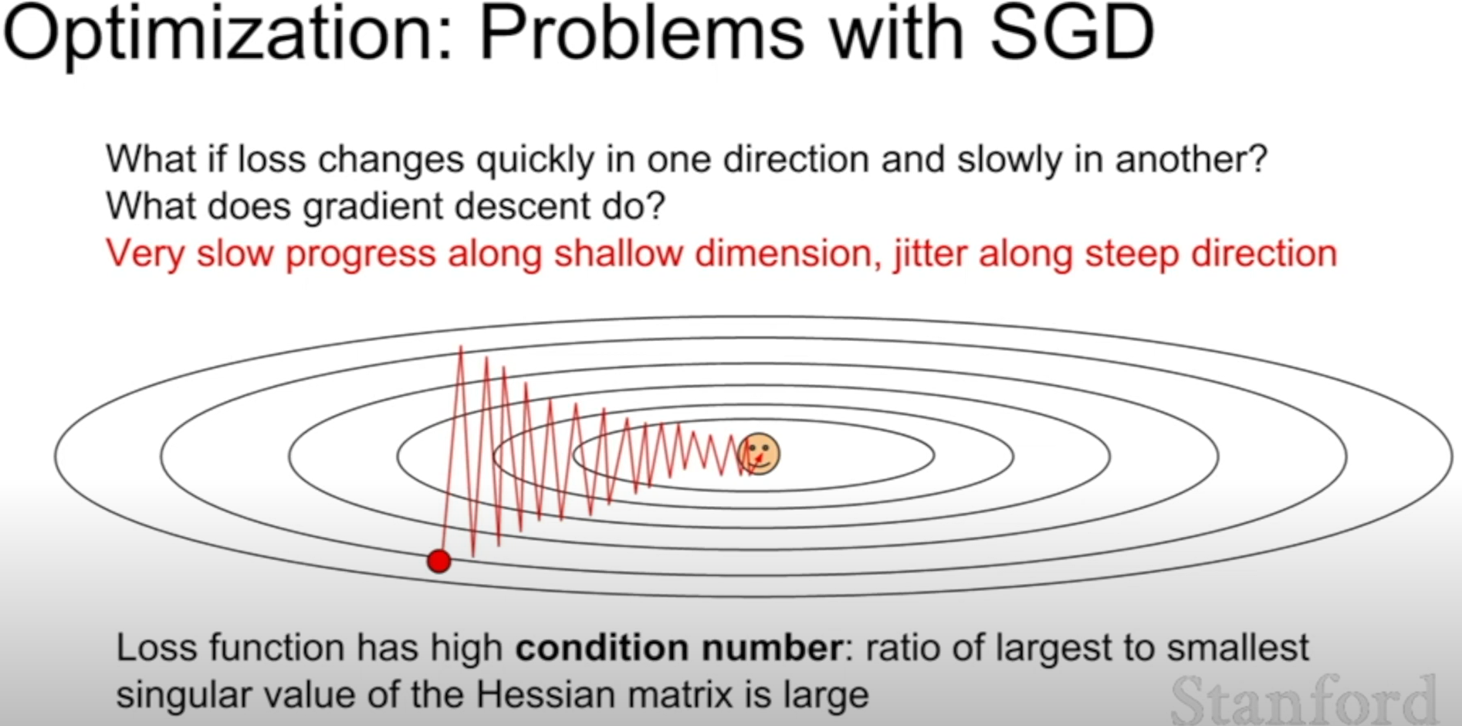 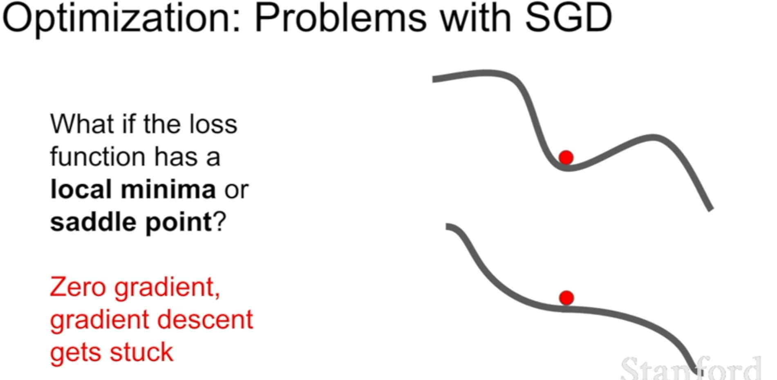

|  |  |
| --- | --- |
|  |  |

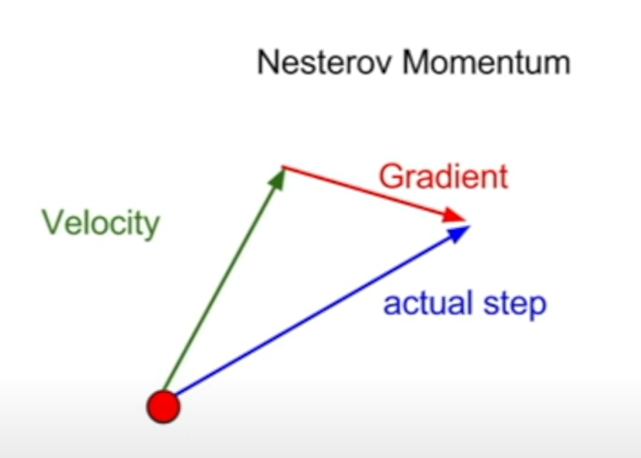Nestrov keep going where velocity is, then computes gradient and then step.

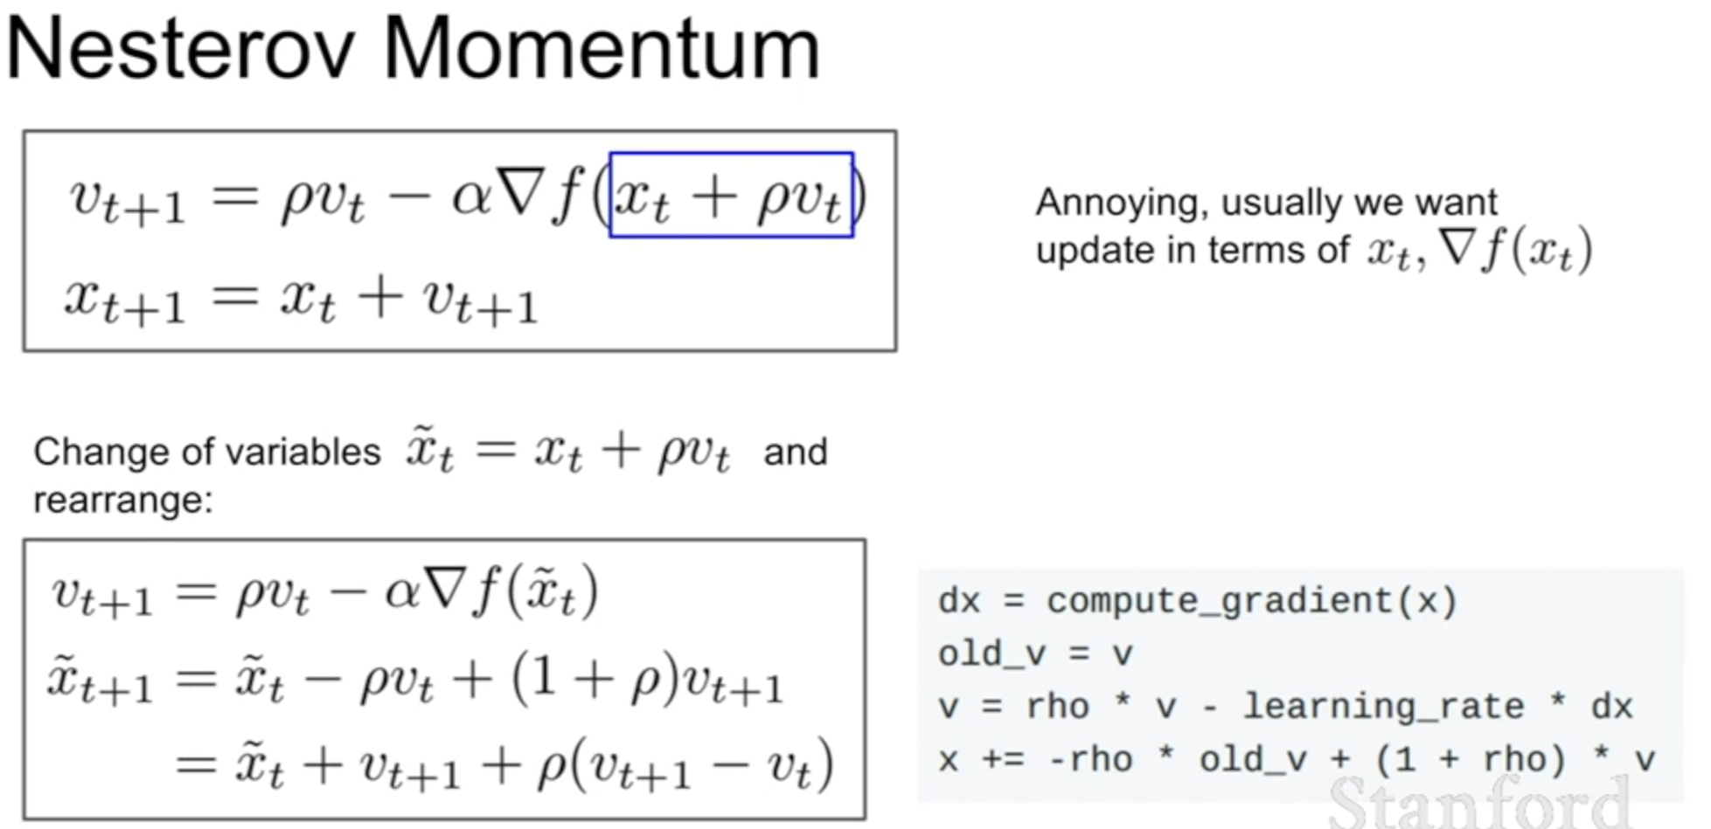

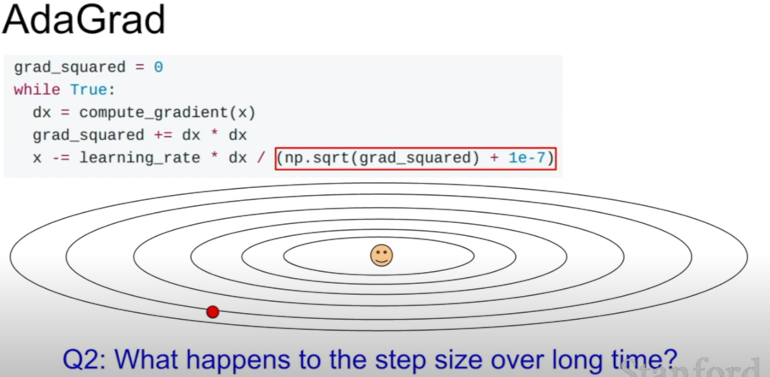

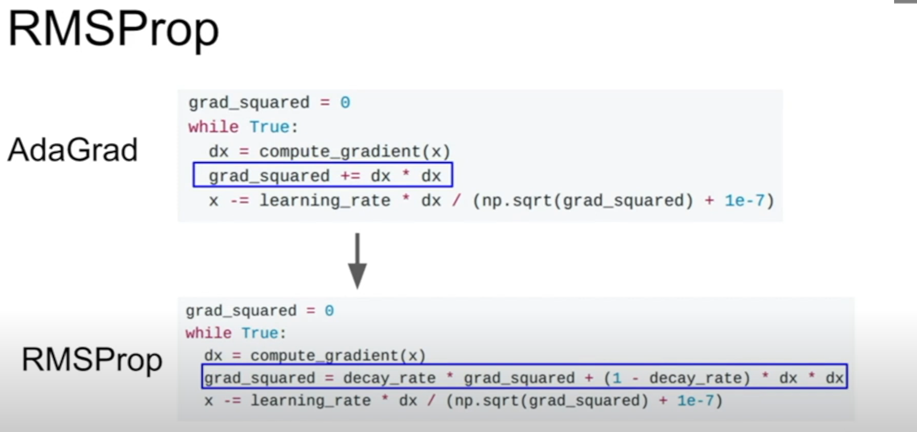

Adagrad isn’t really used for training networks.

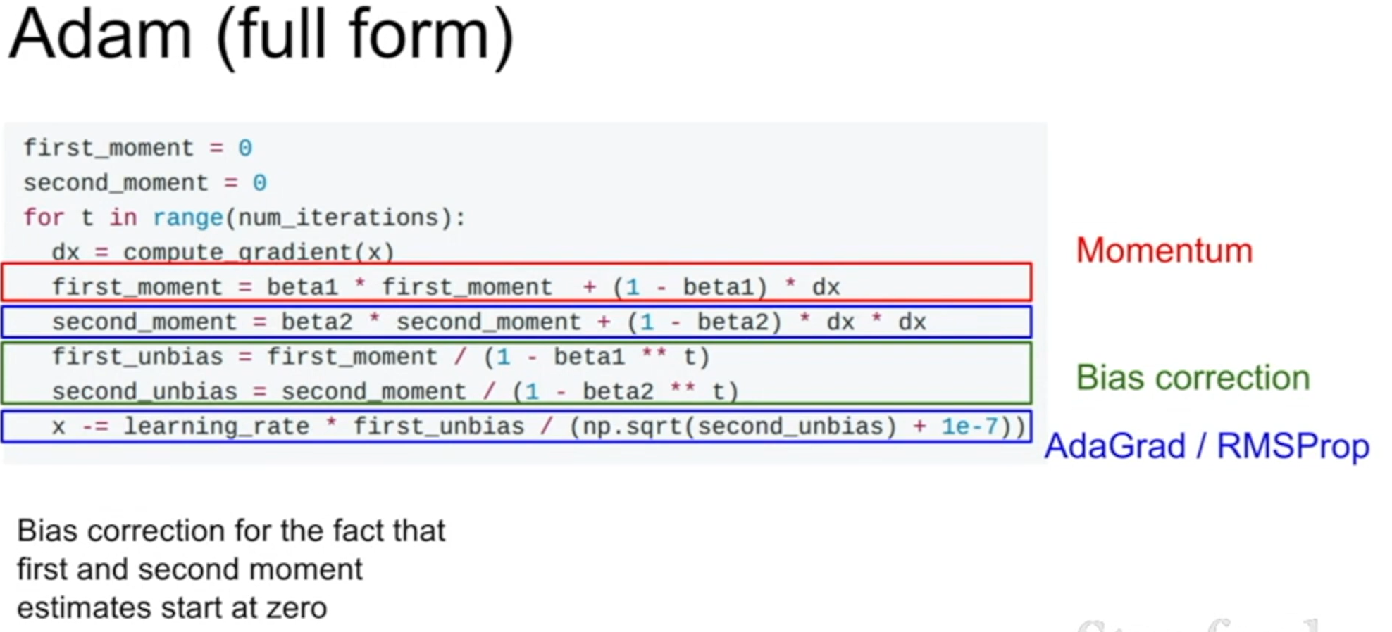

Instead of making tiny steps toward the gradient, there is this:

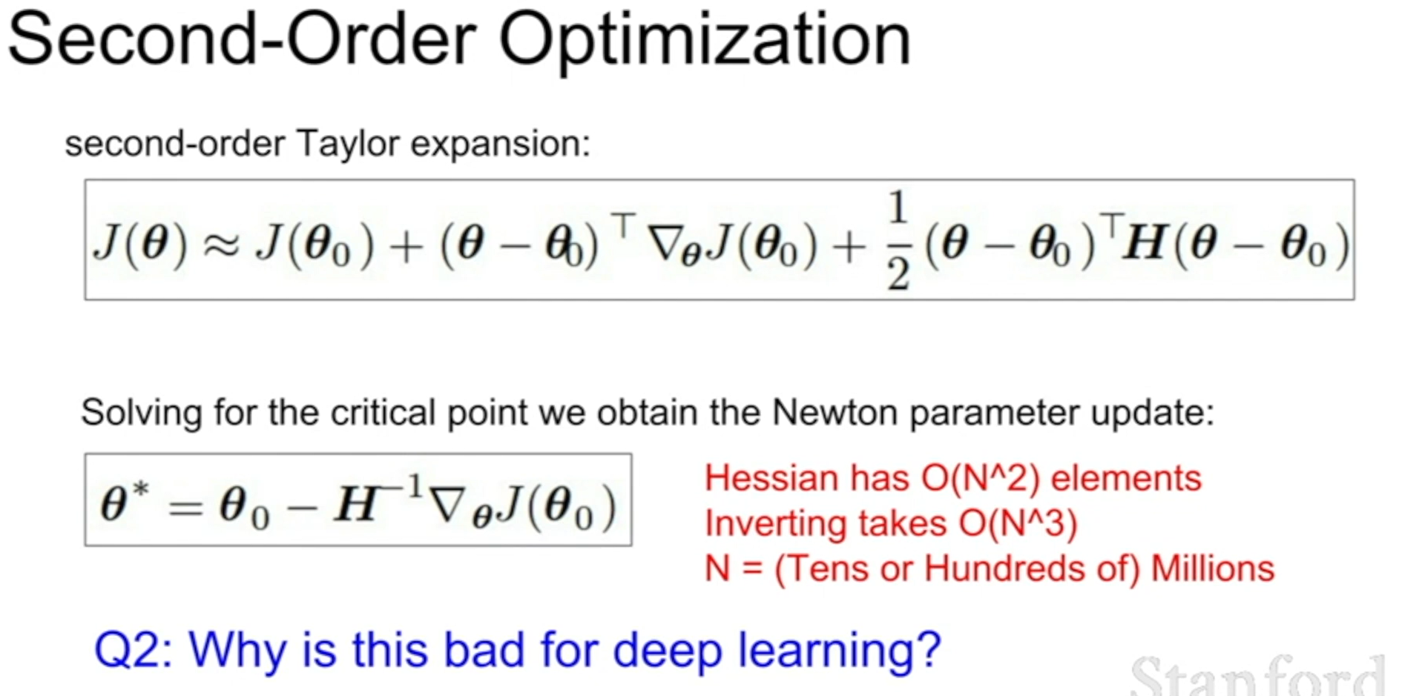

Approximate the function from gradient and the step to minimum. This way you don’t need learning rate, since you are always stepping to the minimum. But impractical in practice.

So they use second order optimizer:

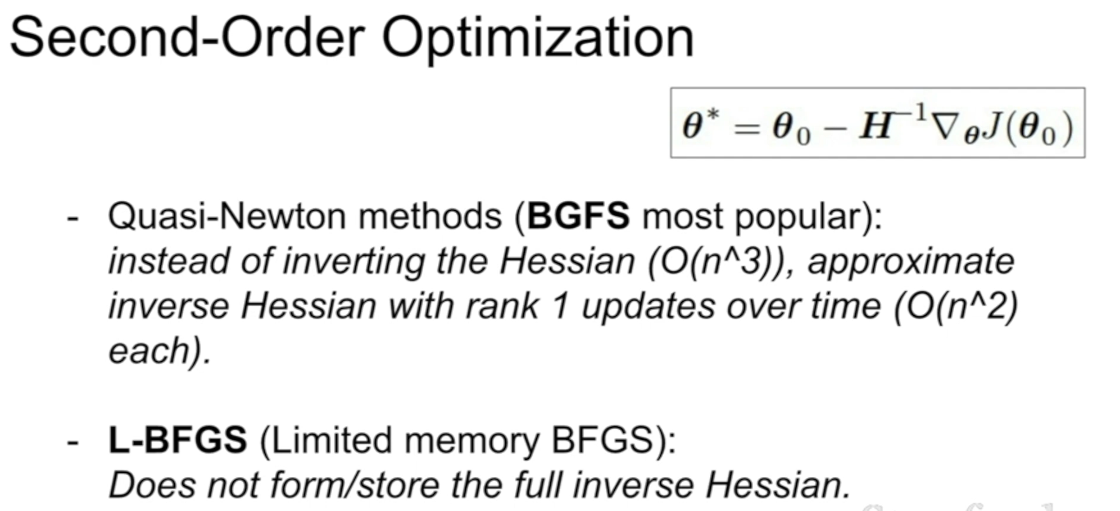 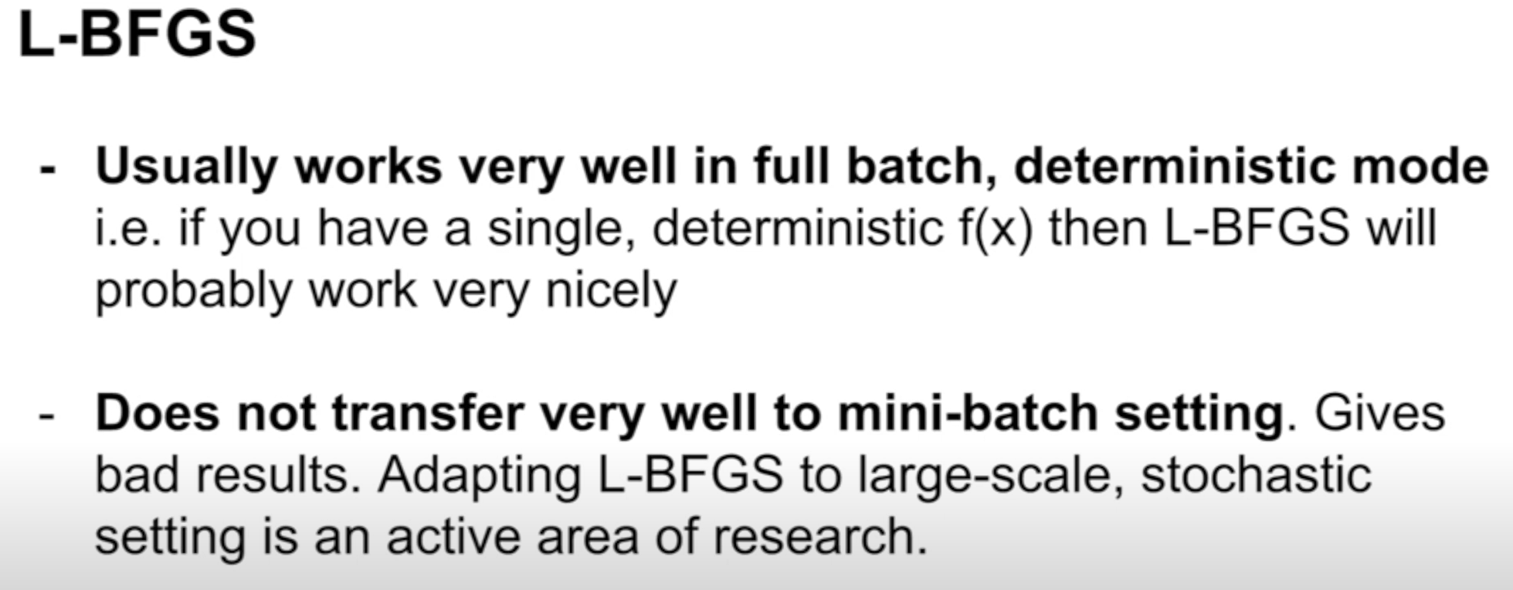

To redcue difference between test results and train results, we start 10 different models from 10 differents hyperparameters… and figure out which one is the best. +2%...

